APPENDIX
Evidence that part of the nominated asset described as “The RNHRD- the Min- and ancillary buildings”, as outlined in the Land Registry Plan attached in the nomination received on 20th June from Bath Preservation Trust, is an electricity sub-station station and as operational land of a statutory undertaker is not of community value and therefore may not be listed

The nomination clearly states that the proposed asset is “The RNHRD – the Min – and ancillary buildings as outlined on the attached Land Registry plan”. An extract of the attached plan is set out below.

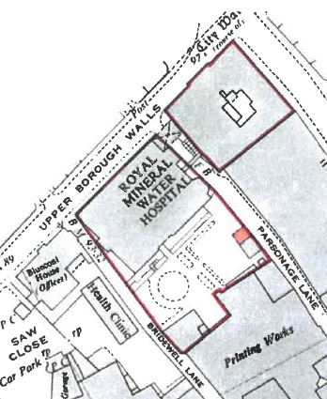

The Land Registry plan was accompanied by a copy of the register for title number AV175474. The Charges Register includes a lease for an electricity sub-station for a term of 99 years from 01.12.1961.
As part of our initial checks for the Pre-eligibility screening for the nomination this was further investigated. Information supplied by the Council’s Property Services showed reference to ‘’El Sub Sta’’ on the section of the site contained within the boundary of the nominated site, as shown on the plan below.

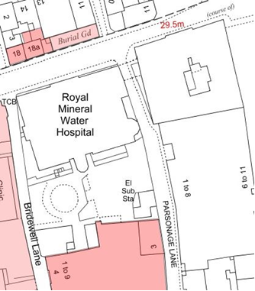

Western Power Distribution have indicated (correspondence 04 July 2017) that the electricity sub-station in question is named 16/0261Parsonage Lane 6.6KV and that electricity apparatus are in the vicinity fo the site and this should be assumed to be live.

