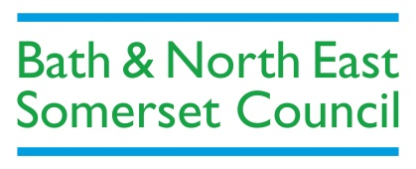
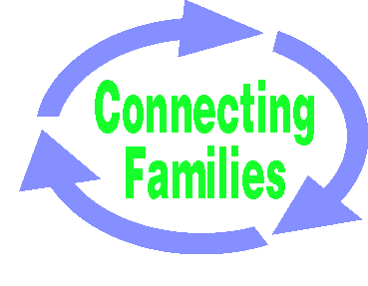
Bath & North East Somerset Connecting Families
Referral Form

The Connecting Families Team supports families with complex needs to make positive change. We encourage and develop new ways of working by co-ordinating local services to work together to meet the whole families’ needs.

- All referrals will need to be made using this form. You will receive an acknowledgment of your referral and the date of the next allocation meeting within 5 working days of receipt of receiving this form. You will be notified of the outcome within 5 working days of the allocation meeting.
- If you need space to provide additional information, please attach extra sheets.

Note for Social Workers – Marie Porter will screen any referrals from Social Care prior to being submitted. Please ensure your referral has gone through Marie before sending it to Connecting families

Professional’s information
Your Name |  | Role |  | Service/Agency
Contact Details
Address, email, tel nos

Family Name

Family’s Address

Family’s Contact Telephone number(s)

Name  (All family members in household) | Gender | DOB | Age | Relationship | Ethnicity | Detail Employment, Training or Education  (All family members) | Detail any Youth Crime / Anti-Social Behaviour? | Details of any health concerns?

Connecting Families Criteria
(The family would need to meet at least 3 of the criteria to be considered by the team, please put a cross in the box next to those criteria that the family meets)

Families Affected By:.
1 | Anti-social behaviour and crime
2 | Poor school attendance, engagement with education
3 | Worklessness, and at risk of financial exclusion
4 | Domestic violence and abuse
5 | Children of all ages who need help and are identified as a child in need or subject to a child protection plan
6 | A range of health issues, including mental ill health and drug and alcohol misuse
The Troubled Families National Criteria is available on the web page below.
http://www.bathnes.gov.uk/services/children-young-people-and-families/connecting-families
The document is called ‘Phase Two Criteria and Outcomes Measures’ and appears under the documents section on the right hand side

Please add further details about the particular issues for the applicable criteria and which family members they relate to. , Please also detail the children who need help and any other information or concerns:

I can confirm that I have discussed this referral with the family and they are happy for me to pass this referral onto you

Sign: Date:

Please return the completed form to the appropriate Connecting Families email address below. If you need to speak to someone in the team, please telephone 01225 396931
Internal to B&NES: Connecting_Families@bathnes.gov.uk
Secure email from outside B&NES: ConnectingFamilies_Team@bathnes.gcsx.gov.uk
Via Globalscape: For outside agencies without a secure email address. If you don’t have a link set up with Connecting families, please contact the team.
By recorded delivery: Send to Connecting Families Team, BANES Council, Lewis House, Manvers Street, Bath, BA1 1JG

January 2016

