Appendix C 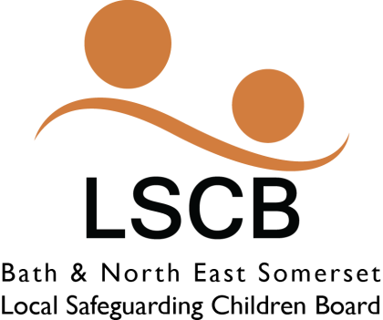
CSE MARAC
Referral Form

This form is to be completed by the allocated Social Worker/Lead Professional working with the young person. It should then be sent to Jean.Williams@bathnes.gcsx.gov.uk
Young Persons Details
Name |  | DOB
Address |  | School/College
Living at home | Yes |  | No
If not at home, where and with whom

Professional Network
Please list key agencies involved and contacts within each agency:

Presenting concerns
Please state your concerns include any names of possible perpetrators, locations and any other intelligence related

Analysis of current risk
What is the referrer’s view of the level of risk and what might be the consequences to the young person if CSE issues are not addressed?

Referrer’s details
Name
Organisation
Email
Telephone no.

By placing the referral, the Social Worker/Lead Professional commits to attending the Panel and presenting the issues/concerns to the Panel for discussion.
The referral cannot be discussed unless a SERAF is completed alongside this referral

Revised January 2016

