Appendix A 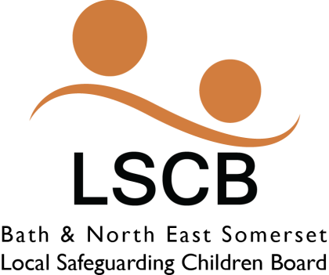

BATH AND NORTH-EAST SOMERSET
CSE MARAC
TERMS OF REFERENCE
INTRODUCTION

These terms of reference cover the organization, decision making and planning aspects of the CSE MARAC set up within Bath and North-East Somerset. The panel will be comprised of professionals, all working within the local area. The MARAC seeks to ensure the safety of young people and to strengthen and further improve multi-profession decision making. The MARAC will look at disruption of CSE across the B&NES area and will commit to developing disruption plans for CSE cases. The CSE MARAC does not replace the requirement for strategy meetings where applicable. The terms of reference need to be read in conjunction with:
- Defensible Decision Making (MARAC Guidance)
- South-West Region Child Protection Procedures

INVOLVED AGENCIES
Agencies represented on the MARAC will be as follows:
- CAMH’s
- Youth Services
- Avon and Somerset Police
- Children’s Services (Social Care)
- Children Missing Education
- Willow Project (representative for)

The panel will be chaired by the police, and Children and Young Peoples Services will act as vice chair. Each panel member is expected to appropriately represent the professional views and responsibilities of their agency.
It is anticipated that members agreeing to recommendations allocated to their agency take full responsibility for the onward delegation of these tasks and for ensuring they have been completed within agreed timescales.

FREQUENCY
The Panel will meet as and when required. With meetings being held at the Civic Centre, Temple Street, Keynsham.
ORGANIZATION AND ADMINISTRATION
All presentations to the Panel will be made by the Lead Professional and where possible or applicable their Team Manager responsible for the young person. They will bring the relevant intelligence and information to the panel.
This paperwork will be circulated to all panel members a minimum of 3 working days prior to the meeting. All panel members will be expected to attend with papers and background knowledge of the cases to be discussed / presented.
Presentations by the Lead Professional (key workers), Team Managers will be scheduled at thirty minutes intervals. Staff presenting cases will be expected to attend promptly at the allocated time. Following discussion of the case by the panel, the chair will complete the Recommendations for action / planning which will constitute the agreed plan to support/ manage / reduce and disrupt the CSE presented (see appendix A). The details of the plan will be confirmed verbally to the presenting worker and agencies at the conclusion of each case discussion. Written confirmation of decisions will be provided to Team Managers by the Chair within 48 hours, with an expectation that recommendations / actions are entered into Care First within 48 hours of receipt of decisions/actions.

CRITERIA FOR CASES
The cases referred to CSE MARAC must have followed the multi-agency CSE protocol that includes referral process for CSE cases

- Specific Practice Concerns:
Child Sexual Exploitation
Child Trafficking

The primary focus for this panel is to disrupt the criminal activity surrounding CSE and ensure patterns can be identified where possible.

CSE MARAC

ESSENTIAL INFORMATION / DECISION SHEET

NAME OF YOUNG PERSON ------------------------------------------------------------

AGE / D.O.B. --------------------------------------------------------------------------

ALLOCATED WORKER -----------------------------------------------------------------

TEAM / SERVICE ----------------------------------------------------------------------

INVOLVED AGENCIES ----------------------------------------------------------------
NATURE OF CONCERN:

POTENTIAL CONSEQUENCES IF IDENTIFIED RISK IS NOT REDUCED

ACTIONS AND DECISIONS: (For use by Panel Chair)
RESOURCES / COST IMPLICATIONS: (For use by Panel Chair)

