Appendix B 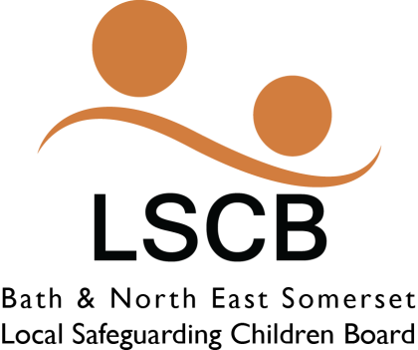
Child Sexual Exploitation Risk Assessment Form (SERAF)
Child’s name & address

Date of Birth |  |  |  | Gender
Ethnicity |  |  |  | Languages spoken
Specify any SEN or disability if child is disabled |  |  |  | Date of this child sexual exploitation risk assessment
Name, agency and contact details of worker completing assessment

Known to children’s social care?  If so, since when? |  |  |  | Is child in care?  If so, start date and legal status
Is child on CP plan?  If so, since when? |  |  |  | Involvement with the Youth Offending Service?  If, since when?
Is the child receiving support or services from any other agency?

Please list them here e.g. CAMHS, CMES, etc.
Vulnerabilities |  |  | Please tick  Score 1 for each ticked | Vulnerabilities |  |  |  |  | Please tick  Score 1 for each ticked
Emotional neglect by parent/carer/family member |  |  |  | Family history of mental health difficulties
Physical abuse by parent/carer/family member |  |  |  | Low self-esteem
Sexual abuse |  |  |  | Unsuitable/inappropriate accommodation
Breakdown of family relationships |  |  |  | Isolated from peers/social networks
Family history of domestic abuse |  |  |  | Lack of positive relationships with a productive/nurturing adult
Family history of substance misuse

Moderate risk indicators |  |  |  |  |  | Please tick if present on date of assessment or during the past 6 months (Score 1 for each ticked)
Staying out late

Multiple callers (unknown adults/older young people)

Use of a mobile phone that causes concern

Expressions of despair (self-harm, overdose, eating disorder, challenging behaviour, aggression)

Exclusion from school or unexplained absences from or not engaged in school/college/training/work

Disclosure of sexual/physical assault followed by withdrawal of allegation

Sexually Transmitted Infections (STIs)

Peers involved in clipping/sexual exploitation

Drugs misuse

Alcohol misuse

Use of the internet that causes concern

Living independently and failing to respond to attempts by worker to keep in touch

Significant risk indicators |  |  | Please tick if present between 6 and 12 months ago  (Score 1 for each tick) |  |  | Please tick if present on date of assessment or during past 6 months (Score 5 for each tick)
Periods of going missing (most of day, overnight or longer)

Older “boyfriend”/relationship with controlling adult

Physical abuse by controlling adult/physical injury without plausible explanation

Emotional abuse by controlling adult
Entering/leaving vehicles driven by unknown adults (Not taking and driving away: car theft)

Unexplained amounts of money, expensive clothing or other items

Frequenting areas known for on/off street sexual exploitation

CSE risk assessment score |  |  |  |  | Risk Category (1-4)
Referral to children’s social care? If so, give date.

Principal area of concern (please state in here any names of possible perpetrators and/or locations if known:

All completed SERAF forms must be sent to: CSE.Referrals@bathnes.GCSX.gov.uk
All forms with a score of 16+ must also be sent to: childcare.duty@bathnes.GCSX.gov.uk

This form was originally devised by Barnardos
Revised May 2016

Professional Judgment Sheet
Please provide any additional information in the box below. This box is for you to provide any relevant information that increases your concerns regarding CSE. It is essential that you pass on any relevant information.

This form was originally devised by Barnardos. Revised May 2016

