YOUTH CONNECT

CURRICULUM POLICY

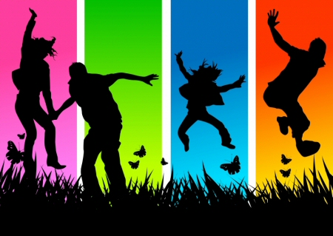

Review December 2017

**Youth Connect is part of the Early Help Preventative Service and works with young people aged 11 – 19 and up to 25 years with SEND throughout the Bath and North East Somerset area.**

“Curriculum” is a range of topics that encourages young people to think about experiences and situations that they encounter, how to develop, and learn from those experiences. Youth Connect staff help young people respond to their environment and challenge

preconceptions/ stereotypes to enable young people to thrive and develop.

This framework is a tool to help plan programs with young people so they get the best out of their experiences with Youth Connect.

Bath and North East Somerset Council believe all young people should have the same life chances, research shows us that if people are in work throughout their lives, their quality of life improves, life span is increased, and their opportunities are increased.

Youth Connect employs professionally qualified staff which brings a range of approaches to working with young people. Staff are mainly trained as Youth Workers and Personal Advisors**.**

***Youth Work***

*Youth work aims to support young people in learning about themselves, others and the society in which they live, through activities combining enjoyment, challenge, learning & achievement. It is a developmental process that starts in places and at times when young people themselves are ready to engage, learn and make use of it.*

*Youth work focuses on working holistically with young people. It’s about building resilience and character and giving young people the life skills (often totally misleadingly described as “soft”) they need to live, learn, work and interact successfully with other people. (NYA)*

***Information Advice and Guidance***

*Information, advice and guidance is an umbrella term which covers a range of activities and interventions that help young people to become more self-reliant and better able to manage their personal and career development, including learning.*

Youth Connect work is delivered through planned programmes based on this **Curriculum model.** This model encourages young people to understand and act on the personal, social, intellectual, political, moral, emotional and physical issues which affect their lives, the lives of others and the communities of which they are part. It supports individuals and groups of young people through their transition to adulthood, from dependence to interdependence, in order to ensure that each young person, no matter who they are, has the best possible start in life and the opportunity to develop and achieve their full potential.

Youth Connect work with individuals and groups through voluntary agreements with young people. These agreements serve as the basis for flexible learning where young people make informed decisions about the direction of their lives. Its principles and working methods present a real opportunity for ensuring that practice within wider social policies yields optimum and desirable outcomes for young people and the wider community. It is a process for enabling young people to navigate successfully their route to adult life, to take more control over their lives and to achieve their aspirations.

The work takes place where young people meet, youth hubs, schools, drop in’s, parks and in the local community.

In order to make sure that the Youth Service works towards

Young people have the right to engage in ‘quality’ youth work and the curriculum provides the framework for planning, delivery, monitoring and evaluation of ‘quality’ youth work programmes.

Our curriculum and planning framework helps us to understand and describe what youth work is, why we do it, how we do it and what young people can gain from our work. It provides us with all that we need to develop our work so that we can identify what young people need and structure our work to meet this need. It also enables us to encourage young people to try new things and develop new skills, make informed decisions and choices, be acknowledged and accredited for their achievements.

**The Curriculum Framework**

The curriculum framework includes well known, tried and tested development and planning models. We have also included our own Wheel of Yearly awareness events designed to meet the personal, social and educational needs of the young people we work with. The framework can be used to clarify Youth Connects role and aims, and guide the planning, delivery, monitoring and evaluation of Youth Connects work, in accordance with standards set by OFSTED and the recently produced Youth Connect commissioned outcomes.

The curriculum framework outlines a holistic programme of informal learning for young people, geared towards meeting their personal, social and educational needs. Youth Connect aims to facilitate the empowerment of young people, these aims are prioritised and met in cooperation with the young person using a “bottom-up”, person-centred approach, working to support the young person in supporting themselves.

**Key Elements of the Youth Connect Curriculum**

***There are four keys elements to the Curriculum Framework:***

* **Curriculum Development Model** The next section shows the ‘seven steps model’. The second model looks at the curriculum steps in a complimentary, but slightly different way and also highlights potential group processes and dynamics through the ‘Forming’ ‘Storming’, ‘Norming’, ‘Performing’ group work model.
* **NAOMIE planning model** This section highlights how to plan and evaluate programmes of work with young people through the use of the NAOMIE planning tool.
* **Yearly Events Wheel** A picture of the wheel highlighting awareness events, every month throughout the year.
* **Youth Connects Commissioned Outcomes (2015-2018)**

**Curriculum Development Model ©John Huskins 1995**

**The Seven Steps Model:**

Stages

**Youth work is recognised at stage 4 – 7**

**Stage 1 Contact**  Initial Contact. Young people have access to information. The relationship level is low. Young people are dependent

**Stage 2** **Meet again** Youth workers and young people make contact, engage with each other, meet regularly, and learn each other’s names. Trust and sharing begins.

**Stage 3 Socialise** Regular discussions based on trust, some activities and referrals. Young people begin to express opinions, test ideas and seek responses

**Stage 4 Take Part**  Young people take part in activities developed from interests and needs. Introduction of participation. Programme developed to meet the expressed and identified needs.

**Stage 5 Be involved** Young people take an active part in planning and running activities and programme, setting agenda re issues and responses. They begin to assist in taking action and responsibility.

**Stage 6 Organise** Young people take responsibility for planning and running the programme, group work is led by them, and they explore issues in depth. Young people begin to demand a share in the process and take responsibility.

**Stage 7 Lead** Young people take a leadership and peer education role, they initiate intensive group work, they plan and run residentials. Young people take full responsibility and control their actions, independence is achieved.

The levels above should most often be used as shorthand to analyse a group or an individual’s progress and engagement with the project. It is not envisaged that there should be a routine analysis of all young people on a regular basis; however, it may be appropriate as a descriptor to monitor the progress of certain individuals or groups as part of the evaluation process.

The curriculum framework helps us move young people through these steps through learning by experience. At any one time, of course, youth workers will be working with young people who are at different stages within their lives and who in consequence are at different stages in the above process with particular issues

**Curriculum Development Model levels, worker roles, relationship levels & group processes**

|  |  |  |  |  |  |
| --- | --- | --- | --- | --- | --- |
| **CDM Level** | **Worker Role** | | **Status** | **Level of Relationship** | **Process** |
| 1. First Contact | Role Model | Providing safe environment  Role modelling language, behaviour and attitudes | Doing things  **for** young people | Superficial  Basic boundaries clear and non-negotiable  Large personal space  No physical contact | Forming |
| 2. Meet Again | Marketing | Telling what's on offer  Setting boundaries  Getting to know you | Consistency of treatment  Being tested by some young people  Negotiations about some behaviour  General information sharing | Forming  Storming  Norming |
| 3. Socialise | Ensuring | Seeking information from young people  Building relationships | Boundaries established  Giving and receiving respect  Finding out more information and using to assess young people's needs  Shrinking personal space | Storming  Norming |
| 4. Take Part | Enabling | Doing things with young people  Sharing activities  Sharing information | Doing things **with** young people | Sharing past experiences  Appropriate personal disclosures  Discussing and exploring issues | Norming  Performing |
| 5. Be Involved | Facilitating | Supporting  Encouraging  Questioning  Challenging | Youth workers as 'safe person'  'Confidential conversations'  Approval and encouragement to be more involved  Challenging and debating  Giving some responsibility and starting to hand over power | Performing |
| 6. Organise | Safety Net | Supporting  Checking  Empowering | Things done  **by**  young people | Drawing back to give young people space to make own decisions and mistakes  Trusting young people's judgements  Giving opinion without expecting it to be acted on | Performing |
| 7. Lead  (Move On) | Analysis | Analysing  Reflecting  Planning  Ending | Shared history with young people  Know each other well  Predicting each other’s behaviour with accuracy  Honest reflection on achievements and events | Performing  (Mourning) |

**Planning, Delivering and Evaluating Curriculum Programmes (NAOMIE model)**

Within Youth Connect projects staff and young people need to be involved and contribute to Curriculum Planning by generating ideas, helping to develop a programme, and ensuring that young people and their views are represented at planning and evaluation stages.

The Curriculum Programme will need both short and long term planning, preparation and review, i.e. for every session, term, and year.

The Curriculum Programme should include a wide and varied range of activities to provide young people with opportunities to develop new skills, understanding and ability; which enables them to cope with the issues they face in their transition to adulthood. It is important that when planning there are clear outcomes that also relate to Youth Connects commissioned outcomes (See below in section Commissioned outcomes)

**Planning the programme**

The NAOMIE model is a well-used planning and evaluating tool which is simple to use when planning the youth work curriculum programme.

**Needs**

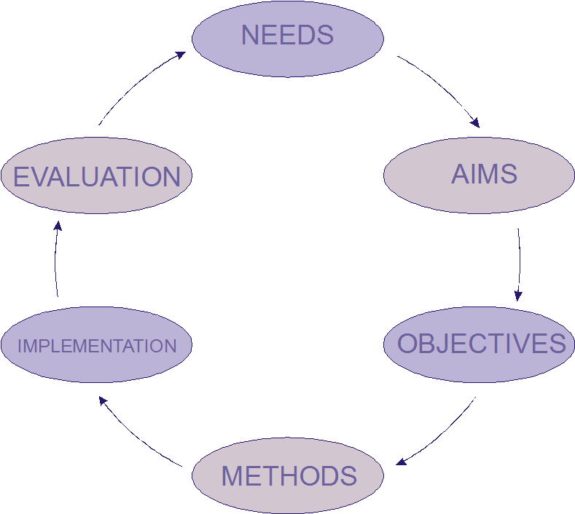

* Identify the demographic profile of the youth project target area
* Identify the issues that are affecting young people’s lives
* Identify the skills, knowledge, understanding and abilities that the young people need, in the short/long term.
* The expressed needs of young people.

**Aims**

* The proposed curriculum programme provides activities that young people want to participate in, including identifying: staffing levels required, resources, appropriate setting/s, partners
* The proposed curriculum programme fits with the purpose and values of Youth Connect and meets the anticipated learning and commissioned outcomes for young people

**Objectives/Outcomes**

* Identify objectives**/**steps/milestones that ensure the curriculum programme achieves learning outcomes for young people.
* Objectives should be “**SMARTI”** i.e. **S**pecific, **M**easurable, **A**chievable, **R**ealistic, **T**imed, and should be planned **I**nvolving staff and young people.
* Outcomes are the difference the programme or project will make to young people and the wider community.
* For Youth Connect the ‘outcomes’ are often in regard to the personal and social development of young people. They also need to link to the commissioned outcomes. They can include skills, knowledge, understanding, attitudes, abilities, etc.

**Methods**

* Identify which method(s) is the most appropriate to meet the needs of young people and aims and objectives/ outcomes of the project or programme. I.e. formal or informal group work, one to one, residential, peer education, off site activity, etc.

**Implementation**

* Deliver the curriculum programme to/with young people.
* Issues, Actions, Timescales, Resources; e.g. identify a group of young people, build relationships, negotiate contract, agree aims & objectives

**Evaluation**

This is a tool used to demonstrate effectiveness and results, and is a regular feature of youth work practice. It enables workers to estimate the progress of young people, record achievement, and assist in future curriculum programmes.

* Identify what is to be evaluated, i.e. targets/aims, staff performance, methods of working, costs, a specific project, a year’s work
* Identify the time-scale for evaluation, i.e. annually, monthly, weekly, seasonally
* Consider the audience for the results of the evaluation, i.e. young people, staff, managers, a sponsor or funding body,
* Identify the methodology to be used for evaluation, i.e. young people discussion/focus groups, surveys/ questionnaires, story boards, quarterly report and annual report, etc.



**Youth Connect Commissioned Outcomes (2015-2018)**

* + - Young people develop self-esteem, confidence and have high aspirations
    - Young people can develop social and life skills
    - Young people are engaged in education, employment or training and are supported to participate and achieve in locally accredited courses
    - Young people are healthy, make healthy life choices and enjoy a healthy lifestyle particularly experiencing positive mental health, healthy relationships and positive sexual health

**Recognising and Accrediting Learning and Achievement**

Youth Connect recognises that it is important that the learning and achievement of young people through our work is recognised and celebrated. This is particularly important for those young people who are not experiencing successes in the more formal curriculum of school and college.

Youth Connect recognises and celebrates young people’s learning and achievement in formal and informal ways. Formal accreditation is delivered through schemes that include Skill Me Up awards, ASDAN Awards, the Duke of Edinburgh Award and other local and national awards. These now fit within a national framework for accrediting young people’s learning and achievement. Less formal ways of celebrating young people’s achievements include preparing individual portfolios of achievements, photographic displays of work, video production and celebratory events, reflecting the individual and collective achievements of young people.

[..\..\Curriculum Areas](../../Curriculum%20Areas) –link to curriculum resources

