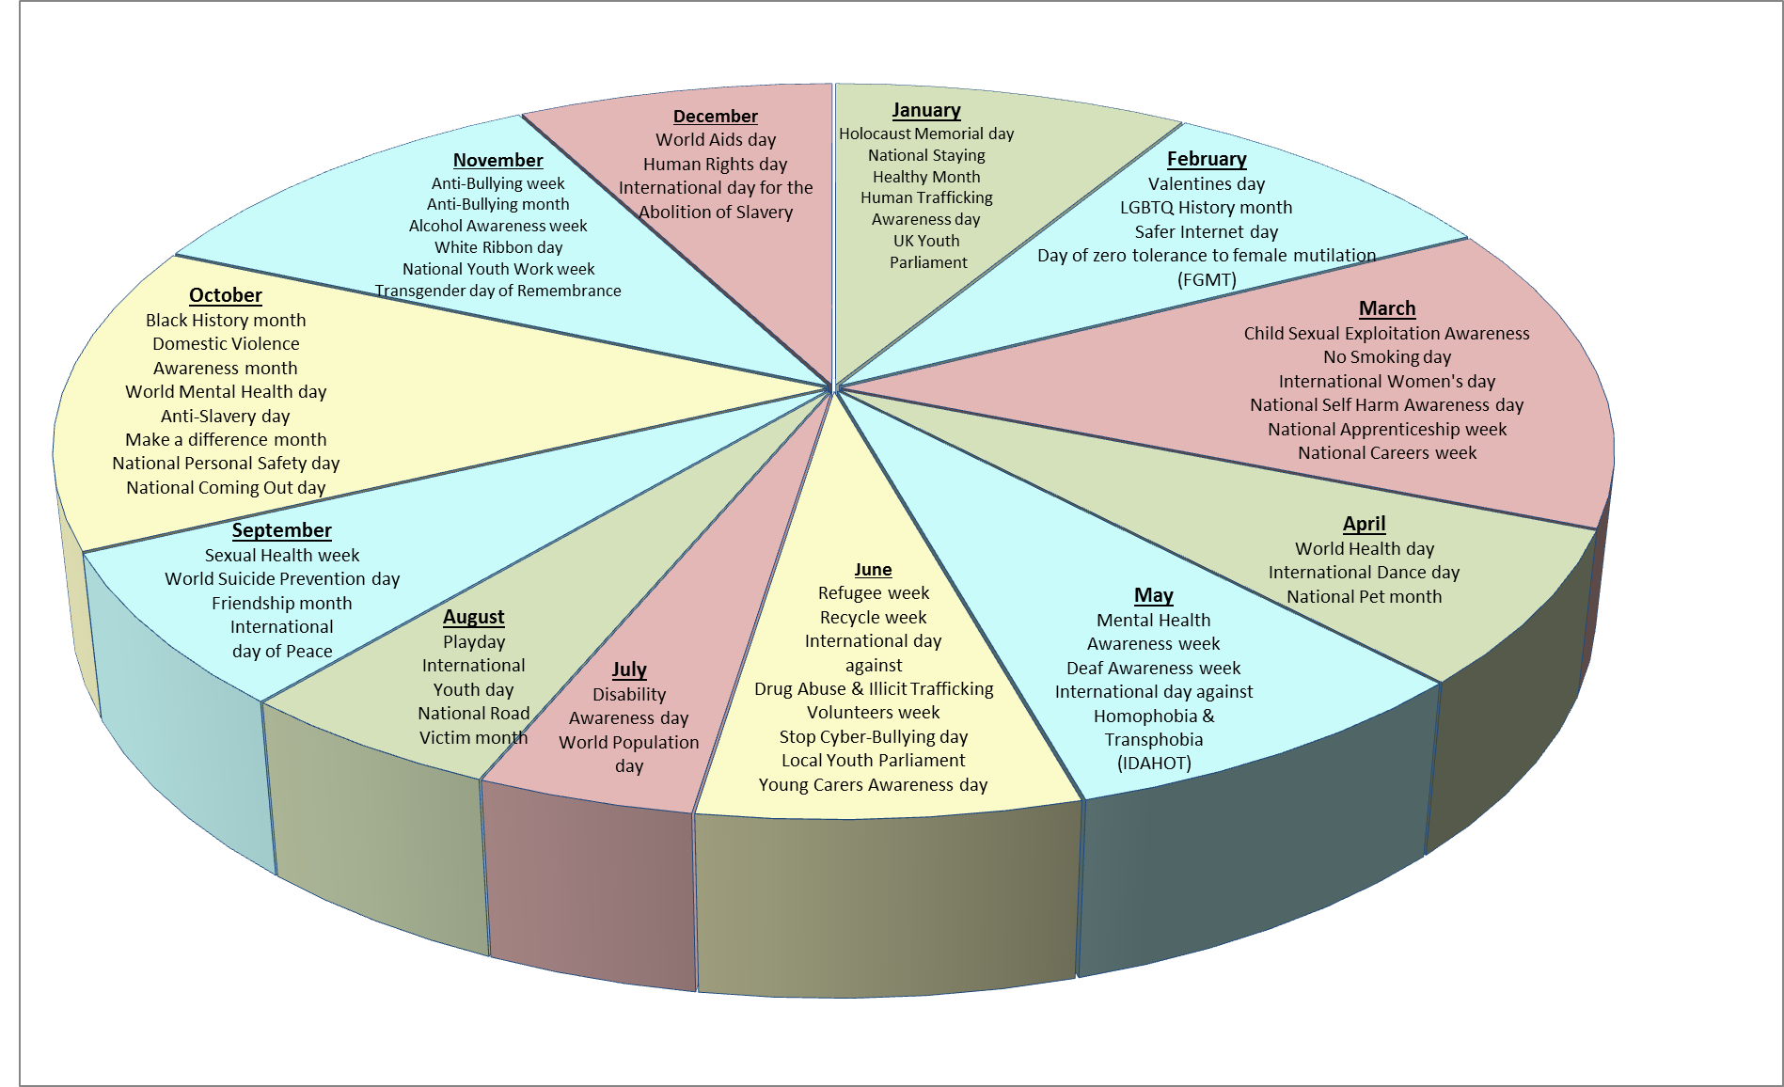

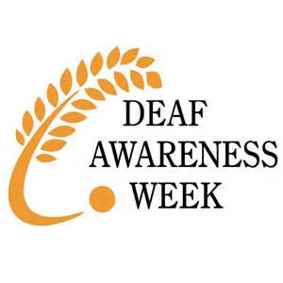





[](http://www.bing.com/images/search?q=local+youth+parliament&view=detailv2&&&id=4614EA2E95F9CB265F78D206D04C486E6787B6DA&selectedIndex=0&ccid=A%2bCIZ3GP&simid=608036609392381056&thid=JN.P%2bHe739W6dkaowlV101Jng)





[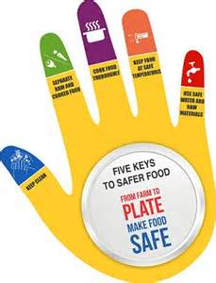](http://www.bing.com/images/search?q=world+health+day+2015&view=detailv2&&&id=C541A9A00A45AF2AF104626FECC343F822061BF3&selectedIndex=4&ccid=Ch7KnxBo&simid=608016264131120738&thid=JN.ILnR1jLrERmfPYuzQagXbA)

**Youth Connect Annual Awareness Events Wheel**

