People & Communities Department |  | 3.0
Civic Centre, Keynsham, Bristol
Tel: 01225 394195

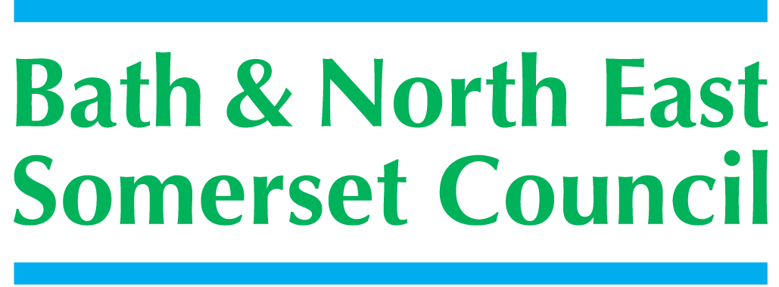

Meeting title | SCHOOLS FORUM
Date | Tuesday 14th November 2017 – Cadbury Room, Somerdale Pavilion
Forum Members Present | Ed Harker (Chair), Sue East, Mark Everett, Colin Cattanach, Claire Hudson, Clare Crowther, Roz Lambert, John Delaney, Alun Williams, Kevin Burnett (sub for Richard Vanstone),
Forum Members Not Present | Dawn Elliott, Jim Crouch, Kerrie Courtier, Gareth Beynon, Richard Vanstone,
Officers Present | Richard Morgan, Cllr. Paul May, Chris Wilford, Philip Frankland, Margaret Simmons-Bird, Mike Bowden, Nick Fortt, Alice McColl, Cllr Paul May
Officers Not Present | Richard Baldwin
Distribution | As above; Theresa Gale; Colleen Collett; Cllr Charles Gerrish; Cllr. Tim Warren, Tim Richens; Jeff Wring;  Wendy Jefferies, All Headteachers
Next meeting | Tuesday 12th December 2017,  Keynsham Community Space, above The Library Building

ACTION
1. | Apologies Received
EH (Chair), welcomed everyone to the meeting.
The following apologies had been sent:
Gareth Beynon, Richard Baldwin, Kerrie Courtier, Dawn Elliott, Richard Vanstone requested Kevin Burnett take his place for this meeting and Jim Crouch (now resigned due to the day-job pressures).
Alice McColl attended to present the Alternative Provision Commission with Chris Wilford.
Nick Fortt attended to present the Early Years SEND report
George Samios Head-teacher of Twerton Infant School attended as an observer.
2. | Declarations of Interest
The following Declaration of Interest and Positions Held were recorded:
John Delaney – School Governor St Gregory’s College Bath
Claire Hudson – Chair of Governors Trinity Church School, Midsomer Norton Schools Partnership since June 2016
3. | Minutes of the last meeting (12th September 2017)
 | Minutes were checked for accuracy and agreed with following amendments/actions.  School Crossing patrol funding? [Minutes; from meeting dated 17-01-17, raised by EH under AOB]. “EH mentioned his concerns regarding the funding of the School Crossing Patrol in the hope that MB could raise this issue at corporate level; MB informed clarification has already been requested”.  MB has raised this with the Highways Department who will be invited to send a written statement to the Forum.  Remains Outstanding Action  4. Mental Health Support in Secondary Schools - MF had produced a very clear and detailed paper; the Forum felt is useful to have a further discussion to enable more secondary heads to attend. Secondary colleagues reported having met – AW to send paper to ML to enable the Forum to make a decision  5. Medical Funding Policy - The Forum fully discussed the policy; whilst agreeing in principle CW and RM will bring the paper to the November meeting to ensure further clarification. CW explained the outstanding exercise to complete re: numbers / funding and will bring the paper to the December meeting.  6. National Funding Formula - The Forum considered the approach to consultation and agreed that the consultation would need to be concise and short due to the timeframes requiring information to be presented to the DFE by 30th November and for schools to be advised of their allocations early in the new year. RM explained the summary of exercises would be discussed further in Item 8 National Funding Formula Consultation Responses.  7. Services to Schools - Changes in the price of catering from £2.40 to £2.60 have resulted in services being bought elsewhere and approximately 5-schools have given notice to BANES. Approximately 12 – 15 schools intend to seek new suppliers of those only 2-formal intentions have been received to date.  A.O.B. - CC mentioned the problems caused to children in Bath due to the cuts in local bus routes / times. RM will investigate and report back. RM reported - the problems have eased; BANES Transport Team have no authority over the bus timetables; pressure is being put on the Bus Company by the Highways department to ensure as much support is provided for school transport as possible. | MB  AW  CW
4. | Early Years Formula Update
PF introduced the Early Years Entitlement and Funding Formula paper with some background information:
From 1st September working parents / families meeting certain income eligibility criteria have been able to apply / access an additional 15 hours of Early years Entitlement for 38-weeks a year for their 3 /4 year old child; i.e. doubling the maximum annual entitlement from 570 to 1140 hours.

PF explained the paper is primarily to update the Forum on the take-up of the offer since September 2017; in addition it is a reminder about the Funding Formula decision made in May 2017 of setting the funding for the 2017/18 financial year only.

Based on term time attendance; the total hours funded are 261,624.89 - an average of 26-hours per week; this equates to an average take-up of 11 of the maximum 15 additional hours – showing that not all families are taking-up the maximum hours available. This is, however, only the first term that the offer has been in place.

This update provided the Forum the chance to fully discuss and question the paper; noting a further consultation would be good to formulate questions as to how the formula has worked and any suitable amendments that could be made within the constraints of the DfE guidance.

5. | SEND Funding Update
CW presented the paper for the SEND Updates, New banding Model and Next Steps to ensure transparency around the progress of this work; In July 2017 the Forum was advised the Local Authority was reviewing the way high need allocations of finances are made for Education Health Care Plans and the SEND Banding group were drawing-up new banding arrangements.
The Forum is advised that the next steps for the proposed banding changes roll-out will be decided at a planned meeting with the group of head-teachers and representatives before Christmas 2017.
CW confirmed KB’s request - the total amount of money will not change bands which equate to the whole ‘pot’.
CW clarified the wording in 3.4 – “We do not propose when completed to share openly all results of the banding with all schools” - this will be released when ready.
A copy of the new bandings (5.1) showing their descriptors was sent with the paper.
6. | Early Years SEND Inclusion Funding
NF introduced the Early Years SEND Report to note how Schools Forum funding is being spent in the Early years on children with additional needs and the impact on the budget as some children (3 – 4-years) are now eligible for an extra 15-hours free childcare (maximum 30-hours).
As of April 2017 the Government required all Local Authorities to establish an inclusion fund – this has been in-place in BANES since 2010. KB congratulated BANES on already having this in-place.
The Forum discussed the budget pressure and Early Years High Needs; Cllr PM noted the Council priorities to support the most vulnerable people.
7. | Alternative Provision Commission
ME – left the room for this item - Alternative Education Provision due to conflict of interest.
Alice McColl presented the Alternative Provision Commission with Chris Wilford for information to provide the Forum an update on the procurement of a new contract to provide alternative education across all key stages covering the Bath and Keynsham area of BANES.
AM explained the service is under recommission – the council’s contract for alternative education expires in August 2018 currently delivered by Aspire Academy. An event is planned in December to bring together all potential tenderers to prepare for a new contract in-place for the beginning of term September 2018.
8. | National Funding Formula Consultation responses
RM circulated the Summary of Responses Including Comments and requested; Following the consultation completed on 13th November 2017 the forum is asked to comment on the responses and decide on certain issues and planned actions for 2018/19.

The main discussion points concentrated on the impact of the options on schools with pupils from deprived backgrounds. The discussion highlighted the funding the local formula had provided to schools with deprived pupils. The difference with the NFF was significant for the schools who had received higher levels of funding under the local formula.

George Samios, Headteacher of Twerton asked to speak to the forum and the chair agreed. He explained the history of the funding Twerton had received and the added benefit the funding would provide to his school if the local formula was maintained for either 1 or 2 years longer.

The Forum voted after full discussions on each of the questions in the Summary of Responses:
Question 1 – Do you prefer Option 1, a National Funding Formula or Option 2, a local Funding Formula from 1st April 2018? 6 voted for Option 1; 4 voted for Option 2
Question 2 – Do you agree that up to 0.5% of the Schools block funding can be transferred to the High Needs block for FY2018-19? The Forum voted unanimously Yes.
Question 3 – Do you prefer Option 1- One annual allocation or 2 – Scaled back termly counts with a limited budget for each term; in respect of a methodology for the calculation of High Needs Targeted Support Funding? The Forum voted 1 for Option 1 and 9 for Option 2.
Question 4 – For each service area, do you wish de-delegation to continue? The Forum, maintained schools only decided yes, but asked that further discussion on the impact of removing the de delegation would have on maintained schools.
9. | Excluded Pupils Funding
RM introduced the paper Permanently Excluded Pupils – Redetermination of schools budgets for the Forum to decide on the request: a change in the redetermination of schools budgets in respect of pupils that are permanently excluded. This request was related to using the academic year for academies in line with their financial year
The provided guidance was discussed noting the extracts from the recent update in the Schools Revenue Funding Operational Guidance for FY2018-19. Following this the Forum voted unanimously in favour of the request.
10. | A.O.B.
 | CC raised the issue around the point of access to panel which determines whether a child goes to Aspire or elsewhere. CC will meet with CW to discuss further | CC/CW
11. | Date of Next Meeting
 | 12th December 2017, Keynsham Community Space.

