|  |  |  |  |
| --- | --- | --- | --- |
| **People and Communities Department** | | **4** | |
|  | Lewis House, Manvers Street, Bath, BA1 1JG  Tel: 01225 395355 Fax: 01225 394011 E-mail: Lorraine_elms@bathnes.gov.uk | |

SCHOOLS FORUM

**Information on the changes proposed to the Educational Psychology Service**

|  |  |
| --- | --- |
| **Lead Officer** | **Richard Baldwin/Sara Willis** |
| **Contact details** | [**Richard_baldwin@bathnes.gov.uk**](mailto:Richard_baldwin@bathnes.gov.uk) |
| **Forum asked to be informed** | **Forum to note the changes proposed to the Educational Psychology Service from September 2015** |
| **Time Needed** | **10 minutes** |
| **Date** | **12th May 2015** |

1. **Purpose**

This paper lays out the local authority’s position on meeting the statutory requirements of providing an Educational Psychology Service, based on the increasing demand for statutory assessments and the budgetary pressures on Children’s Services.

1. **Background**

The SEND reforms were introduced in September 2014. The SEND Team were expanded to support this implementation. The EP Service has attempted to meet the needs of the reforms within the existing budget, however since January the demands have left the service neither able to meet the spirit of the new legislation and attend things like Outcomes meetings, nor to offer the full service they promised non-Academy schools last summer. The service has been in further flux since the retirement of the previous Senior EP. We have employed an Acting Senior from within the service and back-filled some of his casework with a temp. Tte EPs are struggling to deliver traded work on top of their core case work.

1. **Current Position**

The following charts show:

1. the dramatic increase in requests for statutory assessments compared to previous years (September to March) – a situation confirmed by SEN team
2. a sample of the work balance for one EP, since January. (All staff log their work and categorise it by type of visit/work, which enables us to have a clear idea of how staff are spending their time).

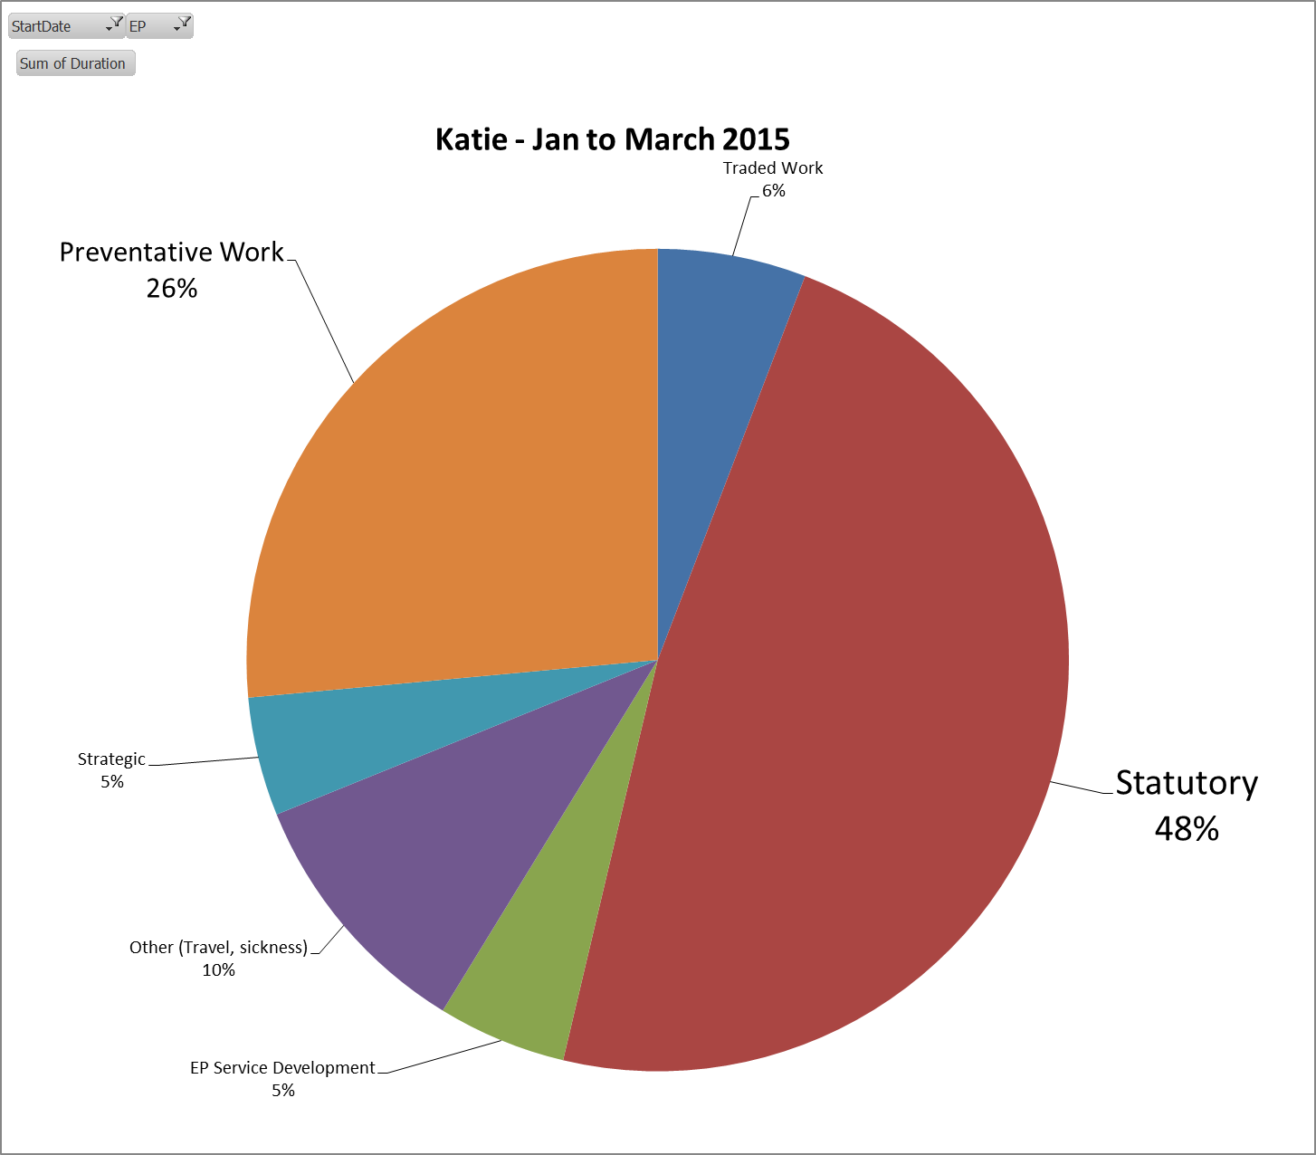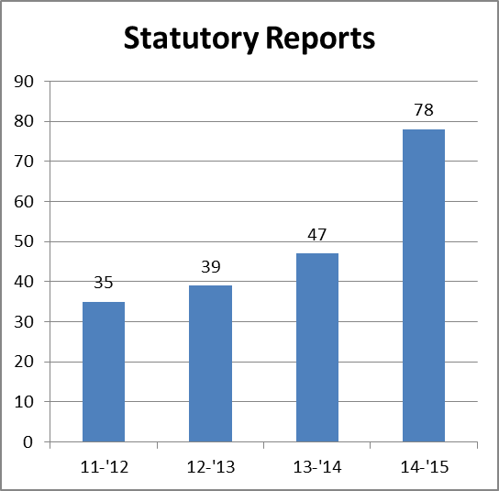

**Sample time split for 1 EP**

In addition to the increase in the number of Statutory reports being provided for the SEN team each report now takes about double the time if done to the highest standard (approx. 15 hours including visits and assessments). Due to the high demand since Christmas we have had to curtail our attendance at Outcomes Meetings and are thus not able to fulfill the Person –Centred objectives of the new legislation.

1. **Proposal**

To manage demand the proposal is to change the focus: instead of each EP having a patch of schools for both preventative work and statutory work together with a small amount of traded work with Academies, the plan is to commit 70% of available time to meet the anticipated rise in statutory work and to reduce the time available for preventative work, whilst retaining a small amount of traded work. To meet such a reduction in preventative work the proposal is to work only with those schools that have an OFSTED category ‘Requires Improvement’, or where we are aware there is a significant inclusion issue. Regular work with schools will be reduced across the board (unless schools chose to buy the service in).