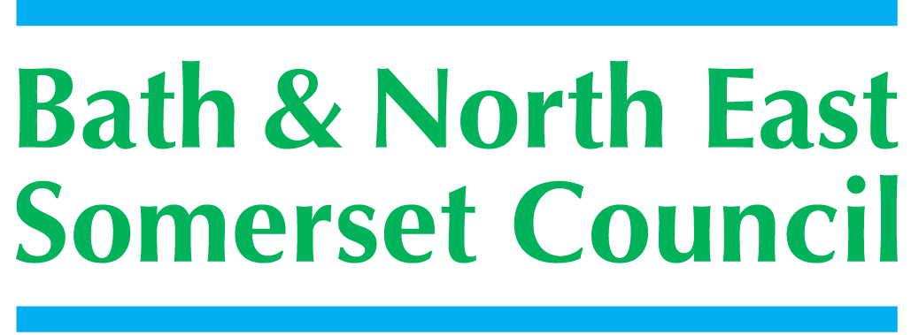 | 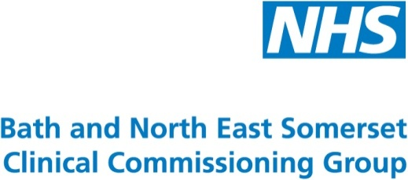

5

SCHOOLS FORUM

Tuesday 18th September 2018

School funding 2019-20 (National Funding Formula)

Lead Officer | Richard Morgan
Contact details | Richard_morgan@bathnes.gov.uk 01225 395220
Forum asked to decide / steer / be informed | To be informed and to provide a steer / decide on the approach to the school funding formula for 2019-20
Time Needed | 20 mins

Purpose of the report

To update the forum about the DFE’s changes to the National Funding Formula for 2019-20 and to explain the consultation that will be required to implement the required changes to the B&NES formula for 2019-20

Recommendation

- Forum is asked to agree to a consultation process on the introduction of changes to the school funding formula
- Forum is asked to comment on the proposal to request additional resources are transferred from the schools block to the High Needs Block

Report

Introduction

The DFE introduced the National Funding Formula for schools in 2018-19. They have also produced a policy document (See appendix A) and an operational guide for Local Authorities to follow in applying the changes required by the DFE to the NFF for 2019-20.

In 2018-19 following a detailed consultation B&NES adopted the funding formula established by the DFE (NFF). There are a few minor changes set out in the DFE’s operational guide that we would now need to follow, to ensure that we move further towards the full NFF.

Local Funding Formula

Following the introduction of the NFF in 2018-19 the DFE have observed that a large number of local authorities (including Bath and North East Somerset) have applied a formula very similar to the NFF mechanism that funds the Local Authority.

With this in mind the DFE have now confirmed that they will allow the local authorities a further year of local formula funding prior to introducing the hard formula. Therefore local decision making will occur for the formula for both 2019-20 and 2020-21. The DFE hope that by the 2021-22 financial year the vast majority of local authorities (and schools) will be following the NFF methodology so closely that there will be limited turbulence in imposing the full formula for all schools.

Changes to formula factors

The DFE have indicated that they intend to amend a few factors including the following key areas.

The minimum per pupil funding levels – the minimum per pupil funding level for secondary schools will increase to £4,800 and the minimum per pupil funding level for primary schools will increase to £3,500.
This means that those schools that have a funding allocation of less than these levels will be brought up to these levels in 2019-20
However, as the DFE have capped allocations to the LA the total funding allocated does not fully support the suggested funding values. It is therefore anticipated that the NFF values used to fund schools may need to be reduced to stay within the funding pot allocated to the LA.
The funding floor – the funding floor will increase to ensure that all schools will attract at least a 1% gain per pupil against their 2017-18 baselines.
The effect of this is that schools will again be protected by a minimum funding guarantee of 0.5% per pupil in 2019-20 compared with 2018-19.
However the MFG in our local formula will be over written by the funding floor as the mechanisms are almost identical and are designed to do the same purpose of ensuring that school receive at least 0.5% increase per year from 2017-18.

Growth Funding – in prior years the funding allocated to the LA for growth funding has been based on the amount of money the LA had spent in the past. For 2019-20 the DFE intend to develop a formulaic methodology to provide growth to the LA based on the census data that exists in October 2018. This will be compared with the October 17 census on a MSOA (middle super output area). This geographical area will show the pockets of growth that school will have to accommodate and a financial allocation will flow to the LA to support the schools with the increased growth.

The local authority will use its own methodology of allocating resources to schools, the changes to the NFF will simply change the methodology of allocating the funds to the LA. At present it is not possible to predict the effect on the LA of this change and further reports to the Forum will be required when we know the outcome of the exact methodology

The overall impact of the NFF in 2019-20

The DFE have issued several spreadsheets with analysis of the impact of the NFF on schools and Local Authorities. The DFE spreadsheets keep referring to the 2017-18 baselines rather than showing a comparison of funding between 2019-20 and 2018-19. However when analysing the data it is estimated (several issues have yet to be addressed) that the increase in resources for Bath and North East Somerset Schools is

Factor | 2018-19 | 2019-20 | Increase | % change
Primary Unit of funding | £3,675 | £3,787 | £112 | 3.04
Sec Unit of Funding | £4,813 | £4,943 | £130 | 2.70
Pupil Numbers
Primary | 12,936 | 13,035 | 99 | 0.92
Secondary | 10,541 | 10,785 | 244 | 2.32
total | 23,477 | 23,820 | 343 | 1.46
Overall Funds
Primary and secondary | £99,872,782 | £104,283,203 | £4,410,421 | 4.41
High Needs Budget
DFE allocation | £22,949,364 | £23,649,920 | £700,556 | 3.05
Less increase in imported pupils | 0 | £301,320
Total | £22,949,364 | £23,348,600 | £399,236 | 1.74
Pupil number growth | 23477 | 23820 |  | 1.46
Central Services Block
Total Allocation | £1,111,190 | £1,136,937 | £25,747 | 2.3
Pupil number growth | 23477 | 23820 |  | 1.46

The estimated impact on each school is shown in appendix 2. The calculations of these estimates has been complicated by the data provided by the DFE and therefore the estimates have been generated using exactly the same pupil number as 2018-19. We have also assumed certain issues to demonstrate the impact of the NFF between the years, we have shown our assumptions within the appendix.

It must be stressed that the figures shown in the modelling are estimates and schools should not utilise any of this information as part of their budget planning as the main driver of budget changes (pupil numbers) has been extracted from the modelling.

Utilisation of Schools Block for High Needs

Within the operational guidance the DFE have confirmed that utilising the schools block to support High Needs cost pressures as we did in 2018-19 is again allowed. As the forum is aware the high needs pressures in B&NES are growing and mitigating actions will be necessary to balance that budget. In order to utilise the schools block for High Needs it is necessary to consult schools with a proposal and the level of transfer to the high needs is limited to 0.5% of the schools block without Sec of State approval.

It is also suggested that as the increase in school budgets is greater than the high needs that further resources could be transferred to High Needs Budget. The Local Authority is therefore proposing that consultation should occur to request a further transfer for 2019-20. The requested transfer would be 1% in total amounting to approx. £1,040,000. This transfer equates to the original 0.5% approved in 2018-19 and further 0.5% requested for 2019-20. In order to get approval for this additional request the schools will need to be consulted and then following the schools forum comments the Sec of State would have to approve.

Consultation would start as soon as we can get papers out with a response date of Wed 24th October so that papers can be prepared for the November 6th Schools Forum. This will allow us time to make the formal request of the Sec of State by the DFE Deadlines.

In 2018-19 several local authorities around the country gained approval from the Sec of State for increases above the 0.5% the Schools Forum has power to approve.

De delegation of Services

Forum is reminded that in 2019-20 the de-delegation of services for maintained schools will cease following the decision of the schools Forum in January 2018.

Teachers Pay Grant

In the announcement made by the Sec of State confirm the pay awards for teachers in Sept 2018. He announced a new pay grant totalling £321m in the full year to support the pay award. The exact detail of this grant have yet to be confirmed both in terms of the methodology of allocating the funds and the percentage amounts that will covered by the grants. It is advised that schools bear in mind the lack of detail in the allocation the grant in determining the pay awards allocated to different staff groups.

Free School Meals Grant

Due to the roll-out of Universal Credit and from the 1st April 2018, the DFE have introduced an income-based threshold for free school meal eligibility. As a result of this change to the benefit system and free school meal eligibility, the number of pupils eligible for free school meals will increase. Part of this increase will be because of the transitional protections the DFE have put in place, which mean that pupils who were eligible for free school meals on 1 April 2018, and those who become eligible during the Universal Credit rollout period, will retain eligibility until the end of this rollout period. For those still in education at this point, protections will continue until the end of their current phase of education; this covers until at least summer 2023. This means that schools should not remove free school meals eligibility for pupils over this period, unless the pupil’s parent requests that they do so.
The school funding system already reflects the number of meals that schools need to provide. The DFE have recognised that for some schools this increase in free school meal numbers may be difficult to manage in the short term, because school funding operates on a lagged basis. That means that changes in the characteristics of pupils in a school take time to have an impact on the funding the school receives. This grant will provide schools with extra funding to help them meet the higher costs of providing extra meals before the lagged funding system catches up.

