BANES Ash Dieback Response Summary
What is Ash Dieback?
Ash dieback is the most significant tree disease to affect the UK since Dutch elm disease was first recognised in the 1960s. It will lead to the decline and death of the majority of ash trees in Britain and has the potential to infect around two billion ash trees (over 1.8 billion saplings and seedlings and more than 150 million mature trees) across the country. Infected trees become structurally weakened and liable to failure very quickly, potentially within one growing season. 95% of all ash trees are anticipated to die from ADB.
Ash Trees are the third most common species of individual tree in the UK, and in the South West represents 12.6% of total trees cover.
Ash Dieback caused by a fungus known as Hymenoscyphus fraxineus (also known as Chalara fraxinea), arrived from Asia to Europe during the 1990s and spread rapidly across Europe. This invasive fungus causes a range of symptoms from foliar leaf spots to branch dieback to the death of Fraxinus excelsior (ash) trees and some other Fraxinus species. Once infected, most trees will die.

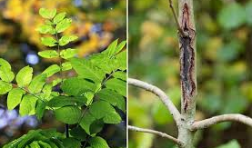

(left) Healthy foliage,
(right) bark lesion in ash tree sapling

A few ash trees may survive the infection because of genetic factors which give them tolerance to the disease. In woodlands, evidence in December 2018 suggests mortality rates may be between 70% and 85%. Evidence from Europe suggests that around 10% of trees were found to be moderately tolerant to the disease, with 1-2% having high levels of tolerance.
With all this in mind, Our Tree Team has designed an Ash Dieback Action Plan to guide our response.

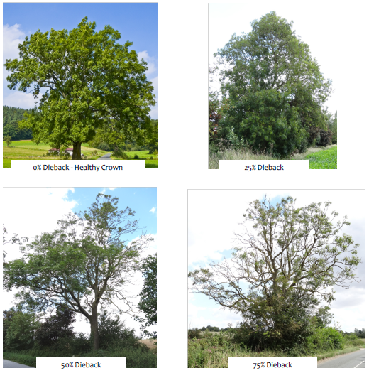

B&NES is directly responsible for more than 5000 individual ash trees above 10m in height, including trees in council owned A and B road highway verges, plus 30ha of ash in woodlands. Those trees on minor roads have not yet been surveyed. Our ash dieback action plan relates to ash trees the council is directly responsible for and those in private ownership adjacent to highways and council sites.
Loss of these trees as a result of ADB will have an impact on the ability of the area to absorb the effects of pollution and climate change, and interception of runoff from flood events, and hence on B&NES’ ability to meet government clean air obligations and its commitments to addressing declared Climate and Ecological Emergencies.
B&NES Council has a statutory duty of care to users of the highway, so action will be required to be taken by the council in relation to ash trees showing severe symptoms of the disease on private land adjacent to the highway.
A crucial part of the general response will be the development of a recovery phase in which there is a plan for council sites without the dominant ash, where the ash are replaced with alternative species on council land to help ameliorate the effects of atmospheric pollution and climate change (plus biodiversity) as we move toward a lower carbon economy.
The timescale for Ash Dieback as a significant problem in B&NES is not known, but it is anticipated this will range from 5 to 10 years. It is prevalent in 2021.
Why Do we Need an Action Plan?
The Aim of our Ash Dieback action Plan is to identify, communicate and address the risks of ash dieback, both for public safety and to the environment, and to infrastructure such as electric distribution network. Our parks team has a dedicated ash dieback tree inspector who works in the tree management team to help identify and prioritise works when they become necessary.
The forestry commission advises that a small proportion of ash trees, 1-2%, are expected to show some resilience to Ash Dieback. These trees will become vital in future for the continuation of ash trees as a part of our native flora. It is therefore of great importance to identify and where possible to retain these trees, and any programme for removal of affected ash trees must include an inspection regime which allows for this identification.
What are the aims of our Action Plan?
Our action plan aims to help us target our efforts to most effectively minimise the health and safety, economic and environmental impacts resulting from Ash Dieback Disease. Our tree management team have developed a system of inspection whereby all ash trees in the public estate will be or have already been mapped. The inventory is being used to deal with the trees as they become affected in a systematic, risk based, cost effective way. Those trees which have the highest value targets to be dealt with at the highest priority level etc.
How Will our Action Plan be implemented?
- An ash tree and woodland survey has been undertaken in the spring and summer of trees adjacent to highways and council owned woodlands.
- Communication established between council departments including Highways and Emergency Planning regarding the risks associated with ash dieback.
- The tree team is constantly updating our risk management plan, reviewing inspection frequencies and developing our ash specific inspection rota
- Communicating with the public via our social media channels eg twitter
- Developing an Ash Dieback recovery plan which will aim to ameliorate for the loss of ash as a species in terms of ecological niche and green infrastructure. This will involve replanting with selected species which may provide resilience against future pests and diseases.

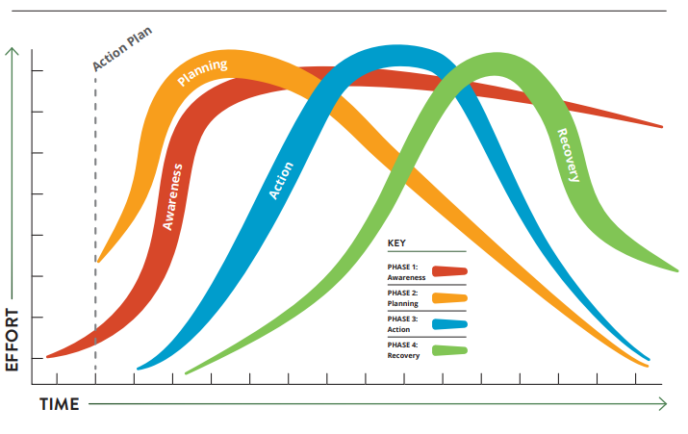
The diagram above shows the four stages of our response to the ash dieback outbreak, based on the protocols of emergency planners.

How are We dealing with affected trees?
Unfortunately, most ash trees will become affected by Ash Dieback disease. How we then deal with these trees is informed both by the degree to which the trees are affected, and by the context of their situation. Regardless of any degree of resistance that an ash treee may have to the disease, it’s branches will be weakened by the fungus, which results in the tree shedding deadwood unpredictably and becoming unsafe for our tree teams to work with.
Our primary concern is the management of risk to an acceptable level for both the general public and our tree team workers. Therefore, most ash trees in high risk locations will ultimately be felled, as retention may represent an unacceptable level of risk. With this in mind, our ash dieback tree inspectors are sorting ash trees into four categories;
Sketches show typical winter and summer crown appearance patterns
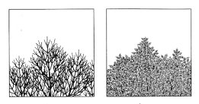
Category 1; 0-25% Ash Dieback
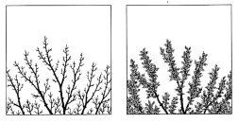
Category 2; 25-50% ash dieback
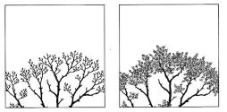
Category 3; 50-75%ash dieback
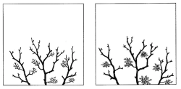
Category 4; 75-100% ash dieback

To control risk to the public and our tree teams, those trees in categories 3 and 4 are added to prioritised felling schedules, and those in categories 1 and 2 are reinspected annually.
Trees in lower risk settings will be managed less intensively, and in some woodland situations it may be more suitable to leave trees standing, to allow natural decomposition and and to temporarily restrict public access.
Timber and chip from felled trees will in most instances be allowed to rot naturally on site, but where public safety may be a factor, such as hazards caused on roads by people stocking up on firewood, timber will be removed.
The cycle of annual sesonal reinspections and fellings will continue until the majority of the stock of ash in high risk locations has been removed and the main impact of the disease is seen to have passed. Whilst we do not know exactly how long this will last, we anticipate it will be between 5 and 10 years.
Our tree team is working on expanding capacity to undertake most works in house, and some contractors will be used to ease the strain on our hard working permanent staff.

How do we manage recovery from Ash Dieback?

Recovery from ash dieback disease is essentially the strategic planting of trees and the management of natural regeneration in our public areas and woodlands. As our third most numerous native tree, ash is exceptionally important in providing ecosystem services, such as rainwater interception for flood amelioration, carbon sequestration and biodiversity. Forestry commission research has shown that as many as 955 species are reliant to some extent on ash.
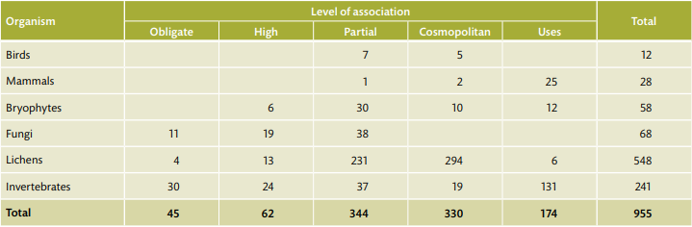

Whilst we cannot replicate this unique diversity we can try to plant a spread of species to compenste for the loss to the ecosystem.
Ash trees have a big impact on soil quality because their leaves are nutrient and base rich, and decompose rapidly. Alder and lime leaves have similar qualities, as to a lesser extent do sycamore, field maple and aspen. In terms of pollen and nectar production, flowering time, fruit type and tree height, elm is the closest match, followed by birch and rowan. Many of the generalist animal species that feed on ash can also be found on oak and beech, along with sycamore, birch and hazel. However, for specialist insects, mosses and lichens, elm is the best substitute, followed by sycamore, aspen, oak and hazel. No one species alone can substitute ash. However, aspen, alder, field maple, sycamore, birch, rowan and disease-resistant elm, along with native oaks, are good contenders.
Our Parks department has recently appointed a Tree and Woodland Delivery Manager in the Tree Team to focus on meeting the aspiration to plant 100,000 trees by 2023. The Parks Tree team will be working together to ensure that a broad spectrum of trees encourage a healthy recovery for our ecosystems in the wake of Ash dieback.

