  People and Communities Department |  |   7
PO Box 25, Riverside, Temple Street, Keynsham, Bristol BS31 1DN
Tel: 01225 395355 Fax: 01225 394011 E-mail: dawn_jenkins@bathnes.gov.uk

SCHOOLS FORUM

Tuesday 13th May 2014

Energy Efficiency Project Update

Lead Officer | Richard Morgan
Contact details | Richard_morgan@bathnes.gov.uk 01225 395220
Forum asked to decide / steer / be informed | For information
Time Needed | 10 minutes

Introduction

- Project Description

The Heating Controls Project was a continuation of the Schools Energy Surveys Project carried out in 2013.

In Autumn 2013 the consultants who delivered the Energy Surveys, were instructed to re-visit up to 40 Schools to make improvement to basic heating controls settings, train the caretakers or other staff members in how to make further adjustments and improvements, and create a change log to record the previous, new and future settings.

The heating and hot water settings covered by this project were:
- Time clock settings
- Occupation time settings
- Occupancy temperature setting
- Frost protection settings
- Holiday period settings

This report first analyses the energy savings and then evaluates the project as a whole.

- Analysis Methodology

This report analyses the results by assessing the gas consumption of all Primary School Gas Meters fitted with an AMR meter. Those Schools which took part in the Heating Controls Project (HCP) are compared with those that did not.

The analysis compares the following time periods:
1st Oct 2012 – 31st Jan 13 (Period 1)
1st Oct 2013 – 31st Jan 14 (Period 2)

The consumption is compared in three ways:
- Comparison of absolute kWh consumed in the periods
- Comparison of weather adjusted consumption over the period
- Annualised savings projection for both of the previous comparisons.

This analysis extends that already provided by Verco which covered a portion of the Schools visited.
The aim is to show the impact of the project and in order to make the case for repeating the project.

Some AMR meters have been excluded due to errors in the data.

Results

- Comparison of absolute kWh consumed in the periods

The graph below shows the % reduction in gas consumed each week of period 2 compared to period 1.
The green bars show the % reduction by all the schools taking part in the project. The grey bars show the % reduction in gas consumed by all the schools which did not take part in the project.

Due to the much warmer winter of period 2 compared to period 1, all schools show reductions in gas use for all but two of the weeks. However the Schools taking part in the project had consistently greater % reductions.

Overall, schools taking part in the project reduced gas consumption by 27% compared to 16% for those not taking part in the project.
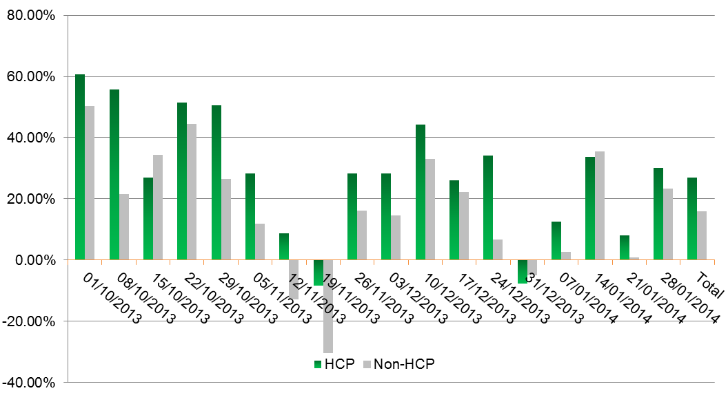
- Comparison of Weather Adjusted Consumption over the Period

Degree day analysis was used to calculate how many kWh schools consumed per degree day (DD). Simply speaking, degree days are a measure of coldness. The more degree days, the more cold the weather was. This is the standard methodology used to be able to compare energy use taking into account the variations in weather. This will give a more complete view of the effect of the HCP.

The new kWh/DD factor was applied to the 20 year average number of degree days for the period to give a corrected consumption. The bar chart below shows the weather adjusted gas consumption and the absolute gas consumption.
When taking weather into account the HCP Schools show an increase in energy efficiency of 11% compared to a 5% decrease for non-HCP schools.

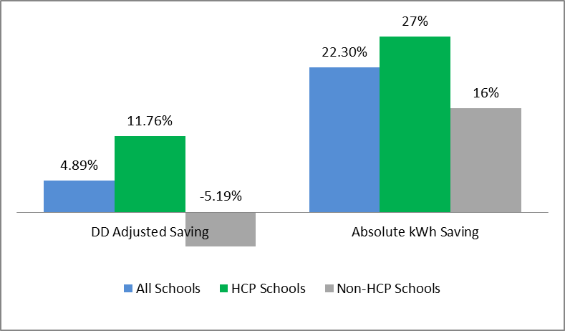

Data tables for this graph can be found in annex 1.

- Annualise Savings Projections

This graph shows the potential annual savings from the project. This involves taking both the absolute and the degree day adjusted savings and applying it to the annual gas consumption over the last 12 months.

The minimum savings have been calculated based on the degree day savings and the maximum savings are calculated by applying the absolute savings.

The most likely future savings will lie somewhere between the two as the majority of changes made to the heating control settings were not relating to temperature control, but were changes to time and occupancy settings.
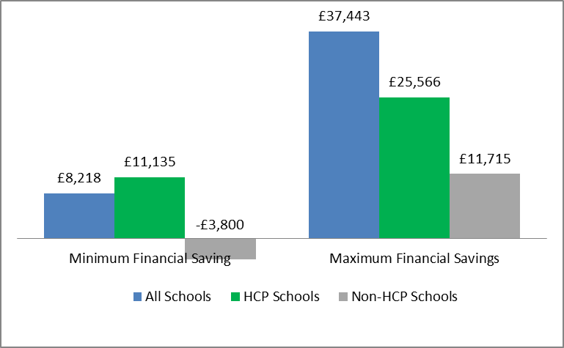

- Project Evaluation

The project is evaluated on the four project objectives; to make energy savings, to train staff, to evaluate the savings using AMR analysis and to create a change log to ensure good record keeping and to ensure the optimum settings are maintained. Finally there is an assessment of the financial benefit of the project.

Carbon Saving
The results show strong energy, financial and carbon savings. This bar chart shows the tonnes of carbon saved by the project:

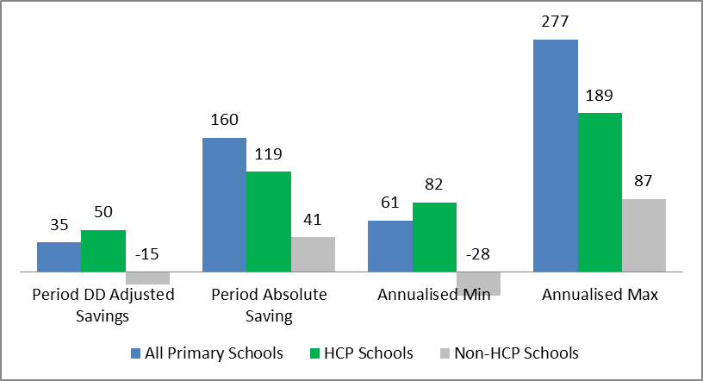

Training
The project aimed to train caretakers to be able to repeat the project themselves, to check and correct time clocks, occupation times, temp settings and holiday schedules.

In some cases this has worked, however due to the complicated nature of the heating controllers in most schools, some school staff do not feel comfortable using the controllers and will always need outside help to make changes. Additionally due to staff turnover further training will be required.

AMR Analysis
Verco provided AMR analysis for a portion of schools visited, but not for those where only very limited changes were made. This analysis was sent out to the schools to show the impact for them in their school.
No analysis was provided across the schools estate as a whole. This analysis was provided by the Schools Energy Officer.

Change Logs
Change Logs have been created and in some cases used. In other cases they have not been integrated as hoped.
Legacy of this project depends on vigilance of the school to ensure the log is located in the boiler room and updated with any changes made by themselves or others.
Further work is in hand by Sustainability and Property to ensure that log books are introduced into plant rooms and the change logs are integrated with contractors employed by BANES.

Financial Evaluation

The expected annual financial savings are at least £11k and more likely between £15 -£20k per year.

We expect some level of annual savings to continue in future years, and some to drop off as settings will require regular updating; future holiday dates need to be inputted and occupancy times and temperatures change with changes in use.

Savings are more likely to be maintained where the training has succeeded and the change logs used. This varies from school to school.

The total project cost was £15,600, meaning that the full cost is very likely to be saved within one year,

- Conclusion and Recommendations

It is recommended to repeat the project annual at lower cost. This can be achieved by integrating it with annual boiler servicing visits. Pre-visit AMR analysis would still be required, but this could take the form of a simple viewing of the data via a web browser. The Schools Energy officer has already provided training in this to those B&NES engineers who deliver the boiler servicing. Post-project analysis can be provided by the Schools Energy Officer, and change logs will not need to be re-created.

In the absence of integrating it with boiler servicing, rolling out the project to the remaining schools should be the first priority. Repeating the project with those schools that still are not able to makes changes themselves should be the next priority.

The gas consumption of the remainder should be closely monitored over the next winter to help ensure the savings are sustained.

Annex 1.
 | Total Primary School Consumption | Total Degree Days | kWh/DD | Corrected Consumption
Period 1 | 3,861,668 | 1107 | 3488.41 | 3,847,714
Period 2 | 2,995,851 | 903 | 3317.66 | 3,659,384
Savings for Reported Period |  |  |  | 188,330
% Saving |  |  |  | 4.89%
£ Saving |  |  |  | £4,708.26
 | Total Consumption for HCP Schools | Total Degree Days | kWh/DD | Corrected Consumption
Period 1 | 2,297,518 | 1107 | 2075.445348 | 2289216.219
Period 2 | 1,653,730 | 903 | 1831.3732 | 2020004.64
Savings for Reported Period |  |  |  | 269211.5785
% Saving |  |  |  | 11.76%
£ Saving |  |  |  | £6,730.29
 | Total Consumption for Non-HCP Schools | Total Degree Days | kWh/DD | Corrected Consumption
Period 1 | 1,564,150 | 1107 | 1412.962963 | 1558498.148
Period 2 | 1,342,121 | 903 | 1486.291251 | 1639379.25
Savings for Reported Period |  |  |  | -80881.10213
% Saving |  |  |  | -5.19%
£ Saving |  |  |  | -£2,022.03

