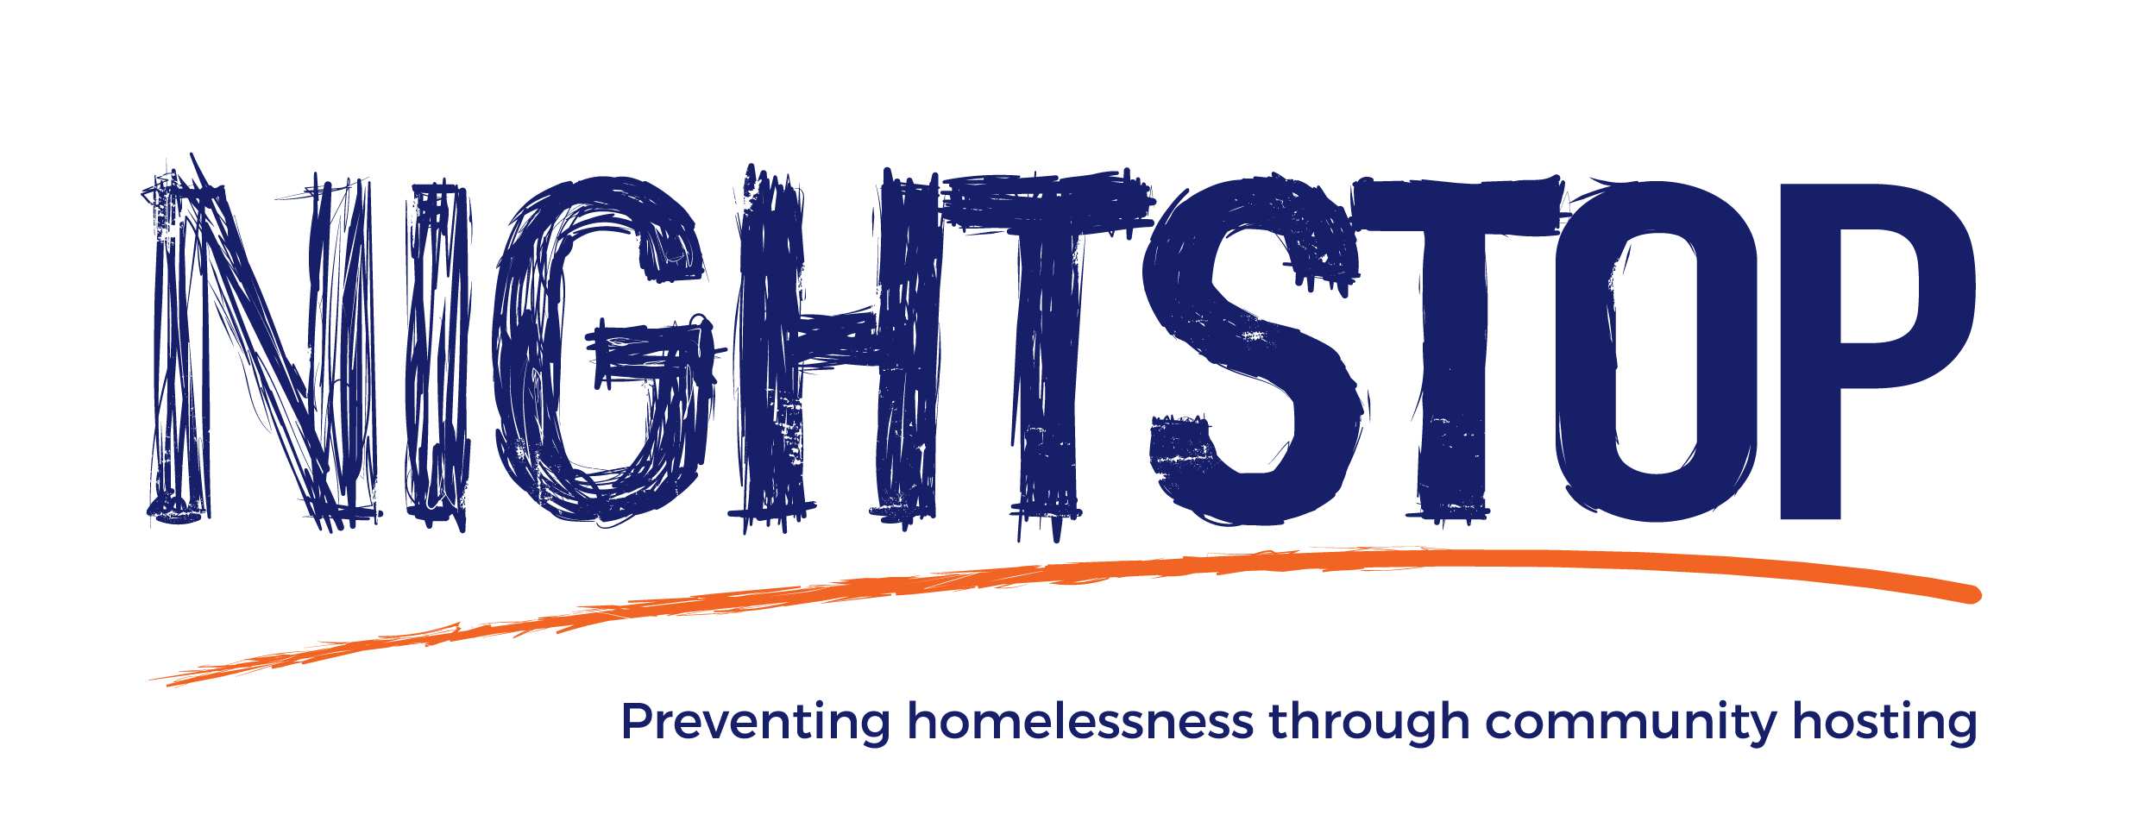

Bath Nightstop

Bath Nightstop is a YMCA project supporting young people aged 16-25 who are homeless or at risk of homelessness/sleeping rough in the B&NES area.

The purpose of the project is to provide support to young people aged 16-25 through offering independent advice, helping them to return home where possible and securing a safe place to stay through a Volunteer Host Network when no other options are available.
Volunteer Hosts will offer a warm room to stay in their own home, an evening meal, breakfast, support and compassion and will be recruited, trained, supported and supervised by staff.

The project will work in collaboration with other agencies, organisations and service providers in the B&NES area to create a network of support and develop unique partnerships, working together to prevent young people from entering into a cycle of homelessness.

All hosts will be entitled to receive an expenses allowance of £10 every time they accommodate a young person for the evening. This covers a young person staying overnight, having an evening meal and breakfast the following day. Any additional expenses incurred in the course of the role may also be claimed.
We’d love to build a strong community of hosts who can support our young people, as well as each other. Please contact us if you're interested in becoming a Volunteer Host with Bath Nightstop.

Contact:
lowrigrove@bathymca.co.uk
Direct tel: 01225325912
Mobile: 0789928155

