

E Team Progress Reports

Spring 2014

*Examples of equalities work led by young people in schools and other settings*

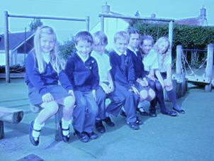

|  |  |
| --- | --- |
| **Chew Valley School…………………** | **Page 2** |
| **Marksbury School…………………..** | **Page 3** |
| **Midsomer Norton Primary School..** | **Page 4** |
| **Norton Hill School…………………..** | **Page 5** |
| **Pensford Primary School………….** | **Page 6** |
| **Prior Park College…………………..** | **Page 7** |
| **Shoscombe Primary School………** | **Page 8** |
| **Three Way’s School…………………** | **Page 9** |
| **93 (City of Bath) Squadron………..** | **Page 10** |
| **St Saviours Junior School…………** | **Page 11** |
| **Compass………………………………**  **St Keyna School E-Newsletter……** | **Page 12**  **Page 13** |
|  |  |

Chew Valley School

E team report on progress

1. **Introduction/summary**

Our Equalities team started life as the Youth Involvement group working with Off the Record to develop resources for schools to raise awareness about violence against women and girls. When that project came to an end the group continued its work with Mrs Pope, the head of PSHE.

***2.* The problems and how we tackled them**

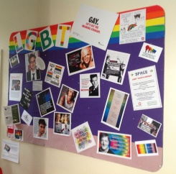The team has worked to encourage Chew Valley School to become a more equal and fair place. We have run directed campaigns to highlight and arm people to combat sexual bullying and have worked closely with Stonewall to combat homophobia.

**3. Who was involved?**

The team involves students from year 7 to year 12 and has a quite fluid membership. Some people join for a specific campaign or come and go as other commitments dictate. There is a core group of around a dozen members who drive things forward facilitated by Mrs Pope and Mrs Rowlands (Deputy Head).

**4. Outcomes and impact**

We have found that bullying incidents in the school have reduced and people are far more aware of what we are doing as a school. Our anti-homophobic language campaign has been particularly successful. Staff are more confident in challenging homophobic language and the term ‘gay’ is rarely used as a term of abuse.

**5. Next steps**

Our next step is to work closely with Mrs Rowlands to develop a campaign to counter an increase in racist name calling which has been noted by the senior management. We will also be continuing our strong relationship with Stonewall and further developing our work to include local primary schools.

E team report on progress Marksbury School

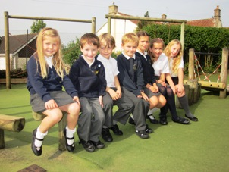**Introduction**

The e-team was set up by Margaret Allen in 2004. We call it a pupil council and it has been running each year under the supervision of one teacher to liaise between staff and pupils.

For the past 2 years that has been Mrs Brightwell.

**The problems and how we faced them**

The pupil council focused on improving play times in the autumn term of 2013. Each class had a circle time to discover the issues children were not happy with and to suggest ways to improve the playground. This linked in with our Olympic and Paralympic values we have adopted as a school for respect and equality in particular.

**Who was involved?**

All pupils, all lunchtime staff, head teacher, teachers and teaching assistants - pretty much everybody!

**Outcomes and impact**

Another circle time was held in classes and a pupil council meeting after these. The consensus was overwhelmingly positive as children commented on the new daily challenges and games that had been arranged by year 5 and 6 and lunchtime staff. The pupil council agreed that children were using their imaginations a lot more in the playground and there was more mixing between the age groups. The amber gem - helping others to learn - was being witnessed a great deal too. In the daily challenges triplets of children from years 5 and 6 lead a little challenge sport or non-sport based every lunchtime. Highlights include funniest impressions of an animal, hurdles, longest jump and guess the object in three words. Children have learnt to measure, time and record results and give out prizes as well as manage the behaviour of younger children.

**Next steps**

To encourage communication to pupil councillors, each class is designing and creating a tree to put up in their classroom for ideas to take to the pupil council meetings.



**Introduction**

Our school set up the Equalities team because we wanted a team of children that could help get rid of bullying and deal with issues such as friendship and making playtimes better. It was part of our whole school drive for better behaviour and for our school ethos to be one of equality and respect for all. We setup the E- team in early November. We got members by putting up posters around the school.

**The problems**

As our head master always says “I want our school to be a bully free school!” But there are always bullying issues in a school. We thought the best way to tackle this problem is to setup a team especially focused on bullying issues and making our playtimes happier. We think if children are bored then some will have time to behave badly and pick on people.

**Who Was Involved?**

Ms Biss decided to setup an E team and asked me if I would make posters to advertise for members. I got 25 responses and we picked 8 people to be our E- team. At our first meeting we brought coloured bands to set up ‘playground friends’.

**Outcomes and Impacts**

We now have 3 teams of playground friends who teach people how to play games and play those games with them. We also help people who are lonely and tackle the horridness of bullying if they come across it.

**Next Steps**

The E team are going to do a whole school assembly on

bullying soon. We are also going to be buying new equipment with our money for the school, so everyone will be busy and hopefully there will be no bullying in our school.

Sam Cook & Megan Carey

E-Team Members

Norton Hill school

E team report on progress

**Introduction/summary**

Every half term we aim to have a meeting between all key members of the current anti-bullying group, and some representatives of the school council. As well as any school students interested. Furthermore we aim to invite a cross section of people in the wider school community, including some members of the SMT and parent governors. We use the time to discuss the wider work of the anti-bullying team, and ensure all voices are heard.

**The problems and how we tackled them**

* Lack of cyber bullying support
* Lack of Student mentoring schemes, so we developed a new student led anti-bullying system
* Raising awareness of the work we do (Posters around school)
* Raising awareness of the issues and solutions we provide associated with a lack of equality within vulnerable groups
* Student involvement in anti-bullying with anti-bullying poster competition

**Did the E Team focus on bullying?**

One of the key focuses of the E Team was bullying, alongside general student safety and their sense of security*.*

**Who was involved?**

1.Anti-bullying coordinator

2.School Council

3.Identified Vulnerable groups

4.Year 8 – Year 11 and some members of the sixth form SMT

**Outcomes and impact**

* Students receive more outreach options giving them more of a voice
* ‘I feel very safe in school’ – Student benefiter of our mentoring system
* Anti-bullying posters in all major areas of the school, on A3 or larger paper. Posters that were designed by students.
* Reduction in bullying as evidenced by the SHEU survey

**Next steps**

* Develop drop in centres
* Begin Half termly meetings for members of the anti-bullying network to support them in their work and work co-productively and youth led.
* Run a new poster competition to raise awareness again

Pensford Primary School

We are the S.T.O.P team. We are people who want to stop bullies in our school. There is very little bullying in our school, but we want it to go for good. We decided to come up with the STOP (Several Times on Purpose) team to help children who are being bullied and to make everyone more aware of how to STOP it.

There are a few things that people in our school get upset about e.g.

Children feeling left out,

Children hurting others’ feelings,

Children not being listened to at lunchtimes.

We have just started the S.T.O.P. team so we haven’t solved our bulling problem yet. But we are planning to get training for our SMSAs and ourselves.

The S.T.O.P team includes four pupils from Kingfisher class (Year 5 and 6):

Mia

Sophie

Sam

Peter

We started the S.T.O.P. team just before the Christmas holidays so we haven’t really started the S.T.O.P team completely but we have met with Mrs Murphy and have a plan to give extra training to our SMSAs on how to listen to us properly at lunchtimes, and will be doing an assembly at the end of February to introduce our project to the whole school.

The S.T.O.P. team is going to try and get some headbands, wristbands and other accessorises to show that we are the S.T.O.P. team and we can help.

Thank you for your consideration

The S.T.O.P. team

Lorna_McIsaac@BATHNES.GOV.UK

E-Team Report on Progress

Prior Park College

**Introduction**

I am a pupil at Prior Park College. Students at Prior Park are put into single sex Houses from Year 9 and remain members of the house until they leave the school. Our school has an Anti-Bullying Policy, however, each House also develops specific practices to promote the ethos of the Anti-Bullying strategy within the individual Houses. As I am a member of the Anti-Bullying Strategy Group and the Young People's Equalities Group, I have been able to actively Champion Equalities Awareness in my House.

Being an Independent School, there was little knowledge or awareness about the different types of local services available to support victims of bullying. During an assembly dedicated to Anti-Bullying I have provided information and contact details about the various support services available locally. I am pleased to say that these details have now been published on the school website and school diaries, which has ensured that all pupils and their parents have access to this information.

Within the House, we have set up a 'buddy-system’, this involves a Sixth Form pupil ‘looking out for' and supporting a Year 9 pupil with any issues.

Every pupil in the House meets with the House Mistress regularly to discuss how things are going, including relationships with other pupils. Everyone is provided with strategies and the confidence to challenge inappropriate behaviour of fellow pupils. Serious matters are dealt with swiftly and sensitively.

Everyone in the House, both pupils, staff and the Head of Discipline is involved in this process via Tutor Group Meetings, Year 9 assemblies and whole House assemblies. Any good ideas that come out of this have been shared with the Head of Discipline so that other Houses in the school can also benefit.

The outcomes and impact of the above has been improved awareness, better reporting of incidents, individuals feeling safe and supported by

both staff and fellow pupils who feel more confident to challenge any inappropriate or unkind behaviour.

**Next Steps­**

* Good Practice and information to be shared with relevant school committees.
* E-champion to link up with PSHE Lead in the school and act as a resource for information.
* Competition to develop Anti Bullying/Equalities posters for school

Savarna Chaddha

E Team Report on Progress

Shoscombe School

**Introduction/ Summary**

The E team was set up in November 2013. Their focus is on Celebrating differences. They are running a series of days celebrating different cultures that are represented in our school, starting with a Thai day on 3rd March.

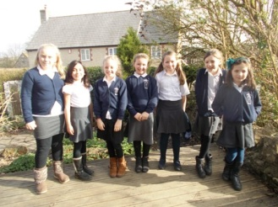

**The Problems and how we tackled them**

Jasmine Moore joined year 4 in September 2013 , she is half Thai. The girls in year 4 decided that a way of making her feel welcome would be to find out more about her culture. There is another Thai girl Jessica in year 2 who is keen to be involved in the project.

**Who was involved?**

The year 4 girls; Katelyn, Jasmine, Evie, Clover, Anoushka, Lucy and Jazmine have organised the day with the help of Kate, Mrs Rorison, Mrs Burge and Jessica and her Mother.

**Outcome and Impact**

Jasmine has settled into the school well. We have started to develop closer links to the Thai Community. After the day we hope that the children at Shoscombe will have a greater knowledge and appreciation of Thai Culture.

**Next Steps**

To organise a Thai day. The girls are then planning on organising a South Africa Day. We have connections with 3 South African Families.

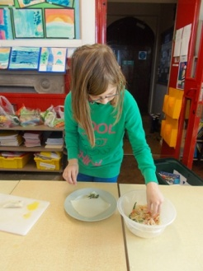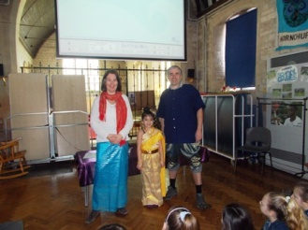

E Team Report on Progress

Three Ways School

**Introduction to the Three Ways E Team meeting 22/01/14**

1) The E team was set up alongside the existing school council to ensure that there was a fair representation of our pupils, their varied challenges and strengths and of course their views. Brandon Head is our lead E Team pupil who will work alongside our chairperson Kye Copp who is the lead pupil on the school council. Mrs Eleanor Richardson (Dormouse Class Teacher and lead staff member on the school council) and Ben Edwards (Primary manager are working in support of the E Team.

**Problems and how tackled**

2) The team discussed issues around inclusive play at break and lunch times and the need for a retreat space for pupils with more complex needs away from the hustle and bustle of the main play area. This will allow for greater levels of interaction between pupils of a range of abilities and the provision of play activities that meet the needs of our more complex students more effectively. We intend to celebrate difference and develop our inclusive play provision.

**Who was involved?**

3) The E Team at the initial meeting have discussed the issues and brought forward a range of suggestions to enable us to develop the space and begin a wider campaign to attract attention to this issue.

**Outcomes and Impact**

At this stage we have already begun to attract more funding from other streams within the school and in raising the issue with school council and in staff briefings we have ensured that we will change the fabric of our provision. Pupils voice has been captured more effectively as part of this start up project than in the past three years as all classes were able to develop their ideas prior to the meeting and were brilliantly supported by their staff teams. We are really excited about continuing to build on capturing pupil voice and bringing their ideas into form as part of the development of our outdoor play space.

**What next**

5) We will make a short presentation to all parents and users of the Web site to highlight what our youngsters have achieved with this project and look to further involve the PTFA and Governors in this process. Further to this we will begin to purchase initial elements to the garden and see how effective these are in involving a more diverse group of our students in interactive play during their break and lunch times.

93 (City of Bath) Squadron E Team Progress Report.

The E Team was set up on September 2013 to improve the cadet welfare on the squadron. The team included me (a new member of staff and recent cadet) and a group of cadet NCO's.

We felt we needed to improve the level of respect cadets have for each other

and the understanding of the difference between 'banter' and bullying. To

improve these issues we invited the Kate Murphy, had discussions with cadets

about their views on the differences between the two and created a cadet welfare board with information on organisations/charities provided by BANES that are available to help them.

Over 100 cadets were involved in these lectures and took part in engaging discussions.

The impact is cadets are now more aware of whom they can talk to, have more confidence to speak to their staff and NCO's and therefore have better relationships amongst each other and are working better within a team.

Our next steps are to create an 'open room' in which cadets can freely come in and discuss with the E Team anything they wish to discuss be it personal problems, stress from school/exam or how to improve performance and progression down cadets.

Written by: Jennifer Fowles (Cadet Welfare Staff Member)

**St Saviours Junior School**

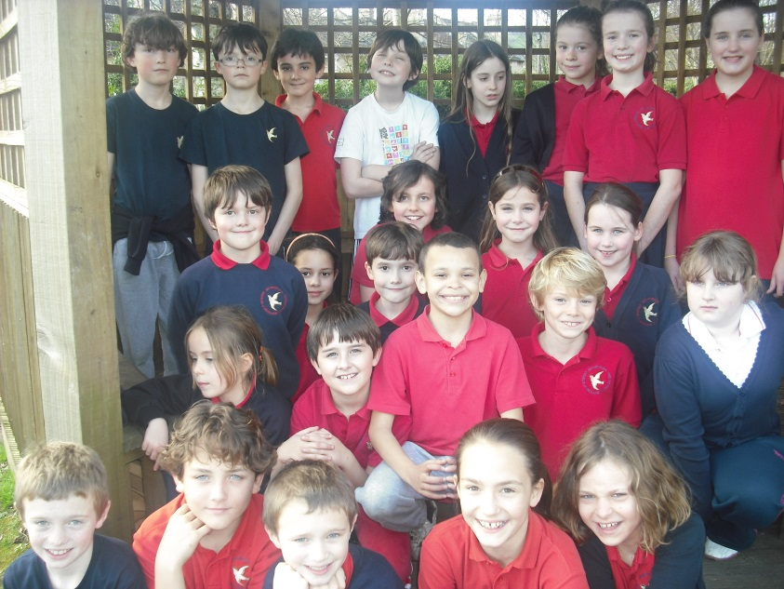Working together for better play

Councillors and ambassadors working together

The E-Team at St Saviours was set up in January 2014 and consists of the head teacher, two teachers and five pupils from across the year groups who are either school councillors or anti-bullying ambassadors. The active St Saviours school council has been running for many years and the anti-bullying ambassadors were established after training with Alex Holmes of the Diana Award Scheme in June 2013.

After meeting in early September the anti- bullying ambassadors decided to build on St Saviour’s reputation as an environment with little or no bullying (SHEU report 2011) and focus their efforts on the playground. The ambassadors and the councillors collated choices of playground games gathered from children in the school and the favoured games were purchased along with two storage cupboards, one for the year 4/5 playground and one for the year 5/6 playground.

It was also suggested that we introduce playtime ‘Buddies’ where the older children play with the younger children teaching and helping them with the games. A timetable has been set up indicating which class has the games on which day and each classroom will have a ‘Buddie chart’ for daily volunteers.

It has not yet been possible to implement the plans due to bad weather but we hope to have the children’s ideas up and running very soon.

We plan to use the £100 grant to purchase more giant outdoor games and introduce playground game markings.

**Compass: E team report on progress**

1. **Introduction/summary**

The Compass E-Team was set up after we had been helping to interview staff and helping with their inductions and designing the new leaflet. We decided we should meet regularly to put our views across.

1. **The problems and how we tackled them**

We thought that it was most important to help children with their anger, and to have things that we can take into schools. We looked through a catalogue and chose some resources. We chose ‘The Talk about Game’ for children and ‘Teen Issues Colour Cards’ for older kids. With the money left over we will buy some ‘tech decks’ which is something fun we can do in school after we have done the work.

1. **Who was involved?**

3 young people and 3 Compass workers.

1. **Outcomes and impact**

We have more of a say about how Compass works with us and we have some new resources to work on anger and other things.

1. **Next steps**

We will make a plan to meet regularly and get more funding.

**ST KEYNA**

ISSUE NO: 2 March 2014

**ST KEYNA E-NEWS**

**E TEAM NEWS**

We hope you enjoy the second edition of E News! It has been written by members of the E team including Tommy, Aryna, Frankie, Isabelle, Ellie, Elisha and Alysia. Take a look at the E-Team notice board to see what we’ve been up to recently.

**Anti bullying poster drawn by Sofia.**



**E-Team Logo Competition**

As everyone knows the E - Team held a Logo Competition recently. There were lots of fantastic entries but the E – Team chose two entries that stood out from the rest.

In 2nd place was **Frankie Smith** from Year 5/Amber Class - her runner up prize was a Bronze Chocolate Ammonite ☺

In 1st place was **Elena Bees** from Year 5/Amber Class – her winning prize was a Gold Chocolate Ammonite and a Tesco gift for £5.00 ☺

You can see Elena’s winning logo on the E Team notice board.

***Aryna and Ellie***

PROBLEM PAGE...    

**This page of the magazine is for you dear readers to send in any of your problems and for our expert advisor to answer your problems so you can have a better life and be happier!**

*Dear E Team,*

*Some of the people in my class just leave me out from games that I love like stuck in the mud. What shall*

*I do?*

E Team Answer: Ask politely if you can join in. If they still don’t then tell a teacher. ☺

*Dear E Team,*

*There are some girls in my class that laugh at me because I still sleep with my teddy.*

E Team Answer: Tell them that you are being yourself and that it doesn’t matter if you do. ☺

*Dear E Team,*

*Please help me, my friends keep calling me a weirdo and I really don’t like it.*

E Team Answer: Firstly you need to find out why they call you that, if they do it just for fun, then tell them that you don’t find it funny and for them to stop doing that. ☺

**We hope that helps, if you have any problems then put them in your class Worry Box and they will be answered and printed in the next issue of the School Magazine. But please DO NOT write your name because it has to be Anonymous. *The E Team***

C:\Users\alina lynden\AppData\Local\Microsoft\Windows\Temporary Internet Files\Content.IE5\STGBFU5I\dglxasset[1].aspx C:\Users\alina lynden\AppData\Local\Microsoft\Windows\Temporary Internet Files\Content.IE5\STGBFU5I\dglxasset[1].aspx C:\Users\alina lynden\AppData\Local\Microsoft\Windows\Temporary Internet Files\Content.IE5\STGBFU5I\dglxasset[1].aspx C:\Users\alina lynden\AppData\Local\Microsoft\Windows\Temporary Internet Files\Content.IE5\STGBFU5I\dglxasset[1].aspx C:\Users\alina lynden\AppData\Local\Microsoft\Windows\Temporary Internet Files\Content.IE5\STGBFU5I\dglxasset[1].aspx C:\Users\alina lynden\AppData\Local\Microsoft\Windows\Temporary Internet Files\Content.IE5\STGBFU5I\dglxasset[1].aspx C:\Users\alina lynden\AppData\Local\Microsoft\Windows\Temporary Internet Files\Content.IE5\STGBFU5I\dglxasset[1].aspx C:\Users\alina lynden\AppData\Local\Microsoft\Windows\Temporary Internet Files\Content.IE5\STGBFU5I\dglxasset[1].aspx

By Isabelle – the Shakeathon project really helped year 5 to work as a team as well.

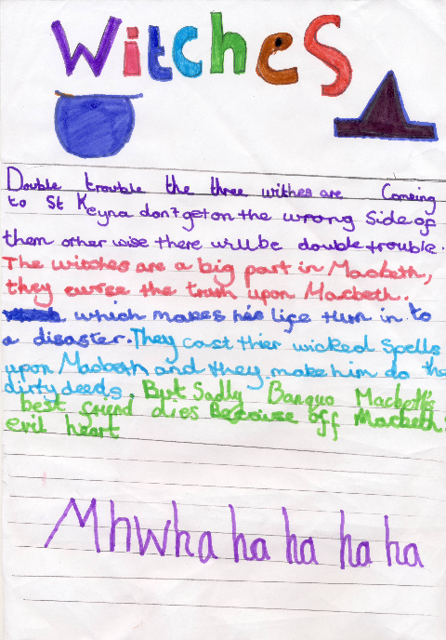

The challenge for each class was to make as much money as possible. Each class was given £20 and they had to make it grow.

They spent money on things and got money back from selling things. The class that makes the most money can keep the £20 to spend on things for their class.

By Tommy

Working as a team is fun and helps raise money for our school!!

**Bullying survey**

Kate Murphy, from the council, recently came back to St Keyna to find out how we have been getting on since last year’s Anti Bullying week. She talked to several children in different classes to find out how they feel about behaviour at playtime and in the classroom. KS1 children feel that unkind behaviour (pushing, shouting, leaving people out etc) does happen sometimes in the playground. People get picked on because of the way they look, sometimes people bully because their parents don’t teach them about these things or the bullies don’t feel good about themselves. To help improve this, they suggested doing role plays at assembly and making films which the E Team can help with.

KS2 children also let Kate know that there’s sometimes bullying and unkind behaviour in the playground and occasionally in class. They also felt people did it sometimes for “revenge” if someone had said something to them or because they felt someone was better than them.

All the children who chatted to Kate want to help each other to improve behaviour and gave examples of things that had been done already. They would like to have some training in how to help each other sort out problems.

Here are some of the things they said are good about St Keyna:

* The playpod
* It’s good fun here and we like the rewards
* The teachers let us play
* We learn a lot
* Bullies have to explain what they’ve done
* The teachers are nice and kind here - people get on well
* The Head Teacher is good
* It’s well-organised
* We have to work really hard in the morning and then our teacher lets us relax & do fun things in the afternoon good assemblies
* Ms Hughes gives us good challenges

**Survey Results – what do you like about St Keyna?**

**KS1**

* The playpod
* It’s good fun here
* The teachers let us play
* We learn a lot
* I like sums / maths
* Bullies have to explain what they’ve done
* Choosing time on Fridays
* The teachers are kind

**KS2**

* It’s fun here
* Teachers are nice and kind
* People get on well
* The Headteacher is good
* It’s well-organised
* We have to work really hard in the morning and then our teacher lets us relax a bit more and do more fun things in the afternoon
* We have good assemblies
* The rewards are good
* Ms Hughes gives us good challenges

**??? Anti bullying Quiz ???**

**1. Name something that’s horrid that starts with the letter ‘B’** A. Bully B. Bug C. Bear

**2. What do you do if you’re being bullied?**

A. Tell a teacher B. Bully back

C. Stick your head down a toilet.

**3. Which one of these things is bullying?**

A. Name calling B. Eating porridge

C. Smelling cheese

**4. What would you do if you saw someone being bullied?**

A. Find a kangaroo

B. Tell a responsible adult

C. Splash Cola on them

**5. What do you do if the bully strikes again?**

A. Call the ambulance

B. Tell them to leave you alone

C. Read a book

**6. What do you do if someone’s in trouble?**

A. Tell someone B. Ignore them and laugh

C. Join in bullying

**7. What do you do if your best friend is getting bullied?**

A. Join in with the bullying B. Get a teacher

C. Just ignore and laugh

**8. What do you do if you get in trouble?**

A. Argue with the teacher B. Answer the teacher back

C. Accept that you are in trouble

**That’s the end of the quiz we hope you enjoyed it!! The answers will be posted on the e team notice board after the Easter holidays**