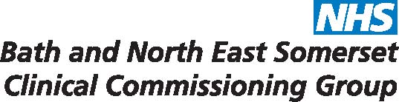

Parent / Carer / Young Person to complete

I give permission for the Early Help Assessment (previously CAF) and subsequent information held by the Integrated Working Team completed for

(Child / Young Person’s Name) _____________________________________
to be shared with
(Professional’s Name and Address) _____________________________________
_____________________________________
_____________________________________
_____________________________________
_____________________________________

Parent/Carer/Young person’s Name ______________________________________
Parent/Carer/Young Person’s Signature _____________________________________
Date _____________________________________

Please note - Permission should normally be given by the person who originally signed the common assessment.

Please return the completed form to:

Integrated Working Team
People and Communities Department
Bath & North East Somerset Council
Lewis House, Manvers Street
Bath, BA1 1JG

Email: IWT@bathnes.gov.uk
Telephone: 01225 395021

