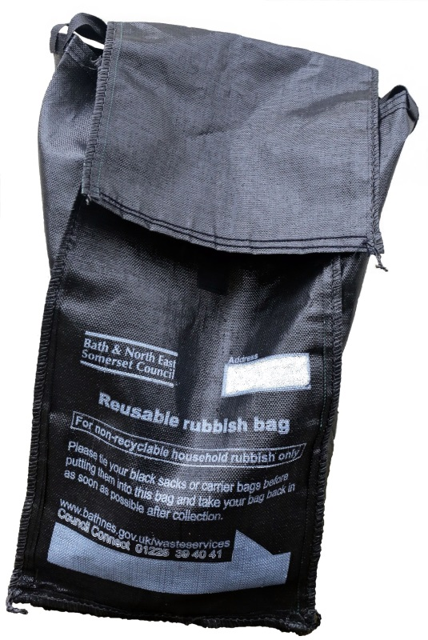
Guidelines for using your gull-proof sack
Please
- Use your gull-proof sack for household rubbish only.
- Tie up your plastic sacks or carrier bags containing your rubbish before placing them in your gull-proof sack so that our crews can lift the rubbish bags out of the gull-proof sack and throw them into the back of the collection vehicle.
- Write in your address on the space provided on the bag.
- Put your gull-proof sack out for collection in your usual place at the front edge of your home by 7am on your collection day, or as late as possible after 8pm the previous evening.
- You must bring your gull-proof sack back in as soon as you can after emptying – your sack must not be left out on the street or on railings between collections.

Please
- Do not put any loose rubbish or split sacks into your gull proof sack – our crews will not take this.
- Do not put out any other rubbish bags next to your gull proof sack – we will give you one bag when we visit
- Do not leave your empty bag out after collection. All bags must be brought back onto your property as soon as possible after collection.
- Do not leave your bag on railings between collections
- Do not use your gull proof sack for any items that we collect for recycling. Use your green box, blue bag, food waste bin and your weekly small electricals recycling collection to recycle as much as you can. All food should be recycled in your food waste bin.
- Do not use your sack to store anything else other than the general rubbish you want us to collect. Please note that the bag remains the property of the Council.

If you have any queries or would like to order an extra reusable bag or any recycling container please contact Council Connect
Telephone: 01225 39 40 41
Email: Councilconnect@bathnes.gov.uk
Visit: www.bathnes.gov.uk/wasteservices

