Contents

The Somer Valley Partnership………………………………………… 3

Statement from The Chair…………………………………………………… 5

Summary of the Plan………………………………………………………… 7

1. Introduction
What is the Market and Coastal Towns Initiative?............................................................ 11
Why does Norton-Radstock need a Community Plan?............................................. 12
How does our Plan relate to other Plans?........................................................................ 13
Implementing our Plan………………………………………………………………………… 13
What’s in our Plan……………………………………………………………………………… 13
The Plan area…………………………………………………………………………………... 14
A brief history…………………………………………………………………………………... 15

2. The Community Planning Process
Community Planning process………………………………………………………………… 17
How have we worked with the community and others to prepare our Plan?................... 17
The Midsomer Norton and Radstock Steering Group……………………………………... 18
Theme Groups…………………………………………………………………………………. 18
Publicity and Communication………………………………………………………………… 18
The Parishes…………………………………………………………………………………… 19
Capacity Building……………………………………………………………………………… 19
Ready to Go Projects…………………………………………………………………………. 20

- Our Vision
Why do we need a vision for Midsomer Norton and Radstock?..................................... 21
Our Vision for Midsomer Norton, Radstock and the surrounding area…………………. 21
Cross Cutting Issues…………………………………………………………………………. 22

- Where are we now?
Our starting point……………………………………………………………………………… 23
SWOT Analysis……………………………………………………………………………….. 25

- The Projects
Achieving the Vision and addressing the key issues……………………………………… 27
Priority Projects………………………………………………………………………………... 28
The Projects – Full list………………………………………………………………………… 29

6. Villages and Rural Areas
Working Together……………………………………………………………………………... 47
Improvements to Midsomer Norton and Radstock………………………………………… 48
Issues that apply to a number of Parishes…………………………………………………. 48
Village issues – Project 38 – Parish Plans…………………………………………………. 48

- The Next Steps
How will we organise ourselves to the manage the implementation of the Plan?.......... 51
How are we going to keep the community involved?..................................................... 51
How will the community know what’s happening?......................................................... 51
How will we measure the success of the Plan?............................................................. 52
Funding Sources……………………………………………………………………………... 52

Appendix 1…………………………………………………………………… 55

Appendix 2…………………………………………………………………… 65

Brighter Futures

The Somer Valley Partnership

Trudi Cannock (Chair) – Shoscombe Resident

Irene Burchell – Radstock Community Association

David Evans – Midsomer Norton & Radstock Chamber of Commerce
Caroline Green – North East Somerset Arts
Cllr Alan Hall – Radstock Town Council

Terry Taylor – Midsomer Norton Community Association

The Somer Valley Partnership

Chair’s Statement

Welcome to the 2007 revised “Norton - Radstock Area Community Plan”

We have called our plan “A Brighter Future” to reflect the optimism of a community that is working hard to improve the quality of life for everyone who lives and works here. Getting to this point has involved the hard work, enthusiasm, dedication and skills of local people, many of whom are volunteers. We have also had a lot of fun and numerous lively discussions during the consultation stages, when the whole community had the opportunity to help shape the plan.

The Market and Coastal Towns initiative has enabled the community to work alongside Bath & North East Somerset and Mendip Councils, the Town and Parish councils and local organisations of all kinds. This has proved a productive and successful way of working and means that “A Brighter Future” is the result of true co-operation, producing a plan reflecting issues of real importance.

We have sought to include projects which help retain the separate identities of Midsomer Norton and Radstock whilst addressing issues that affect the whole area and the surrounding villages. Several community projects have already benefited from small grants made under our “Ready to Go” scheme. These projects had an immediate impact and should produce long-term benefits.

Personally I have enjoyed meeting new people, developing new skills and learning more about the fascinating history of the area. It’s been hard work but I’m sure that everyone who has worked on producing “A Brighter Future” will agree that it has been worthwhile.
I look forward to the next phase as we move towards the implementation of the projects.
There will be new challenges which will require the continued commitment of the people of Midsomer Norton and Radstock but I feel sure that we can look forward to success in the future.

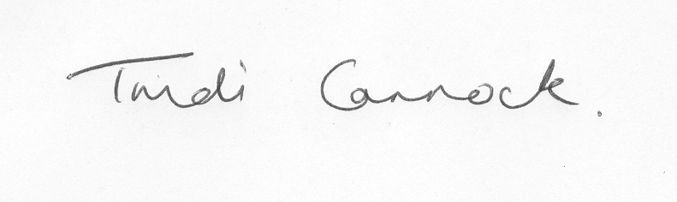

Summary of the Plan

Introduction
This Plan for Midsomer Norton, Radstock and the surrounding Parishes has been produced by members of the community as part of the South West Regional Development Agency’s (SWRDA) Market and Coastal Towns Initiative.
The aim of the Market and Coastal Towns Initiative (MCTi) is to support communities in Market and Coastal towns across the region to produce long term Plans (typically 10 – 20 years) for their areas that identify key issues and needs and actions to address them.
The Plans are produced from a community perspective (although with support and input from Local Authorities and other bodies) by a Steering Group of local people
Once the Plan is produced, the Steering Group’s task is to:
- Oversee the delivery of the actions
- Bring together potential Funders and present projects to them
- Keep progress under review and the Plan updated.
A further responsibility of the Steering Group is to:
- Establish the best way for the community to retain control of the delivery and development of the Plan.
A list of our Steering Group members is shown on page 52

Our Community - Towns and Parishes
Our Community Plan is based on the two towns of Midsomer Norton and Radstock, as well as the surrounding Parishes. The reason for including the Parishes is to recognise the important role that Market Towns play for people living in the wider area. The main focus of the Plan is the two Towns but we have included the issues and needs of all the Parishes and will seek funding to support Parishes produce their own individual Plans. Because Midsomer Norton and Radstock are on the southern edge of Bath and North East Somerset, the Parishes to the South of the Towns are in Mendip District Council – part of Somerset County.
The Parishes included in the Plan area are:
Camerton, Farrington Gurney, High Littleton, Paulton, Peasedown St John, Shoscombe, Timsbury (all in B&NES)
Chilcompton, Coleford, Holcombe, Kilmersdon, Stratton on the Fosse (all in Mendip)

Why do we need a Plan?
A lot of attention is placed on the needs of major Towns and Cities, but rural areas and Market Towns are where many people live and work – our Community Plan area has a population of 46,000, half the size of Bath. The role of Market Towns is changing and the danger is that they will become overshadowed by neighbouring larger Towns and Cities and lose their identity.
At Local Authority, sub regional (the former Avon area now known as the West of England) and Regional (South West of England) levels planning and delivery is increasingly being undertaken by Partnerships that bring together a range of organisations and interests.
There is also a need for Partnership working at a local community level and MCTi Community Plans provide an opportunity for this to happen with, most importantly, the strong voice of local people. It also makes it more possible for The Midsomer Norton & Radstock area to link into plans being produced at Local Authority and sub regional level – for instance by the Local Strategic Partnership.

How Did We Get Here?
This Plan represents an enormous amount of hard work over a long time. The most important stage was a widespread consultation across the whole area. This involved talking individually with people as well as holding public meetings. The Steering Group appointed Community Agents to do the consultation and made great efforts to make sure that people who are often excluded had their say.
The Steering Group also relied on Task Groups to help focus on specific issues that came out of the Consultation. The Steering Group is very grateful for the hard work and invaluable contribution of the following Groups:
Town Centre Link, Sports, Community Safety and Drugs, Tourism, Somerscene (Arts), PRIDE (Equalities).

Themes in the Plan
Out of the Consultation process we identified a number of key themes;
- Business and the Local Economy
- Town Centres
- The Environment
- Transport
- Public Services
- Housing
- Community Safety
- Equality
- Sustainability
The last three are so called “cross cutting” themes that have an impact on all the others.
We have developed a “vision” for each of these themes as well as an overall “vision” for the area, which is:
“We envisage a thriving and vibrant area with a sense of well being, its own identity and promoted as a whole, with Midsomer Norton & Radstock as the focus. Facilities in Midsomer Norton & Radstock will be available and accessible by the communities in the surrounding villages. Village communities will have the support and resources necessary to develop solutions to their particular needs”.

The Projects
Having identified the key themes and issues for the area, the Steering Group looked for projects that would help tackle them. In total there are 39 projects in the Plan. They have not been “invented” by the Steering Group, they are Projects brought forward by a wide range of Agencies and Organisations. Some of them have already been started, some have been thought about and discussed for a long time and some of them are new ideas.
The Steering Group is committed to all of these Projects and will do its utmost to help them succeed. However, from amongst all the Projects, five have been identified as the Steering Groups priorities. They are (in no order):
- Midsomer Norton Skateboard Park
- Somer Centre expansion (feasibility study)
- Midsomer Norton & Radstock Town Park
- Victoria Hall (feasibility study)
- Norton Radstock Regeneration Co – Railway land redevelopment.
As well as these five specific projects, the Steering group is also keen to prioritise the project aimed at helping the Parishes develop their own Plans.

What Next?
Over the next 1- 6 months we will:
- Make as many people in the area as possible aware of our Plan, by seeking publicity and by distributing thousands of summaries of the Plan.
- Identify potential Funders, especially for our key projects, and start to make presentations to them along with the Project sponsors.
- Present our Plan to the South West Regional Development Agency and seek funding support from them towards projects with an economic impact and for continued funding to support the operation and development of the Steering Group.
- Discuss with all interested parties what the best structure is going to be for continuing the work we have started.
- Report our progress to the community
Over the next 6 – 18 months we will:
- Continue to help Project sponsors to raise funding and deliver their Projects
- Agree and implement a structure for continuing our work into the future
- Review and update the Plan
- Report our progress to the community

- Introduction

1.1. What is the Market and Coastal Towns Initiative (MCTi)?

1.1.1. The term ‘market town’ refers to towns that have traditionally hosted an agricultural market. In recent years the description has been extended to include seaside resorts, fishing ports, mining and farming communities. These towns play an important role in meeting many of the needs of local people, including providing access to a wide range of employment, retail, leisure, professional and public services.

1.1.2. The Government’s ‘White Paper’, called ‘The Future of the Countryside’, published in November 2000 sets out a range of measures to help to secure the future of the countryside as a place to live, work and for leisure.

1.1.3. The Government is particularly concerned to maintain and enhance the role that market and coastal towns play in keeping the countryside alive by providing employment, shopping and other services. The ‘White Paper’ addresses the many changes happening in the countryside, such as the decline in tourism, agriculture, fishing and mining.

1.1.4. Part of the Government’s strategy involves local communities working with local authorities, local businesses and development agencies to consolidate and expand the role that market and coastal towns play in the social and economic fabric of the countryside, by preparing plans to secure the future of their own towns and the surrounding parishes and to build up skills necessary to make these plans a reality.

1.1.5. To assist this process the South West of England Regional Development Agency (SWRDA) has created a partnership of regional agencies, called the ‘Market and Coastal Towns Initiative’ (MCTi), comprising SWRDA, The Countryside Agency, English Heritage, the Government Office South West (GOSW), the South West Regional Assembly, the Housing Corporation, Lottery Funds South West and the South West Area Network of Rural Community Councils (SWAN). This partnership has now evolved into an Association of agencies and towns involved in the MCTi process.

1.1.6. SWRDA has created a budget of £5 million a year from 2005 to 2008 to support projects emerging from the Plans of those communities participating in MCTi.’

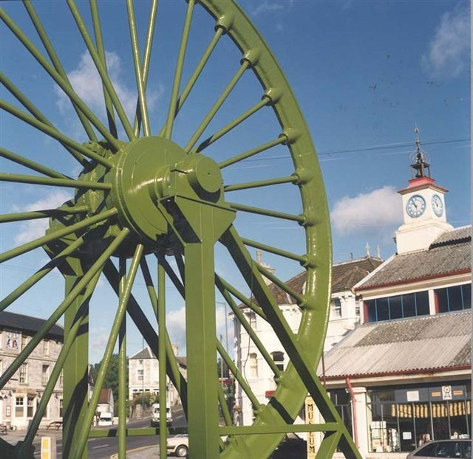

The Miners Wheel , Radstock

1.2. Why does the Midsomer Norton & Radstock area need a Community Plan?

1.2.1. A ‘Community Plan’ is prepared by and for the community, looks ten or twenty years ahead and includes specific proposals for the community’s future. In preparing its Plan the community works with local authorities, central government and private sector partners to plan and promote the future wellbeing of its area.

1.2.2. The Plan should help to ensure that the community is actively involved in making decisions on all aspects of its future. This includes the provision of local services and the design and delivery of projects and programmes in areas which affect people’s lives such as health, education, the economy, transport, safety and the environment.

1.2.3. A Community Plan is not a ‘statutory’ plan. It does not need to be approved by anyone other than the community itself. However, the Plan should not simply be a ‘wish list’ of things that people would like to see happen. Organisations that may be asked to support a particular project may wish to test the Plan’s rationale and the evidence that it presents in support of the project. The Plan must therefore demonstrate a solid ‘evidence base’ for the projects it is proposing.

1.2.4. Not being a ‘statutory’ document means the Plan has no prescribed form or content. It can deal with any issues that concern the community at a particular time, leaving less important, or more difficult, issues to be addressed when the plan is reviewed at a later date. The plan has no finite ‘life’ and can be reviewed and changed at any time.

1.2.5. The benefits to a community having a Plan are that it should:
- Encourage the community to take responsibility for and become involved
in its own future
- Help the community influence projects and programmes rather than being influenced by them
- Help those responsible for projects and programmes to deliver them on time and on budget with clearly measurable outputs
- Provide a yardstick against which communities can measure new projects before deciding whether or not they want to support them
- Allow communities to obtain financial support to undertake projects themselves.
- Make effective links to Local Authority and sub regional plans from the Local Strategic Partnership etc.

1.2.6. The documents included in our Community Plan are:

The Community Plan itself (this document)

A leaflet describing the key projects in the Plan

An ‘Action Framework’ which details the projects contained in the plan

A ‘Consultation Scrapbook’ outlining how we have consulted the community

Details of the plans and strategies we have consulted in preparing our plan

The ‘Ready to Go’ projects we have supported
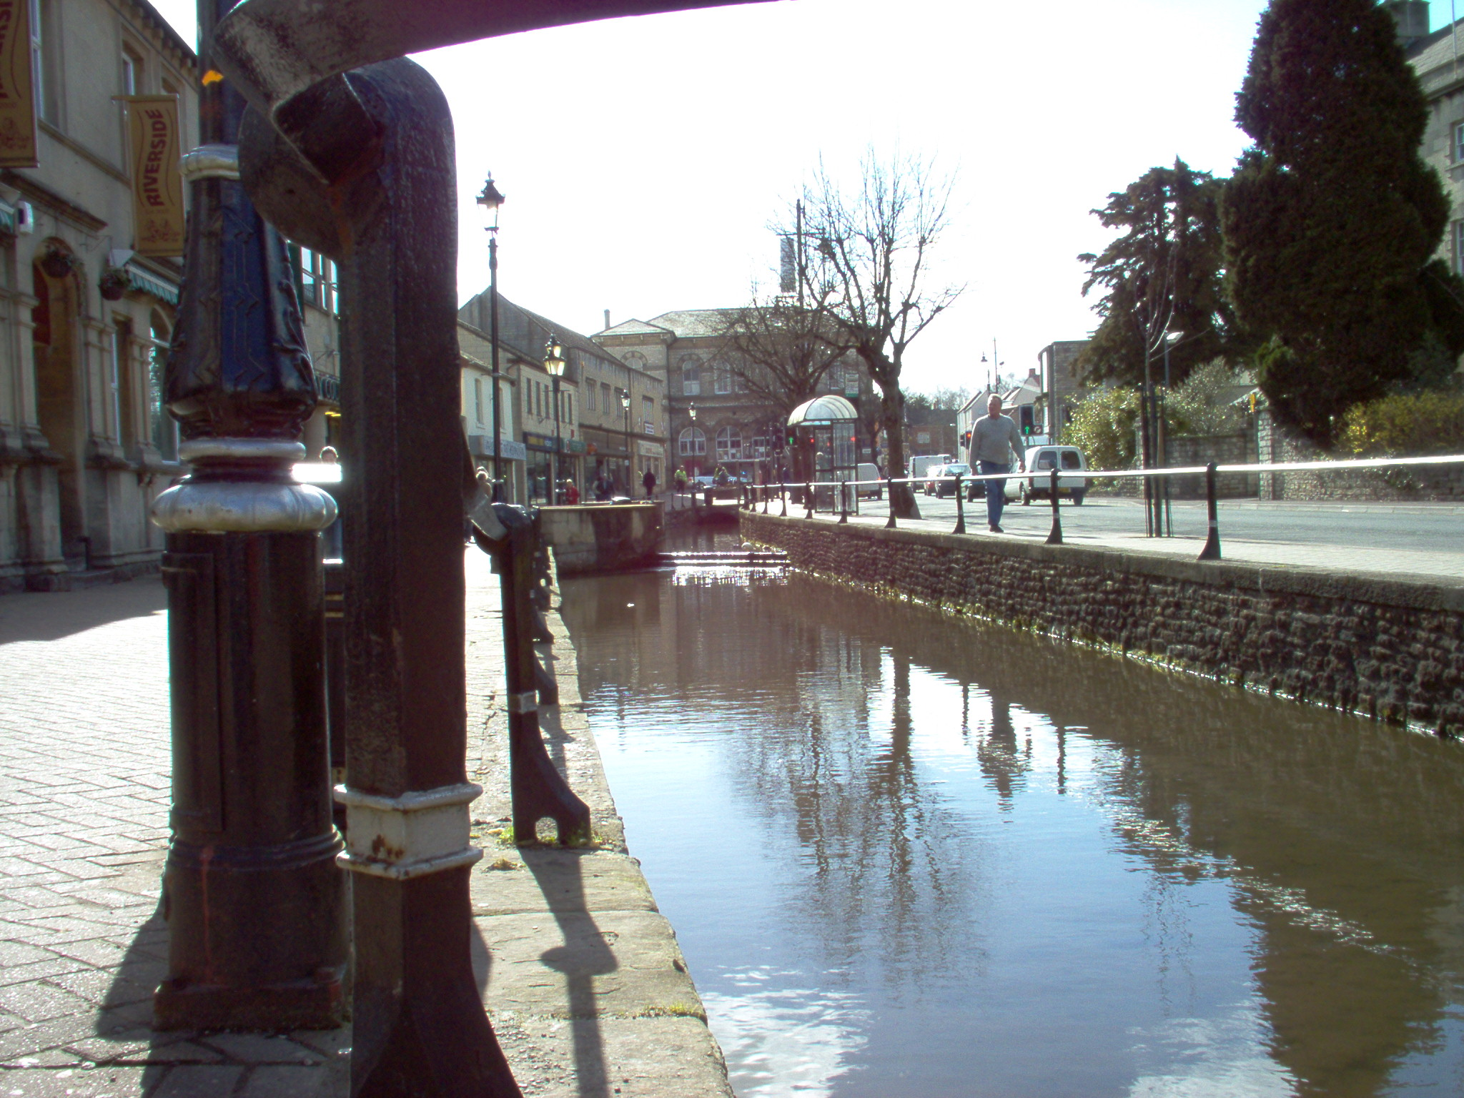

High Street, Midsomer Norton

1.3. How Does Our Plan Relate to Other Plans?

1.3.1. Various organisations and agencies have their own plans which guide what they do in our area and beyond. Our Community Plan does not seek to duplicate or replace these plans. We have taken account of existing plans and aim, through our Community Plan, to influence the plans of relevant organistations and agencies in the future. Equally, as we review our Plan we will continue to take into account these other plans.

1.3.2. Of particular significance is the Government requirement for Local Authorities to engage in community planning to produce a community strategy for their area. This is to be done through what are called Local Strategic Partnerships (LSP). These bring together key organisations, including those from the voluntary and community sector, to work together in producing and implementing a community strategy.

1.3.3. We consider that our Plan fits well with the Community Strategy for Bath and North East Somerset. We aim to continue to develop links with the strategic or ‘bigger picture’ level through the Bath & North East Somerset and Somerset LSPs.

1.4. Implementing Our Plan

1.4.1. We aim to use our Community Plan to bring organisations and agencies together to agree how they can help us implement projects and provide services in ways that will fulfil our vision and objectives.

1.4.2. Chapter 8 sets out next steps in more detail.

1.5. What’s in Our Plan?

1.5.1. This Plan belongs to the community. To be successful, it is vital that the community endorses and supports the Plan and the proposals contained in it.

1.5.2. The Plan should allow us to be better prepared to respond to issues as they arise and the ‘capacity building’ element should make us more able to respond to these challenges by building up our skills and ability to work together. Most importantly, the Plan is a way for our community to build on what’s already happening in the area, to influence decisions that are taken on our behalf and ensure that things get done!

1.5.3. However, if we want our plan to influence the decisions of local authorities and other agencies we need to take note of their own strategies. We have looked to see whether the proposals contained in these strategies match our own.

1.5.4. In the same way, the various authorities are obliged to ensure that their plans take into account the aspirations of the community. Our plan should be a great help to them in ensuring that this happens.

1.5.5. Our Plan identifies projects that have substantial community support. This will be particularly important when we approach our partners for help in delivering them.

1.5.6. In our Community Plan:

Chapter 1 – ‘Introduction’ - sets out the background, describes the plan area and provides a brief snapshot of the social & economic conditions.
- Chapter 2 – ‘The Community Planning Process’ - describes how we have consulted and worked with residents, interest groups, local authorities, other public agencies and the private sector to identify the issues and opportunities in our area.

- Chapter 3 – ‘Our Vision’ - sets out the community’s ‘vision’ for the future of the area as a whole so that we know ‘where we are going’. It also describes the ‘objectives’ we have set for the key Themes in our Plan.
- Chapter 4 – ‘Where are we now?’ - highlights the key issues and opportunities facing the community based on the consultations we have carried out and the ‘Healthcheck’ we have prepared describing the way things are in the area at the moment. The Chapter also contains an analysis of the strengths/ weaknesses/ opportunities and threats facing the area – called a SWOT analysis.
- Chapter 5 – ‘The Projects- describes the projects we hope to implement, or to have implemented in business, housing, health, leisure and the arts and transport to achieve our vision for the area.
- Chapter 6 – ‘Villages and Rural Areas’ – describes the projects we hope to implement, or to have implemented in building the community’s capacity, community safety, young people, older people, the environment and equalities to achieve our vision for the area
- Chapter 7 - ‘Next steps’ - outlines the steps we intend to take to implement our Plan, particularly the way in which we intend to organise ourselves in order to make all of this happen and how we will keep the community informed of our progress.
- Appendix 1 – A Social and Economic Snapshot – Background information about the area.
- Appendix 2 – Key Issues – information about the key issues identified during the consultation process.

1.6. The Plan Area
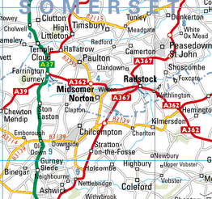

1.6.1. The area covered by our Plan is centred on the towns of Midsomer Norton and Radstock and the parishes served by the two towns - Camerton, Chilcompton, Coleford, Farrington Gurney, High Littleton, Holcombe, Kilmersdon, Paulton, Peasedown St John, Shoscombe, Stratton on the Fosse and Timsbury.

1.6.2. The area has a population of just over 46,000, covers about 8,214 hectares and lies broadly within the the circle on the map below.

1.6.3. The northern part of the Plan area is in Bath and North East Somerset (B&NES). The southern part, including Chilcompton, Stratton on Fosse, Holcombe, Coleford and Kilmersdon are in the Mendip District Council area of Somerset.

1.6.4. As the crow flies, the Plan area is c13km from Bath and c20km from Bristol.

1.6.5. Although the area has no immediate access to the national motorway network - the M5 lies some way to the west and the M4 runs north of Bath – the A37 trunk road which runs north to Bristol and the Midlands and south to Exeter and the south west is only five kilometers from Midsomer Norton and the A367 passes through Radstock on its way north east to Bath.

1.6.6. Midsomer Norton & Radstock are not now connected to the national rail network. However, Bath Spa and Frome stations are within 15 km and both are served by direct bus routes.. Bristol International Airport lies only 13km to the west.

1.6.7. Midsomer Norton & Radstock are situated in rolling countryside at the confluence of three streams. The main one, the River Somer runs along Midsomer Norton High Street. The streams become the Wellow Brook further east and join the Avon at Monkton Combe south east of Bath.

1.7. A Brief History

1.7.1. Both Midsomer Norton and Radstock were originally agricultural market and rural service centres which, from the mid 18th century onwards, became mining towns at the heart of the North Somerset Coalfields.

1.7.2. Mining was continuous in the area from 1763 to 1973 when the last collieries closed.

1.7.3. Because most of the ‘batches’ associated with coal mining have been landscaped, it is hard to believe that at one time there were more than fifty collieries serviced by tramways, railways and canals in the countryside around Radstock.

Midsomer Norton

1.7.4. Midsomer Norton, population c16,250, is an ancient market town dating back to Medieval times. It contains one of the oldest houses in the area, now the Old Priory Hotel & Restaurant, as well as a 15th Century Tithe Barn which now houses the Catholic Church.

1.7.5. Midsomer Norton’s historic core, which dates from the 12th century foundation of The Priory, runs along the River Somer. The town has held regular markets and fairs from medieval times.

1.7.6. Since the decline in coal mining there has been a steady expansion of new employment in the area in shoes, textiles, and paper, printing and packaging together with new private residential development driven by the twin factors of the town’s location outside the Bristol-Bath Green Belt and relatively good access to employment.

1.7.7. With the exception of the closure of the Clark’s shoe factory in 1996, the town has suffered rather less from industrial rationalisations than other parts of the region and still has a thriving core of local manufacturers. However, new local employment creation has not kept up with the growth in housing.

Radstock

1.7.8. Radstock, population c5,400, is a former mining and railway town located on the Fosse Way. Once known as the ‘powerhouse’ for Bath, Radstock has been described by English Heritage as the ‘best preserved former mining town in the country.

1.7.9. Radstock, set in some of the most beautiful Somerset countryside was, for many years the centre of the North Somerset Coalfield and the activities associated with coal mining dominated the town.

1.7.10. Two separate railway companies operated in Radstock for many years. The Somerset & Dorset Railway ran from Bath’s Green Park Station to Evercreech Junction and Poole and the Great Western Railway route ran from Bristol to Radstock and on to Frome.
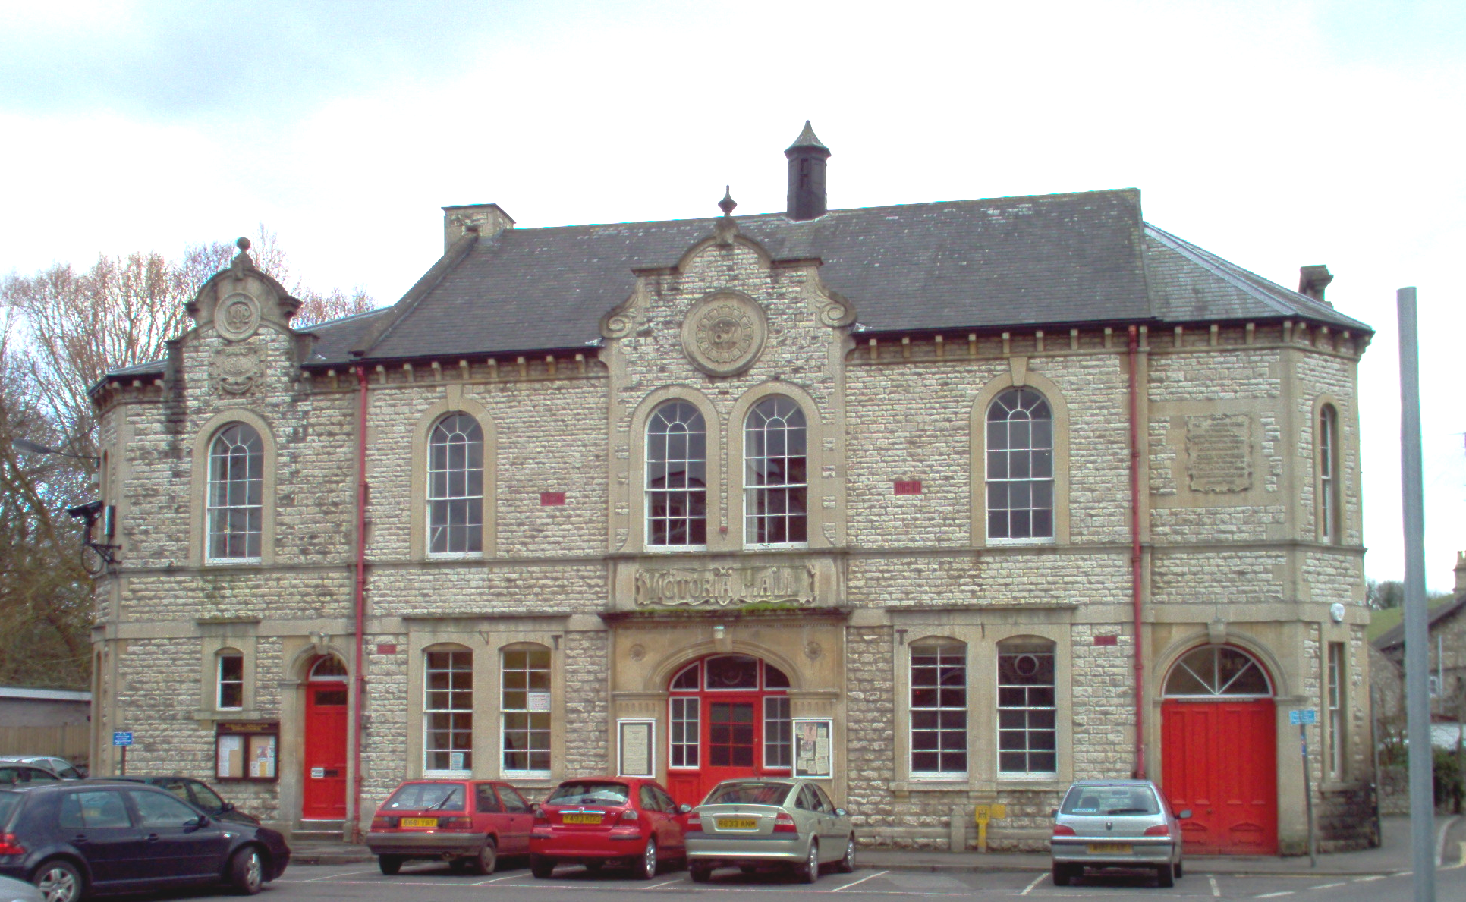

Victoria Hall, Radstock

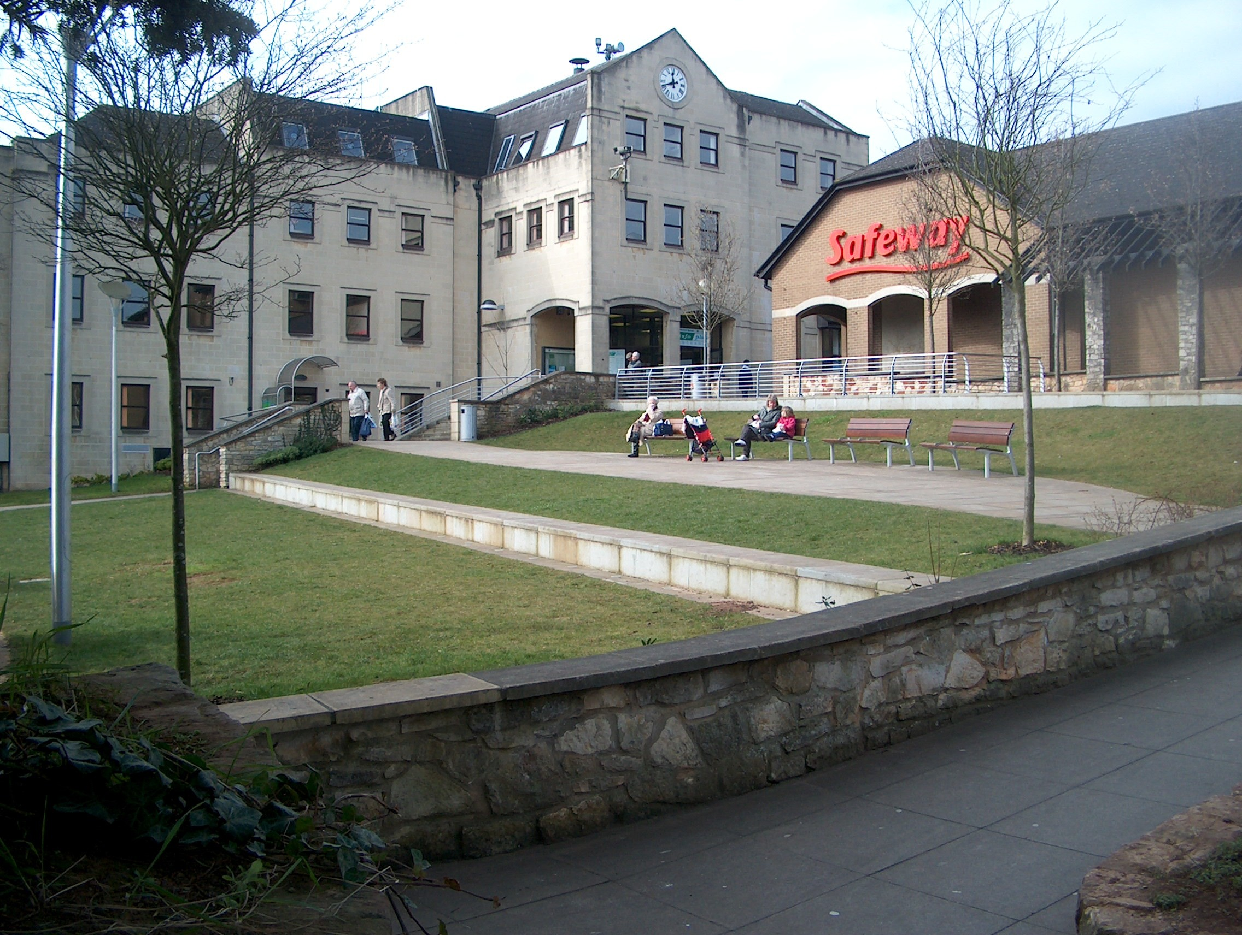

Hollies Gardens, Midsomer Norton

    - Although Radstock life was dominated for over two hundred years until 1973 by coal mining, railways and associated small-scale engineering and craft industries, the town and village communities have retained a close relationship with the surrounding rural environment.

2 The Community Planning Process

2.1. Community Planning Process

2.1.1. Our Community Planning process is divided into three broad stages:
- Stage 1 – Consisted of consultations with the local community, and our own research, to create a ‘vision’ for the future of the area and to identify the key issues that concern the community.

- Stage 2 – Involved the preparation of a detailed Community Plan for the area which identified specific projects, programmes and activities that should help to achieve our vision for the area

- Stage 3 – In Stage 3 we will work to implement the projects contained in the Community Plan

2.1.2. The publication of our Community Plan brings us to the end of Stage 2 of the MCTi process.

2.2. How have we worked with the community and others to prepare our plan?

2.2.1. The process, set up through the Market and Coastal Towns Initiative is community led, to produce a Plan for the area that will help to turn our vision of a thriving community into reality.

2.2.2. Although this is our first attempt at preparing a Community Plan through the MCTi process, local people have, in the past, been involved in a number of regeneration initiatives and projects including the Single Regeneration Budget (SRB) Programme in Midsomer Norton & Radstock and the resultant work of the Norton Radstock Regeneration Company (NRR).

2.2.3. We were also able to draw on informaton audits and Topic and Community Profiles.

2.2.4. Our Plan has to take into account other Plans that are in place, or are being developed by Local Authorities and other agencies and we have done our best to do this.

2.2.5. We asked an independent consultant to hold initial discussions with key officers, councillors and local people as a first step in bringing people together to consider the long-term future of the area.

2.2.6. The second step was to hold a workshop in February 2003 at which groups, organisations and individuals could share views and ideas. Further workshops were held in March and April 2003 when a draft plan to take things forward was adopted and a Steering Group established to move things forward.

2.2.7. We also appointed local people as part time Community Agents and undertook consultation across the area using questionnaires, open meetings and interviews. The Community Agents worked within communities to help ensure that people often excluded from consultations had their say.

2.2.8. We have involved many local people, local groups, businesses and local councils in developing the ideas that have come together in our Community Strategic Plan. This has included open public partcipation events. The community as a whole has been able to participate in preparing and agreeing the plan and in making it happen.

2.2.9. To help us prepare our plan we have received funding from SWRDA and from B&NES, including £3,000 to support a number of small scale Community based ‘Ready to Go’’ projects.

2.2.10. The themes and priorities in this plan all come directly from this community based consultation process.

2.3. The Midsomer Norton and Radstock Steering Group

2.3.1. The Steering group has fourteen members representing a wide cross section of the community. A list of members is shown in appendix 3.

2.3.2. The Group meets every month and has overall responsibility for developing and delivering the Community plan.

2.3.3. The broad representation that we have on the Steering Group has allowed us to build up close working relationships with other organisations in the area such as the Norton Radstock Town Council, Midsomer Norton and Radstock Chamber of Commerce, Bath and North East Somerset Council, the Primary Care Trusts, Police, Schools and local community organisations

2.3.4. All of these contacts and relationships will be vital when we come to implement our plan.

2.3.5. The Steering Group which is leading the plan has also involved existing local groups already working on proposals e.g. developing the town centres. We have set up meetings, involving local people interested in the future of our area, to identify particular problems and opportunities facing the community in the areas of health, employment, leisure, transport, environment, and sport as well as the particular needs of older and younger people and equalities groups.

2.4. Theme Groups

2.4.1. It was not possible to discuss every topic in sufficient depth at large public meetings. Accordingly we have worked with a number of Groups with the specific task of considering in detail a particular aspect of the plan and then bringing forward ideas and proposals to the Steering Group for prioritising.

2.4.2. Brief ‘Topic’ Papers were prepared highlighting the key issues in the area for:
- The Arts
- Economic development
- Farming
- Health and social issues
- Housing
- Strategic Planning and regeneration framework
- Tourism
- Sustainable economic development framework
- Transport
- Young people and children

2.4.3. The Groups met as often as was required to complete their part of the Plan. In practice it was sometimes difficult for groups to maintain momentum and meetings over time, so in some cases we have relied on other methods of consultation and developing project ideas at the public meetings to highlight our priorities.

2.5. Publicity and Communication

2.5.1. We have tried to keep the general public informed of the progress of our plan by articles in the local press, producing our leaflet and by visits to parishes. Details of our consultations are contained in our ‘Consultations Scrapbook’ …

2.5.2. In June 2004 we held a well-attended public open meeting to discuss our ideas.

2.6. The Parishes

2.6.1. An important part of our plan making has been to ensure the inclusion of the rural areas surrounding Midsomer Norton & Radstock.

2.6.2. We have completed community profiles for each of the parishes in our Healthcheck. These provide a ‘snapshot’ of each parish and key issues affecting residents lives.

2.6.3. We have consulted the Parish Clerks of all of the parishes in the area for advice on the issues and actions that should be included in the Plan. Chapter 6 – ‘Working Together’ – summarises how we have addressed`issues for our rural areas.

2.6.4. Our Community Agents also undertook consultation with people living and working in the parishes

2.7. Capacity Building

2.7.1 An important part of the MCTi process is the emphasis placed on what is called ‘capacity building’.

2.7.2. Capacity building simply means encouraging and helping the community to develop the range of skills which it will need to implement its Community Plan.

2.7.3. These skills include being able to:

Analyse the social and economic situation in an area and to suggest ways in which the area may be improved by redirecting existing local and central government programmes or by undertaking new projects

Comment on, and change if necessary, public and private sector projects that are proposed for the area and

Put together robust proposals for new projects and programmes that may need external funding

2.7.4. Being part of the MCTi has helped Midsomer Norton, Radstock and the surrounding parishes to prepare a credible Community Plan that should encourage private and public investment in the area in such a way as to achieve the community’s ‘vision’ of the future.

2.7.5. The availability of public and private sector investment will be important in the area’s regeneration. This includes the redirection of local and central government resources as well as the attraction of additional money for new projects.

2.7.6. It is unlikely that improvements will happen overnight. They are likely to evolve over several years and involve all sections of the community, the private sector and the many different agencies that currently operate in the area.

2.7.7. The Steering Group cannot achieve the vision working on its own. Although it may promote some projects, much of the Steering Group’s effort will be to encourage other parties in the private and public sectors to change their existing investment plans or to undertake, or invest in new projects.

2.7.8. Although it is hoped that the community’s long-term vision for the area will be consistent over the next ten to twenty years, the Community Plan will be reviewed and updated regularly, so that new issues and opportunities may be assessed as and when they arise.

2.7.9. The next steps are to ensure that the local community supports this, our first Community Plan and to take forward the implementation of the projects and programmes contained within it.

2.8. Ready to Go projects

2.8.1. The Steering Group has used some of its overall budget to build community capacity by supporting a range of small scale, low cost, community based activities that generate a positive community profile for MCTi and to encourage a wider and deeper interest in the MCTi process and the Community Plan itself.

2.8.2. The Ready to Go scheme also provides an incentive to us by demonstrating that MCTi delivers something immediate and practical and giving us first hand experience of formally evaluating proposals and requests for financial assistance

2.8.3. A total budget of £3,000 was allocated to Ready to Go with the MCTi Steering Group seeking applications for grants of up to £250.

2.8.4. Ready to Go has achieved its objectives and provided good practical experience for the Steering Group.

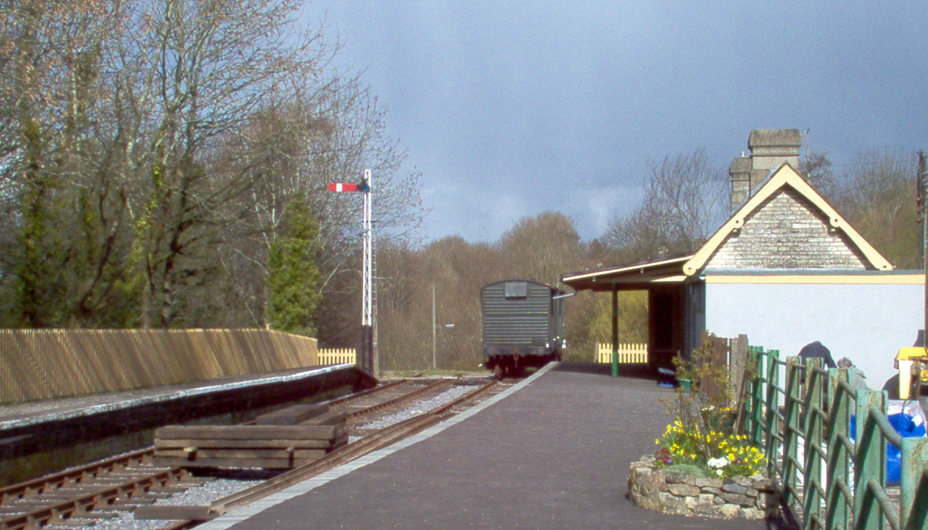

Somerset & Dorset Railway Heritage Trust – Midsomer Norton South Station

2.8.5. The following local community organisations have received ‘Ready to Go’ funding:

Somerset & Dorset Railway Heritage Trust

P.R.I.D.E – Partnership for Racial Identity of Diverse Ethnicities

Paulton Senior Youth Group

Radstock Youth Centre

Welton Dads ‘n’ Lads (Lasses)

Manic Skaterz

Pratten Westfield Amateur Sports Club

Noahs Ark Pre-School

F.A.S.T. (Frederick & Albert Avenue, and St Johns Close Community Group)

F.A.S.T. Community Group – Music Event

Timsbury Postnatal Group

Camerton Youth Club – sports initiative

Chilcompton PreSchool Playgroup

Shoscombe Village Hall

Coleford Village Sign

3 Our Vision

3.1. Why do we need a vision for Midsomer Norton & Radstock?

3.1.1. To be successful in preparing and implementing our Community Plan, we needed to know what kind of place we would like Midsomer Norton, Radstock and the surrounding areas to be in the future. We also needed to know where our community is at present.

3.1.2. The first of these is our ‘Vision’ for the area - our Plan looks ten years into the future – to 2015. The second is the ‘Healthcheck’ we have prepared comprising the ‘Community Profiles’ and the ‘Topic Papers’ – which are a ‘snapshot’ of what our area is like at present; the outcomes of our community consultations, the strategic review and other existing relevant strategies. The Plan also includes more up to date information that is not in these papers.

3.1.3. With this information we are in a position to decide what needs to be done to get from where we are today to where we want to be in ten years time.

3.1.4. Knowing where we have come from will also help us measure where we have got to and just how well we are doing!

3.2. Our Vision for Midsomer Norton, Radstock and the surrounding area

3.2.1. Following public consultation and discussion we have adopted the following ‘Vision’ of the area to help guide our decisions on the projects we wish to see implemented:

We envisage a thriving and vibrant area with a sense of well-being, its own identity and promoted as a whole, with Midsomer Norton and Radstock as the focus. Facilities in Midsomer Norton and Radstock will be available and accessible by the communities in the surrounding villages. Village communities will have the support and resources necessary to develop solutions to their particular needs”

3.2.2. As well as our overall “vision” for the area, we have also adopted a vision for each of the main “themes in our Plan.

The themes are:
- Businesses and the local Economy
- The Town Centres
- The Environment
- Transport
- Public Services
- Housing
And three that cross cut all the others – Community Safety, Equalities, Sustainability.

Businesses and the Local Economy

3.2.3. A successful economy is the bedrock on which our ambitions for the area will be founded. Successful businesses are a fundamental ingredient of a strong and robust economy. Our vision is:
To be economically competitive and diverse: supporting new and existing innovative, sustainable businesses;
creating new, high quality, sustainable employment opportunities for local people.
ensuring that money stays within the local economy and encouraging the use of local people and services;
with economically self sufficient and sustainable towns;
with a thriving tourism industry as an integral part of our economic well-being;

Town and Village Centres

3.2.4. Our town cnd village centres are focal points for the community. The quality of the centres of our towns and villages are an outward manifestation of the well-being of the local community. Our vision is:
To develop Midsomer Norton, Radstock and Village centres as distinctive, complementary, prosperous, vibrant, attractive and safe centres for the benefit of residents, shoppers, visitors, tourists and the business community capitalising on the areas key strengths of strong community, attractive environment and good location:

To develop Midsomer Norton’s role as the market town for the area by consolidating and enhancing the retail offer, the range of available leisure and community facilities and transport links and the creation of new employment opportunities

To develop and enhance Radstock’s role as a local service and employment centre and focal point for the community, by reinforcing and enhancing retail provision and community facilities, expansion of tourism and small business enterprise, and providing for more people to live in the centre, particularly through the opportunities presented by the regeneration of the vacant railway and other land

The Environment

3.2.5. An attractive natural and built environment is an important component of a high quality of life for residents. Our vision is:

To see a clean, pedestrian friendly, tidy environment, which builds on the assets of the built environment and the outstanding landscape and environmental quality of the area by,

the protection and conservation of the existing landscape and high quality uilt environment;

enhancement of areas of poor environment;

good management of the built and natural environment;

sustainable use of resources.

Transport

3.2.6. Transport, particularly public transport, is a vital ingredient in the success of any area. Our vision is:
To have a transport system that lowers congestion, and improves the connections between towns and villages in the area and the facilities and the places where people work – including the wider area. Such a system should be affordable and encourage independence’.

Public Services

3.2.7. The quality of life to be enjoyed in the area will depend partly on the level and quality of the services and facilities available. Our vision is:

Health, education, leisure and cultural facilities that all sections of the community ‘owns’ and wants to use. The facilities should link multiple uses and be readily accessible to all sections of the community including the young, the aged, and people with special needs.

Housing

3.2.8. We believe that all members of the community should have housing adequate for their needs. Our vision is:

To ensure the provision of good quality, balanced and well managed stock of private and public housing of the right type, size and price, in the right locations to meet the present and future needs of the community.’

3.3. Cross cutting issues

Community Safety, Equalities, Sustainability
3.3.1. There are certain aspects of community life that should apply to all activities. Our plan will seek to ensure that all actions proposed take into account:
- The safety of all sections of the community
- The needs of ethnic minority groups within our community
- The needs of people with disabilities
- The principles and practice of sustainable living.

4 Where are we now?

4.1. Our Starting Point

4.1.1. Having set out our Vision for the future we need to find out where the area is at present so that we could decide what needs to be done to achieve our vision.
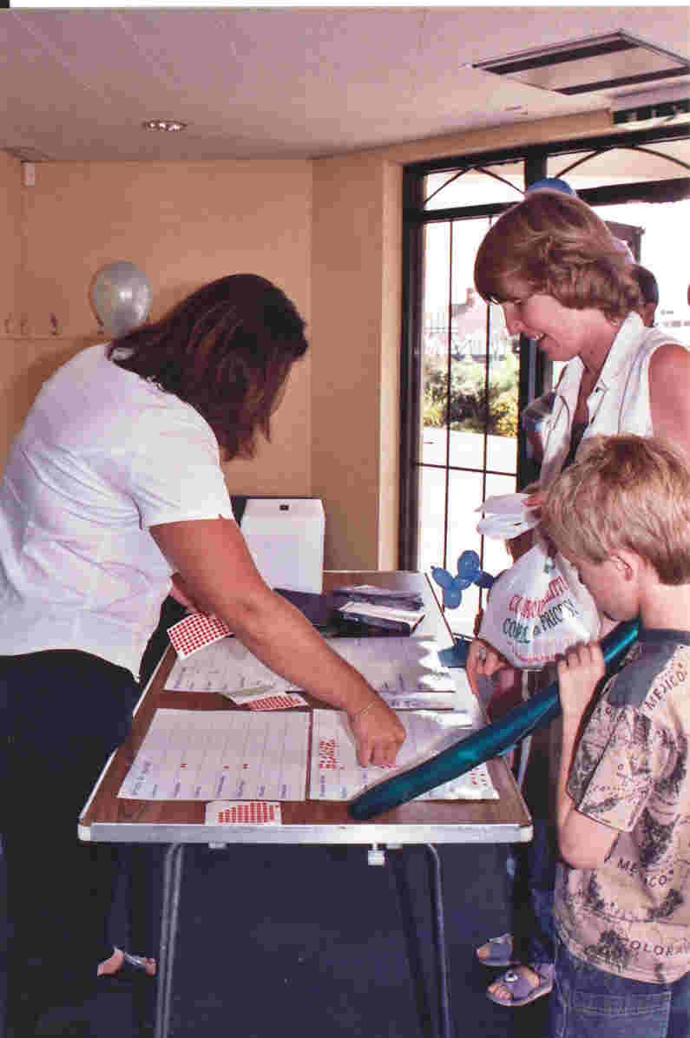

Public Event – June 2004

4.1.2. We did this in four main ways:

By consulting the resident and business communities

By undertaking a detailed ‘Healthcheck’ to look at the facts and figures for the area

By studying the various plans and strategies for the area prepared by the public and private sectors to identify what they intend to do in the area over the next few years

By asking our Theme Groups to look at particular issues in some depth

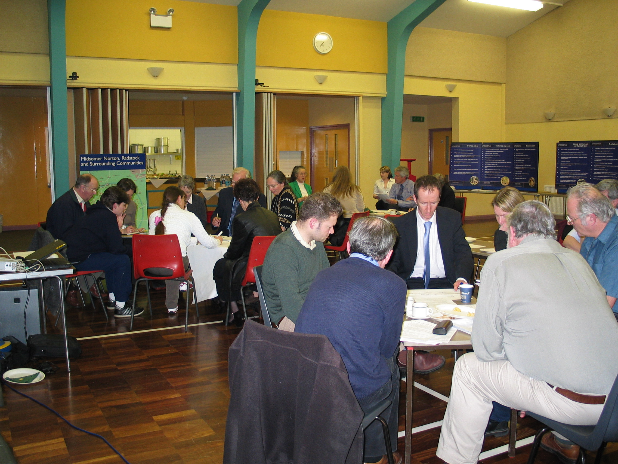

Public Event – March 2004

4.1.3. This chapter summarises the key issues that concern the community about the future of the area under four headings:
- Economy
- Environment
- Social and Community
- Transport

And looks at the areas strengths and weaknesses, the threats the area faces and the opportunities that exists to secure and enhance its future – known as a SWOT analysis.

4.1.4. A fuller description of the key issues is contained in appendix 2
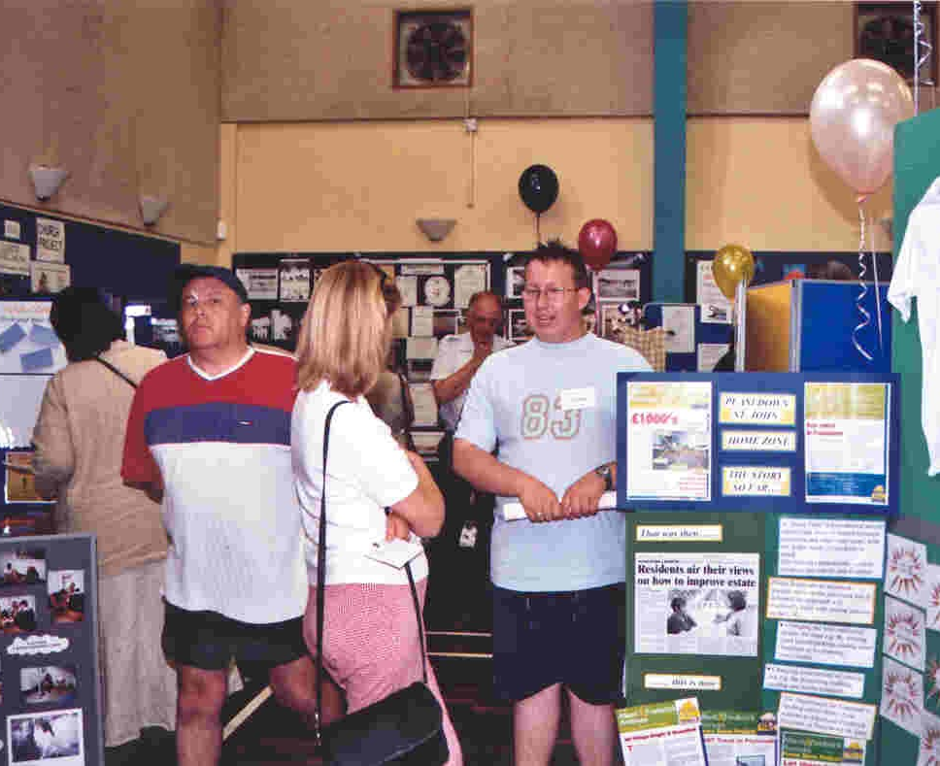

Public Event – June 2004

4.1.5.

Key Issues Summary

Economy

Employment
- Employment opportunities have not kept pace with residential development
- Local economy still dependent on a small number of large employers
- Significant sectors of the local economy are likely to shed jobs in the future.

Business sites and premises
- No proper ‘ladder’ of sites and premises on which to develop and grow.
- Sites and buildings allocated for business use may be lost for housing
- Business advice and support patchy across the area
- Social enterprises do not get enough support.

Skills
- Literacy and numeracy skills are low in parts of the area
- Workforce may not have the skills required by new businesses

Town Centre Retailing
- Lack of national multiples and quality comparison shopping
- Poor quality of the public realm and the dilapidated condition of many of the buildings in Midsomer Norton and Radstock.

Tourism
- Area does not benefit enough from tourism
- Poor visitor infrastructure and image,

Farming
- Local farming is in decline

Environment
- Community fear that environment is not protected

Social and Community
- Families are not fully engaged in community decision making process

Young people
- Inadequate attention paid to the requirements of young people

Housing
- Insufficient affordable housing for local people
- Insufficient appropriate housing ccommodation for elderly people particularly
- Concern that the demand for housing sites may cause the loss of employment land
- Economic development has not kept pace with housing provision

Health
- Community do not feel that access to services is equal across the Plan area

Sport, Leisure & Open Space
- Existing sports and leisure facilities are inadequate

Arts
- Local community not fully engaged in arts activities

Transport
- Transport proposals are not strategic enough
- Traffic volume, congestion and its impact on the environment
- Poor transport links to and from the rural areas and villages and Norton Radstock
Community Safety
- Youth disorder and anti-social behaviour
- Crime against Shops and Businesses

4.2. SWOT Analysis

4.2.1. The SWOT analysis which looks at the strengths/ weaknesses/ opportunities/ threats to the area is a way of analysing the prospects of the area
Strengths:  What advantages does the area have?  What is attractive about the area?  What relevant resources does the area have?  What do other people see as the area’s strengths? | Weaknesses:  How could the area be improved?  What is unattractive about the area?  What should the area not try to do?
Opportunities:  Where are the opportunities in the area?  What are the trends that could benefit the area? | Threats:  What obstacles does the area face?  What will compete with its attempts to be successful?

Strengths | Weaknesses
Midsomer Norton & Radstock are major retail and service centres | Poor quality built environment in parts of the town centres
Attractive location for companies | Poor access to national transport network
Attractive area to live in | Over reliance on a small number of industries
Attractive natural environment | Lack of skills training
Successful and attractive villages | Poor access to/from villages to Midsomer Norton & Radstock
Retail vacancy rates lower than national average | Traffic congestion in towns and villages
Supportive local authorities and NRR | Petty crime, drugs and vandalism
Competitive rent levels | Limited retail offer & lack of restaurants
Active partnership structure | Poor range of leisure facilities.
The skills of our community, groups and agencies | Educational attainment low
Free off & on street parking | Large residential areas without adequate facilities
Strong community spirit and local identity | Length of stay of shoppers is short
Greenway links. | Communities unaware of what is going on in the area.
Industrial & other Heritage | Lack of information about customer perception
Strong presence of local independent traders | Poor understanding of ethnic minorities in the area
Opportunities | Threats
Local to green belt and Bath - can attract businesses | Projected loss of manufacturing jobs
Local to green belt and Bath - can attract new residents | Loss of sites for business to housing
Redevelopment opportunities in both Town Centres | Traffic growth and congestion
Investors willing to invest in area | Community complacency and business apathy
Fine buildings with potential for improvement. | Deterioration and under investment in buildings.
River in Midsomer Norton under - utilised. | Anti-social behaviour
Possible further funding opportunities through MCTi and other programmes | Increasing competition from other towns.
Development of evening economy in Midsomer Norton. | Impact of out of town retailing on Midsomer Norton.
Conservation area designation for Midsomer Norton.
Norton Radstock Regeneration Company – development of former railway land/future role.

5 The Projects

5.1. Achieving the vision and addressing the key issues

5.1.1. Our Community Plan sets out a series of Projects that tackle the issues we have identified and help to build the vision we have set out for the area

5.1.2. The Projects are divided into three categories:

1 - Topics which deal with specific areas for action

2 - Cross-cutting Themes which should be considered as part of every project we propose or support in the Plan

3 - Issues affecting the villages and rural areas

Topics
Transport
Rural
Areas
Community Capacity
Leisure/
Arts/ Sport
Community Safety
Young People

Older
people

Environment

Equalities

Town Centres
Housing

Economy

Our Community Strategic Plan

Cross-cutting

5.2. Priority Projects

5.2.1. All the projects included in the plan are important and have the full support of the Steering Group.

5.2.2. However, amongst the total projects, the Steering Group have identified five priorities. They are (in no order):
- Midsomer Norton Skate and Bike Park
- Victoria Hall (feasibility study)
- Somer Centre (feasibility study)
- Midsomer Norton and Radstock Town Park
- Norton Radstock Regeneration Company (NRR)/ Radstock former Railway Land redevelopment

5.2.3. The first four are priorities for the Steering Group because there is an important role for it (or any successor) in driving them forward. The fifth is a priority because of its strategic significance and immediate high importance to the community. More detail on the significance of these projects is set out below.

5.2.4. Skatepark: the aspiration to create a high quality skatepark for young people in the area goes back over 10 years. The level of demand and need has been well demonstrated and plans for the park are at an advanced stage – funding is the crucial element. The proposed park would provide a top quality facility for young people and give the area an attraction of national significance. The project is well founded in the community and the steering group feels that MCTi can and should help to make it happen.

5.2.5. Victoria Hall (feasibility study): Victoria Hall has been providing community facilities for the people of Radstock for over one hundred years. It is also a proud symbol of Radstocks identity and heritage. The future of the building is now uncertain – its facilities increasingly falling below the standards we expect today. The easy choice would be to close it and see it redeveloped for commercial purposes, and unless a viable alternative can be found this is what will probably happen. The Steering Group believes that every stone should be turned to find a future for Victoria Hall as a Community facility with a renewed purpose and of the highest standard.

5.2.6. The Somer Centre (feasibilty study): this well used, centrally located Community Centre is owned by B&NES Council, but run by Midsomer Norton Community Association. The Community Association wants to take a 21 year lease on the building and has ambituous ideas to expand the building and to develop it as a community “hub” to be used by a variety of community groups and public agencies providing a wide range of services to an equally wide range of users. The Steering group applauds the vision and commitment of the Midsomer Norton Community Association and wants to support it in producing a comprehensive feasibility study to identify a detailed proposal and its commercial viability.

5.2.7. Midsomer Norton and Radstock Town Park: Midsomer Norton and Radstock are surrounded by beautiful countryside. Yet the Towns themselves do not possess a significant civic green open space. The lack of such a space is well documented and recognised by the relevant authorities. There is a suitable area to create such a space, which we believe could be achieved reasonably easily and without great cost. As well as providing a much needed civic amenity, the Town Park would also physically link the two towns and the important residential and commercial area of Westfield. The Steering Group would like to see MCTi help take these aspirations forward to reality.

5.2.8. NRR/Redevelopment of former Railway Land: this important area of land (7.3 ha/18 acres) has blighted the centre of Radstock for over 30 years. Its redevelopment holds the key to the revitalisation of Radstock town centre. The land is now in the ownership of a not-for profit community influence company, The Norton Radstock Regeneration Company (NRR). The Steering Group views this as a key project in enhancing the market towns and their role in serving the community. It endorses the principle of a high quality mixed use development and wishes to support NRR and its partners in achieving this plus the establishment of a long term strategy for the whole town centre, and a potential future wider role for NRR that will benefit the community of Norton Radstock.

5.3. The Projects – Full list

5.3.1. A full list of projects endorsed and supported by the MCTi Steering Group

5.3.2. In this Chapter, we describe the projects we propose for each Topic Theme. In Chapter 5 we describe the projects that we believe will address our Crosscutting Issues and in Chapter 6 we identify issues affecting the rural areas.

5.3.3. We have have prioritised the actions we propose and because a project or action may make a contribution in a number of Theme areas, we have grouped the projects and actions under three headings:

Proposed Actions- which are actions we endorse or support

Complementary Actions - are actions which will contribute to a number of Themes

Other Actions - are actions that have been suggested in our consultations, but which have not yet been fully developed into projects.

5.3.4. In Chapter 3 we said that we hoped to achieve our objectives by:

Identifying, endorsing and supporting in our Plan projects and programmes currently proposed by the public and private sectors that we believe will help to achieve our vision and objectives

Suggesting how current projects and programmes might be changed, improved or redirected to achieve a better ‘fit’ with the community’s vision and objectives

Bringing forward new projects and programmes in areas where little or no action is currently proposed

Seeking finance to create or undertake projects and programmes ‘at our own hand’

Contributing to suitable projects where we are able to

Seeking to change, or have abandoned, projects or programmes which are not in the community’s interest”.

5.3.5. We are keenly aware of the issues our area faces – decline in manufacturing, the need to re-position the skills of our workforce to attract new industries and businesses, the unattractive town centres with a poor range of shopping and the lack of affordable housing, particularly in the rural areas. Nevertheless the next ten years represent a unique opportunity for the Midsomer Norton & Radstock area.

5.3.6. We are delighted to have the support and interest of many agencies and organisations such as Norton Radstock Town Council, Parish Councils, B&NES, Mendip District Council, Midsomer Norton & Radstock Chamber of Commerce, Norton Radstock Regeneration Company, Avon and Somerset Police and Business West

5.3.7. Employment is always a key element in any Plan. The proposals to develop an economic development strategy and task force to target the area are particularly welcome.

5.3.8. We believe that tourism has much more to offer our community and we welcome the Chamber of Commerce initiative in this area and the support for the farming community.

5.3.9. To maintain a thriving community, good quality shops, services and facilities must be available locally. Our Plan seeks to develop the range and quality of the shopping in the area particularly in the centres of Midsomer Norton and Radstock and to improve the shopping environment. We intend to support a number of initiatives aimed at improving these two centres. It will be important that we work closely with those who will take these initiatives forward to avoid duplication of effort and to ensure that the actions proposed are complementary.

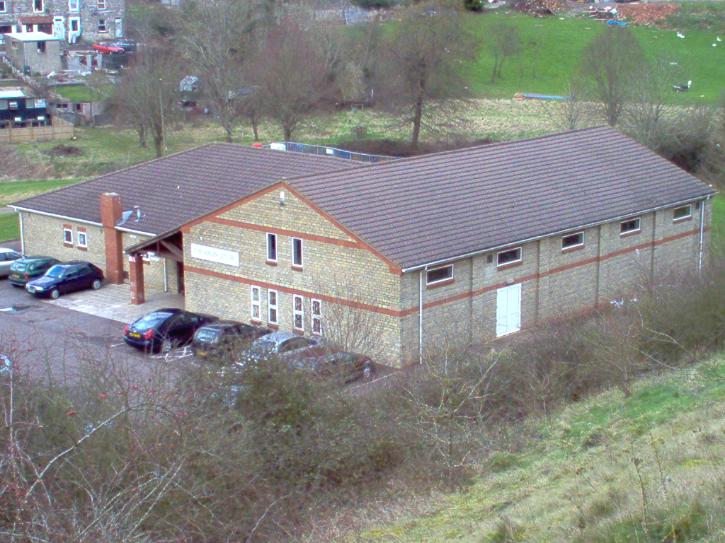

The Somer Centre

5.3.10. We are particulary pleased to be able to support the efforts of The Norton Radstock Regeneration Company in the work to develop the former Radstock Railways land.

5.3.11. Our plan also celebrates the many local community initiatives that provide healthcare services and learning opportunities to older people, young people and families in the area. We want to support these initiatives and help them to develop.

5.3.12. In rural and semi-rural areas roads and public transport are always an issue. We look forward to working with the transport authorities to review and improve that transport arrangements in our community.

5.3.13. It is not possible for us to guarantee the delivery of everything that is in our Plan. However we believe that our Plan is an expression of the community’s aspirations, desires and hopes for the area and it is important that those organisations and individuals in both the public and private sectors who may be responsible for delivering parts of our vision are aware of the community’s aspirations when preparing their own plans and programmes.

5.3.14. However, there are projects for which we intend to seek finance in order to implement them ourselves. In this case it is important that these projects and programmes have a sound basis in consultation and evidence if we are to convince those who might provide the finance of the value of our projects.

5.3.15. If the whole community can work together with our Partners in the various organisations which already invest heavily in our area we are convinced that the community’s vision for the area can be achieved.

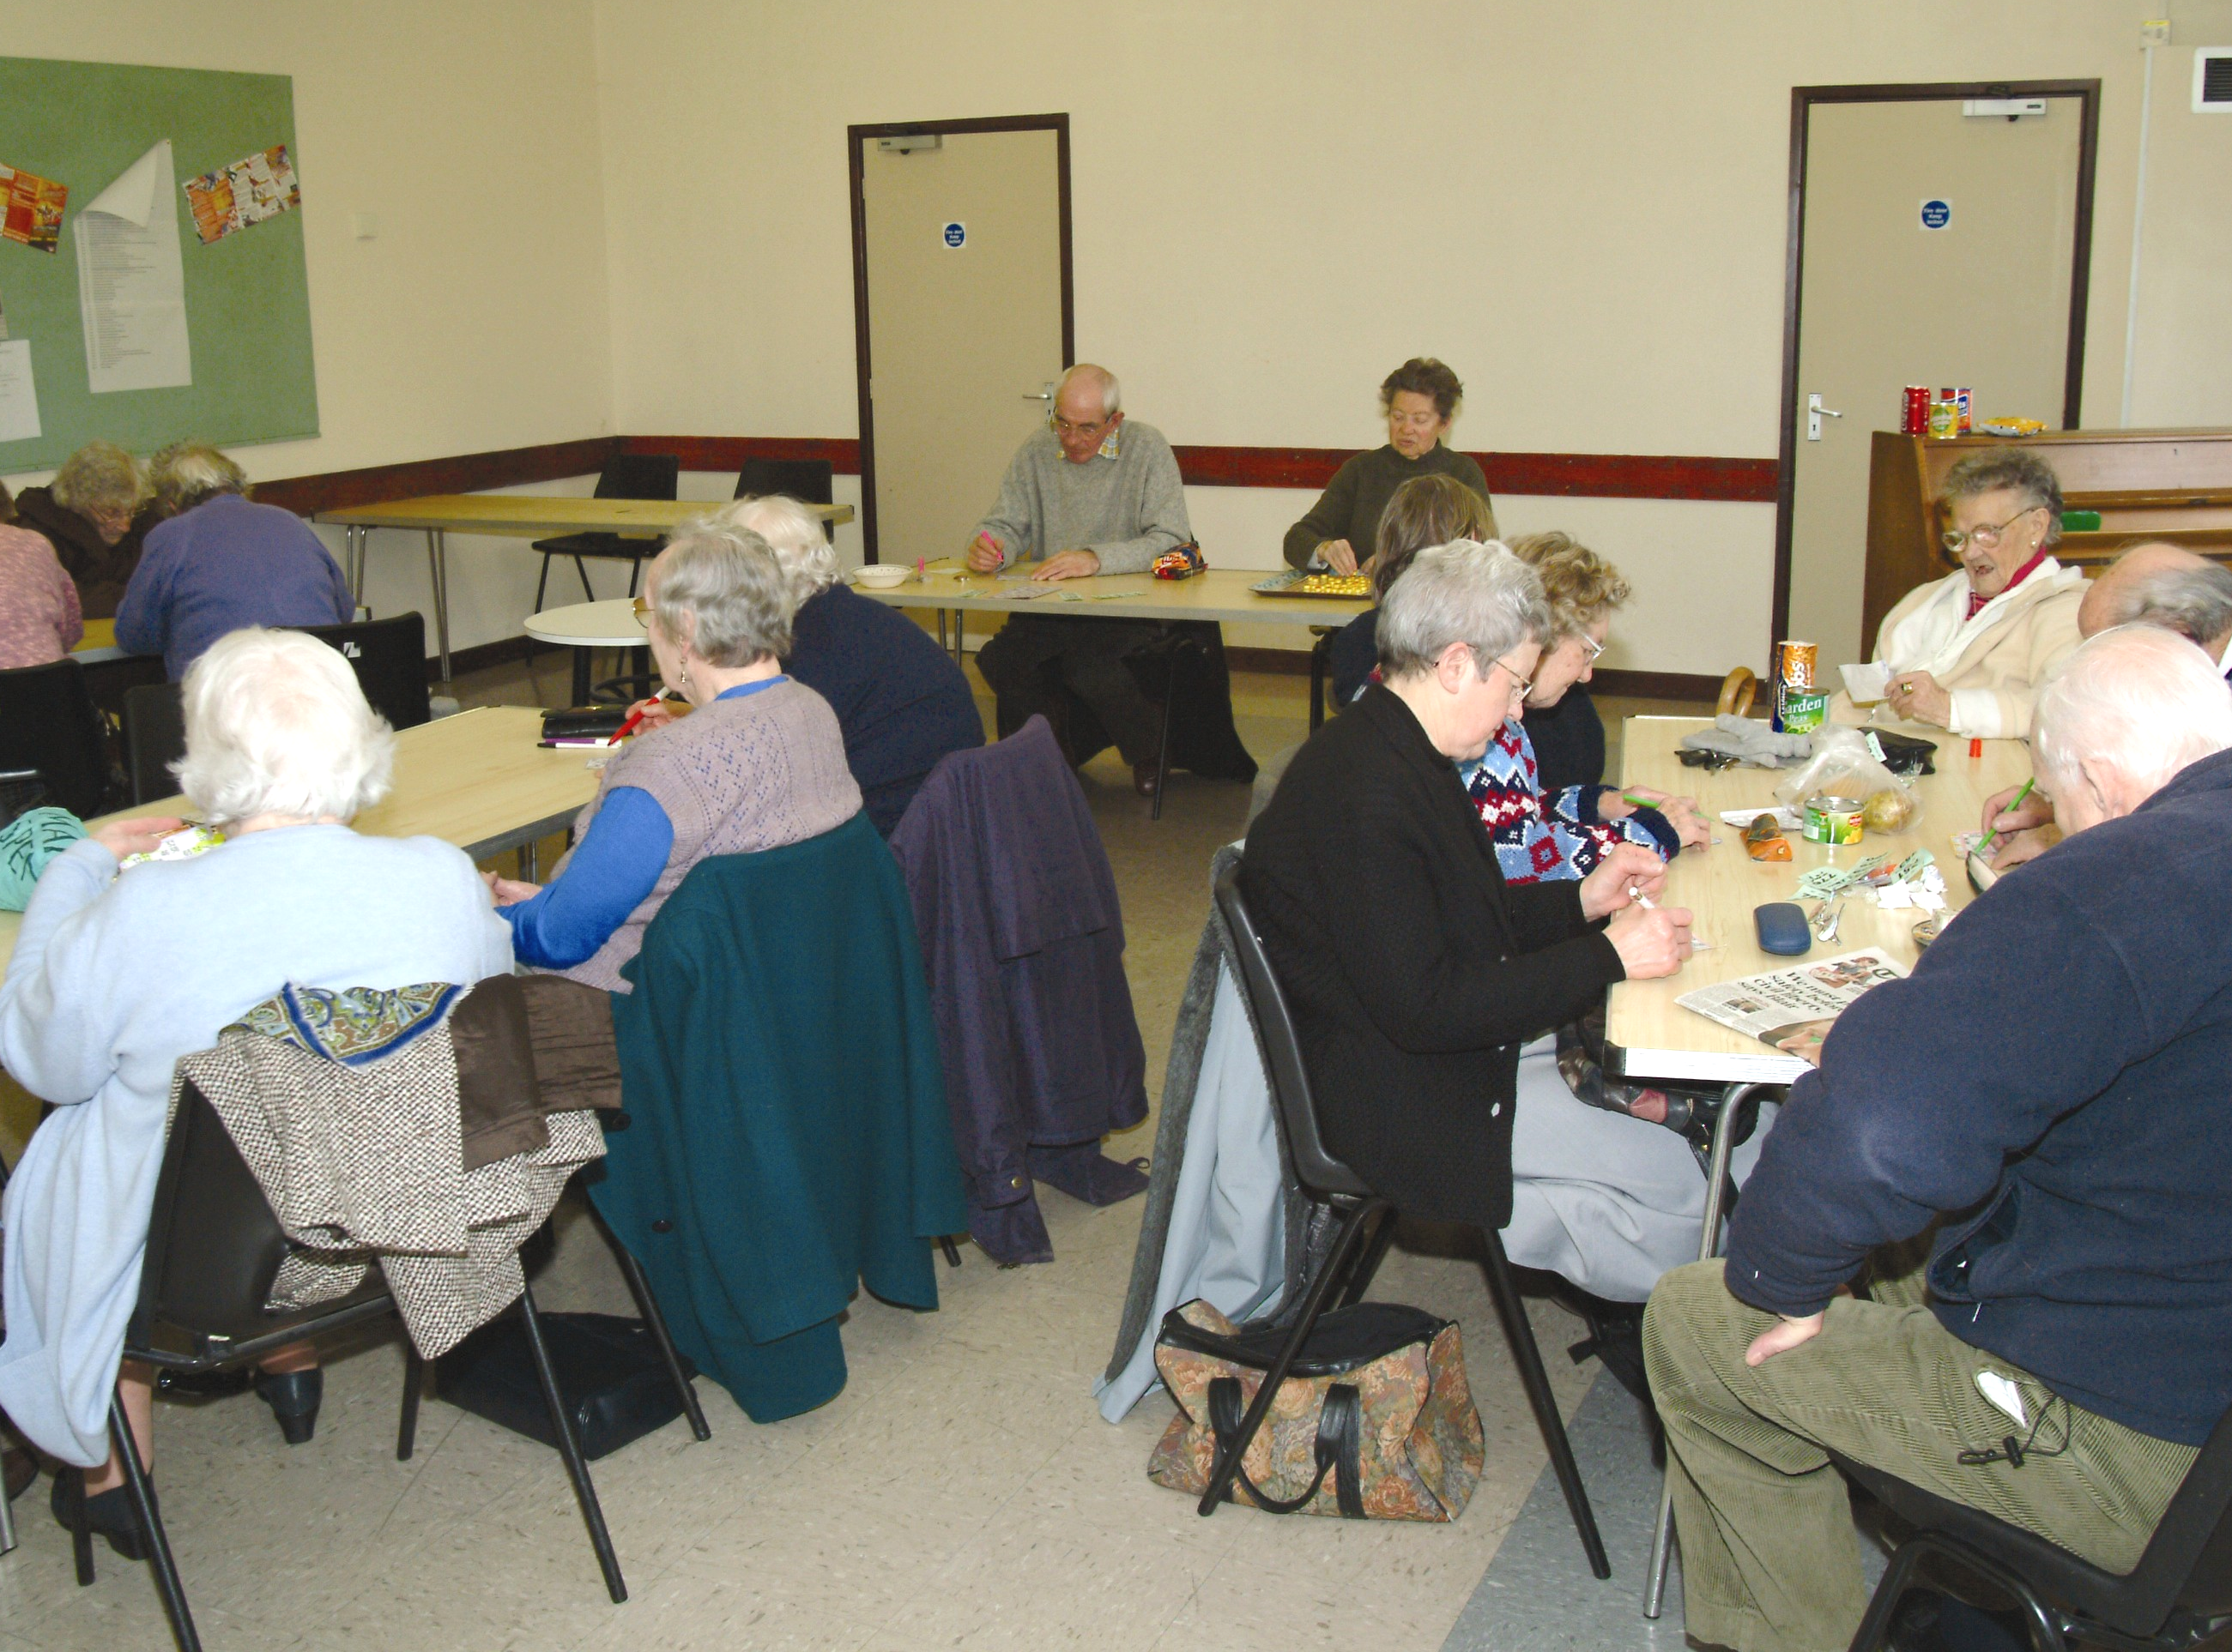

The Thursday Club – Somer Centre

Economy - Business, Skills, Tourism, Farming

Business

5.4. Proposed Actions

Project 1: ‘Towards 2013’ – an economic development strategy

The Bath and North East Somerset Economic Partnership has produced Towards 2013 – a 10 year economic development strategy. We have identified the need for a detailed long -term strategy for the future development of the Midsomer Norton & Radstock economy, linked to Towards 2013. Midsomer Norton and Radstock Chamber of Commerce, Norton Radstock Town Council and Bath & North East Somerset Council have agreed to work together to develop this. The project will identify the likely prospects for job growth, the opportunities and barriers to achieving growth including skills development, bringing forward sites for development and develop a ten year local Economic and Employment Plan to prioritise and guide local actions.

We support this project and will work with Midsomer Norton and Radstock Chamber of Commerce, Norton Radstock Town Council and Bath & North East Somerset Council to develop and implement the strategy. We will seek funding from SWRDA to help implement this project.

Project 2: Establishing an Economic Development Task Force

This will be part of the ‘Towards 2013’ actions outlined above. The Task Force will focus on the MCTi Plan area under the leadership of Midsomer Norton and Radstock Chamber of Commerce. This Task Force will be a sub group of the Bath and North East Somerset Economic Partnership.

We support this project and will work with Midsomer Norton and Radstock Chamber of Commerce, Norton Radstock Town Council and Bath & North East Somerset Council to develop and implement the strategy.

Project 3: Economic Indicators and Monitoring Framework

In parallel with ‘Towards 2013 – economic development strategy’ mentioned there is a need for a monitoring framework. Bath & North East Somerset Economic Development Service will establish this, with baseline indicators to identify the changes in the environment, economy, community, skills base and training, housing and transport Infrastructure in Midsomer Norton & Radstock. The results of the work will be published in a six monthly bulletin and be referenced directly to the Economic Development Strategy on an annual basis. Costs will be met out of the B&NES economic development budget.

We support this project and and will work with Bath & North East Somerset Council to develop and implement the monitoring framework.

Project 4: Connecting South West

All businesses in the Plan area will soon have access to Broadband technology. Companies may require further training to take full advantage of the new technology. Most small businesses will not be able to release staff for off site training. This project will provide business support for small to medium sized businesses to enable them to take up and make best use of Broadband technology. The scheme is being promoted by the South West Regional Development Agency.

We endorse this project and will work with SWRDA and other partners to maximise benefits to the area.

Complementary Actions

Construction of the Colliers Way – National Cycling Network

North East Somerset Tourism and Land based industries

Farmers Support

Somerset Local Food Direct promotion

Area Transport plan

Core MCTI Project

Retail Crime Initiative

Town Centres projects

Other Issues Raised in the Consultations

Investigate and promote local purchasing networks

More/easy accessible information

Libraries more accessible, better equipped and welcoming

Tourism

5.5. Proposed Actions

Project 5: Construction of the Colliers’ Way – National Cycling Network

The Colliers’ Way is a walking and cycle route from Dundas Aqueduct to Frome as part of National Route 24 of the National Cycle Network. It is considered an important addition to the ‘infrastructure’ of the area. It will restore for public use derelict stretches of former railway lines encouraging walking and cycling as sustainable transport for recreation and utility trips, and as a healthy alternative to car travel. The majority of funding has been obtained from SWRDA, Countryside Agency (New Opportunities Fund), and Somerset County Council Aggregates Levy Sustainability Fund.

We endorse this project and will support efforts to ensure its completion

Project 6: Tourist Information Centre

Midsomer Norton and Radstock Chamber of Commerce, in partnership with Bath Tourism Plus, B&NES, Norton Radstock Town Council, the Countryside Agency, SWRDA and Business West intend to promote the development of tourism in North East Somerset and to assist farmers in diversifying into tourism related activities and plan to open a Tourist Information facility in the area.

We endorse this project.

Project 7: Tourism Industry Group

Midsomer Norton and Radstock Chamber of Commerce, in partnership with Bath Tourism Plus, B&NES, Norton Radstock Town Council, the Countryside Agency, SWRDA and Business West have set up a Tourism Industry Group to promote the development of tourism in North East Somerset. The group will also assist farmers wishing to diversify into tourism related activities and intend to develop the role of the group further.

We endorse this project.

Project 8: Midsomer Norton Station

The Somerset & Dorset Railway Heritage Trust intends to work with B&NES, Mendip/Somerset and Norton Radstock Town Councils, and other relevant public and private agencies, to develop a museum and a range of supporting visitor and community facilities, together with associated environmental improvements that will attract 20,000 visitors per annum, restore three hectares of derelict land, Refurbish six historic buildings, Create a single-storey museum, Operate trains on twenty five or more weekends, source goods/services from local suppliers/contractors. Financial support will come from S&DRH Trust; Heritage Lottery Fund; Landfill Tax Credits Sponsorship, local trusts and local councils. Running costs will be met from Trust sources and visitor revenue.

We endorse this project.

Complementary Actions

Memorial Gardens phases 2 & 3

Town Centre Action Plan

Places and Spaces Public Realm Framework

MSN Conservation Area Appraisal – Implementation

North East Somerset Tourism and Land based industries

Area Transport plan

Norton Radstock Greenway extension to Farrington Gurney

Other Issues Raised in the Consultations

Promote and actively encourage tourism for the area as a whole (links to Bath TIC plus Frome, Wells and Glastonbury

Protect and improve local heritage sites in the area

Maximise economic benefits from National Cycle routes through Radstock.

Cycle routes need infrastructure and facilities

Developing the latent tourism potential of the villages - natural, historic, cultural heritage

A new image and identity which links the two towns with the countryside for external promotion of the area in its own right and as a base for family tourism of the wider area

Promotion of Radstock Museum as a showcase for the area and focal point for the strategy

Farming

Proposed Actions

Project 9: Support for Farmers

The National Farmers’ Union, Bath & North East Somerset Council, Mendip District Council and Business West intend to create a dedicated resource to provide business support and advice to farmers wanting to diversify their business activities. The initiative will be focussed on linking to sub regional, regional and national initiatives and the resources local farmers need to diversify their businesses activities and guidance on how to do this.

We endorse this project.

Project 10: Somerset Local Food Direct

Somerset Food Direct will promote this scheme which encourages consumers to purchase food products directly from local producers thus cutting down on transport costs and supporting local food producers.

We endorse this project.

Complementary Actions

Connecting South West - Business support to help SMEs adopt broadband

Town Centres

5.7. Proposed Actions

Project 11: Redevelopment of the Former Railway Lands – Radstock – Priority Project

This project will help to revitalise the heart of Radstock. The Norton Radstock Regeneration Company (NRR) owns 18 acres (7.3ha) of derelict railway land in the centre of Radstock. NRR has developed a masterplan that seeks to ensure development acts as a catalyst for wider regeneration. The masterplan makes provision for; housing which has a mixture of tenure and size and is of high quality, new retail space in order to build and strengthen the existing, new opportunities for enterprise and workspace, improving movement and linkages around the site and between the towns for pedestrians and cyclists, workshops and gallery space for arts and craft industries, improving the delivery of community services and providing opportunities for cultural expressions within a new Community Resource building, making effective use of existing environmental assets and provision of new public spaces. NRR expects to deliver the development in a partnership with a preferred development partner.

We fully support this project and its implementation by the Norton Radstock Regeneration Company.

Project 12: Midsomer Norton and Radstock Town Centres Action Plan –The Town Centres Link Group has produced an Action Plan covering both town centres. The Link Group - Midsomer Norton and Radstock Chamber of Commerce, B&NES Council, Norton Radstock Town Council, Midsomer Norton Residents Assoc. and Radstock Community Assoc. – will review and update the Plan annually. The purpose of the Plan is to set out a ‘vision’ for the two town centres and to describe how the vision will be achieved, who will implement the various projects and their anticipated timing. The Action Plan considers Environment & Community, Safety Promotion & Business Growth and Access & Transport issues. The Plan provides an “umbrella” for all town centre projects.

We support this project and will work with the Link Group and its partner organisations to help implement it.

Project 13: Places and Spaces Public Realm Framework

The public realm (streets and public spaces) is fundamental to the success of our towns. A long term co-ordinated approach is needed fo both day to day actions and specific improvement initiatives. Bath & North East Somerset will produce a public realm framework for interventions in the public realm and to provide a co-ordinated approach to developments in Midsomer Norton & Radstock. It will also highlight specific areas for improvements and, where appropriate, offer design schemes/responses.

We support this project and will work with Bath & North East Somerset Council to develop and implement the public realm framework.

Project 14: Midsomer Norton Conservation Area Appraisal

B&NES Planning Projects and Partnerships intends to build on the good work already done in the conservation character appraisal for Midsomer Norton to produce a prioritised implementation action plan for the Midsomer Norton conservation area by improving quality of its streetscape.

We support this project and look forward to working with Bath & North East Somerset Council to produce the Conservation Area appraisal

Project 15: Radstock Development Strategy

The redevelopment of the former railway land through NRR is the key project for Radstock Twon Centre. To provide a context for this project and maximise long term regeneration, a co-ordinated approach is required across the town. B&NES Council will therefore produce a development framework for the whole of Radstock town centre. The strategy will focus on the physical development opportunities in the town and consideration will be given to incorporating the strategy as part of the formal planning framework for the area.

We support this project and will work with Bath & North East Somerset Council to produce the development strategy.

Project 16: Midsomer Norton High Street Development Brief

An area centred on the former Palladium Cinema in Midsomer Norton High Street presents an important challenge and opportunity for the area. To secure the improvement of the retail offering in Midsomer Norton Town Centre, encourage the creation of new employment opportunities and enhance the public realm, Bath & North East Somerset Council working with Norton Radstock Town Council and the Midsomer Norton and Radstock Chamber of Commerce will produce a development brief for the site which comprises the south side of the High Street, running parallel to South Road from Excelsior Terrace to the pedestrian alley between South Road and the High Street. Consideration will be given to adoption of the Development Brief as a formal planning document.

We support this project and will work with Bath & North East Somerset Council and partners to produce the development brief.

Project 17: Midsomer Norton & Radstock Town Park –

Priority Project

There is a long standing community aspiration for a park within the market towns. Norton Radstock Town Council, Bath & North East Somerset Council, Midsomer Norton and Radstock Chamber, and Community Groups intend to improve the quantity and quality of open public space in Norton Radstock by creating a new Town Park on the area of open land lying between Radstock, Midsomer Norton and Westfield that continues on from the existing Linear Park in Radstock from the Radstock Road following the line of old rail track bed into Midsomer Norton.

We support this project and will seek finance to undertake initial planning and consultation

Project 18: Radstock Memorial Gardens Phases 2 & 3

The first phase of the memorial gardens at Waterloo Road in Radstock is nearing completion. This project has been developed jointly by Norton Radstock Town Council and B&NES Council with support from SRB. Norton Radstock Town Council will create a landscaped open space at the eastern end of the Memorial Gardens site, with a hard landscaped circular feature and a gateway feature at the Sheepwash Bridge entrance (Phase 2) and will upgrade the central section of the site to improve the existing public car park; provide a public plaza and improve access to the adjoining Radco Furniture store.(Phase 3). (Phase 1 of this project has recently been completed). The project will be financed by Norton Radstock Town Council, B&NES Council, and Public Arts grants.

We endorse this project and will work with the partners to secure the funding.

Complementary Actions
Redevelopment of the former railway lands – Radstock
Radstock Development Strategy
Places and Spaces Public Realm Framework

Other Issues Raised in the Consultations
Organise programme of tidy up and awareness raising. Employ road sweeper to keep main road and side alleyways clean. Improve cleanliness – more litter bins
Improve the river in Midsomer Norton
Encourage fast food outlets to have seating areas
Co-operative delivery network from the shops

Housing

Proposed Actions

Project 19: Self Build Project

Bath and District Self Build Association, B&NES Sustainable Self Build Group, Envolve and the Somerset Rural Housing Scheme are seeking opportunities for self build housing developments within the Plan area. Self build offers people the chance to acquire skills as well as providing affordable housing to good design and environmental standards. The organisations hope to work with local house builders and councils to secure the release of suitable plots of land for self build projects.

We endorse this project.

Complementary Actions
NRR – Mixed Redevelopment Railway Land – Priority Project NRR is considering different ways of providing affordable housing one of which includes Self Build units.

Other Issues Raised in the Consultations
Ensure community involvement in housing decision making
Research project to identify provision of affordable housing in the area (and housing need). Part of B&NES and Mendip Strategic Plan Research project to establish just what Local Authorities and Housing providers have planned
Identify how infrastructure (schools, healthcare etc) provide for new developments

Health and Community

5.9. Proposed Actions

Project 20: Barnardos’ Family Centre Projects:–

Barnardos propose a range of actions:

Pathways Counselling – the provision of a free confidential counselling service for parents and carers of children under the age of 12.

Creation of a post to incorporate volunteer co-ordination/ community development and training, to be based at the Family centre in Midsomer Norton linking with local communities in particular those recognised as disadvantaged.

Norton Radstock Family Centre – attic conversion and sensory garden.

Community Schools Play Project – to work with primary schools to develop High Scope based inclusive play during lunch periods.

We support the principle of these projects and will work with Barnardos to identify ways in which we can assist them.

Project 21: Victoria Hall, Radstock - Refurbishment Feasibility Study – Priority Project

The future of Victoria Hall, which adjoins the Railways Lands being redeveloped by Norton and Radstock Regeneration, is in doubt as investment is required to bring it up to modern standards. The hall is an important local public building for Radstock residents. It currently houses the Town Council offices, a multi pupose hall, a billiards room and a reading room. The Hall is owned by B&NES Council and leased to Norton Radstock Town Council

We intend to seek funds to prepare a feasibility study and business plan for the future of the building with a view to seeking funds for its refurbishment.

Complementary Actions
NRR – Mixed Redevelopment of Railway Land – Priority Project NRR has allocated provision within their masterplan to provide a Community Resource Building which will complement other community facilities in Radstock and provide a modern flexible service delivery centre for community services and which could dovetail/ complement proposals for Victoria Hall.
Somer Centre development
Prattens Westfield Amateur Sports Club
Somer Scene
MSN High Street Cycle Path
Midsomer Norton & Radstock Dial-a-Ride
Area Transport plan
Retail Crime Initiative
Norton Radstock Community Safety Action Group
North East Somerset Arts Projects
Barnardos Projects
Norton Radstock Skateboard Project
Youth Action
Norton Radstock – Community Sports Coach Initiative
Elder Aware

Other Issues Raised in the Consultations
Targeting Health Service providers to deliver equitable service to whole community

Leisure, Sport and Arts

Sport

5.10. Proposed Actions

Project 22: Somer Centre – Priority Project

Midsomer Norton Community Association, which has managed the Somer Centre for the last seven years, proposes to refurbish and extend the building to provide additional facilities for the wider community including an additional multi-functional stage, Dojo (matted area for Martial Arts and other Sports/ Leisure use), changing rooms, and space for life skills. The project will target young people. The first stage is to prepare a business plan.

We support this project and intend to seek finance to match fund the Community Association’s contribution to prepare a feasibility study and business plan.

Project 23: Prattens Westfield Amateur Sports Club

Prattens intend to upgrade their facilities by creating a new reception area, table tennis room/ function room, changing rooms, shower rooms and toilets, kitchen and offices.

We endorse this project.

Project 24: Community Sports Initiative

The initiative will increase the amount and range of physical activity available to young people within the area by focusing on sport specific activity as well as promoting healthy lifestyles. The project will work with a range of clubs, schools and organisations, existing community groups and organisations. Our MCTi partnership will work with B&NES Active Leisure Team, Sports West, the University of Bath and Sport England to implement the project. Finance is available through Sport England – via the Community Sports Coaches programme with match funding from B&NES Active Leisure Team.

We endorse this project.

Complementary Actions
NRR – Mixed Redevelopment Railway Land – Priority Project - The National Cycle Network route 24 will be part of the redevelopment of the former railway lands linking the routes from Radstock to Bath and Frome.
Victoria Hall Feasibility Study
Norton Radstock Skateboard Project

Other Issues Raised in the Consultations
Feasibility Study into mobile cinema at Tom Huyton Park
Sensory garden
Project to identify needs of both town and village communities for improved leisure, sports and arts facilities and to meet these needs (including school facilities)
Review membership of sports group – especially from villages
Inter business league for sports to build interest Needs action plan

Arts

5.11. Proposed Actions

Project 25 Radstock Art Project and Creative Links-

North East Somerset Arts plans to develop a number of projects at Radstock Youth Centre including, Improving the frontage of the building, touring a local history based art exhibition to outlying venues, arts workshops with local community groups to create banners for display in Radstock Town Centre and “Creative Links” , addressing mental health issues.

We support the principle of these projects and will work with NESA to identify ways in which we can assist them.

Project 26: Somer Scene

Consultation has identified a need for better co-ordination in promoting arts events. ‘Artsplus’ promotes engagement in the arts through a programme of promotion and other activities.

We endorse this project.

Other Actions
Review membership of arts consortium
Listing of assets and facilities

Transport

5.12. Proposed Actions

Project 27: Midsomer Norton & Radstock Area Local Transport Plan

We intend to work closely with Bath & North East Somerset Council to produce a plan which will improve the transport infrastructure and services and the movement of people and goods in the area by considering traffic movements particularly the east/west and north/south transport infrastructure through the Norton Radstock area.

Bath and North East Somerset Council is producing its new Local Transport Plan. This is being developed in conjunction with other former Avon Authorities as part of a sub regional approach.

We will work with B&NES to develop a plan and will seek funding for implementation of local priorities.

Project 28: Midsomer Norton & Radstock Greenway Extension to Farrington Gurney

The Greenway from Radstock to Thicket Mead is an important traffic free route. Bath & North East Somerset Council will seek to extend this route to Farrington Gurney to encourage walking and cycling as sustainable transport for recreation and utility trips and as a healthy alternative to car travel.

We endorse this project.

Project 29: Midsomer Norton Cycle Path

A potentially important traffic free route has been identified along the route of the former railway between Radstock and Midsomer Norton. A feasibility study will be undertaken by Bath & NE Somerset Council. This route would also benefit both residents of the Fosseway and the Westfield Estate providing a safe alternative to the car for local trips

We endorse this project and will consider the feasibilty study as a basis for supporting efforts to secure funding for the route.

Other Actions
Improve A362/367 Junction
Create link to strategic highway network
Review of transport services for villages and how these can become more integrated
Shuttle Bus to link the town centres to new facilities, such as sports development at Writhlington
Safe routes to school implemented throughout the area should be part of radical rethink on school transport provision
Provide up to date information on transport services available
Ensure safe and convenient pedestrian routes in towns and villages
Encourage use of cycle routes and Paths

Crosscutting Themes

Building Community Capacity

5.13. Proposed Actions

Project 30: Developing and Delivering the Community Plan – Priority Project

Over the next three years we will have to maximise the delivery of the projects contained in the plan, review the Plan and evaluate its delivery and create a sustainable community planning process for the Norton Radstock area for the future. If the Plan is to fulfil expectations we need the resources to deliver these roles. The Steering Group and the Task Groups are the essential community infrastructure required to make our Community Plan work and require Management and Administration support to operate. Other areas in which we will have to engage include:

Community Outreach - ensuring that there is broad community involvement in the MCTi process.

Partnership Working - working with Norton Radstock Town Council, Midsomer Norton and Radstock Chamber of Commerce, Parish Councils, NRR Co, B&NES Council Services, the Regional Development Agency, the private sector and others.

Delivering Projects - we need to devote resources to working with the Agencies and Organisations able to finance and deliver our projects.

Community Plan and Process – we have to make sure that the plan is reviewed, evaluated and updated - to know how well we are doing in delivering the Plan and to know how effective the Plan is and filling in gaps that we know about or become apparent.

We will seek funding to allow us to undertake these vital activities over the next three years.

Other Actions
Develop a ‘Community Chest’ for small scale projects. That enables the community to take a lead in implementing projects, helps promote the community led process and delivers small scale high visibility projects.

Crime and Community Safety

5.14. Proposed Actions

Project 31: Shopwatch and Retail Crime Initiative

Avon and Somerset Police will promote the development of the Bath and Area Business Crime Reduction Partnership in the Plan area. This initiative will provide a reliable and readily accessible method by which local traders can be made and kept aware of issues in relation to crime trends, incidents and offenders not only in the immediate area but across the district. The initiative will also be a means whereby emergency and support services can be more readily contacted and utilised in the event of crimes committed locally. The project involves the establishment of a radio link for local traders that enables them to communicate with CCTV control centres and where appropriate emergency services. This is likely to require the purchase of the necessary electronic equipment both for issue to members and for installation as base/relay stations. This initiative will involve rolling out the already successful activity in Bath. It is a membership organisation and is funded by membership fees.

We endorse this project.

Project 32: Norton Radstock Area Community Safety and Drugs

Action Group

Avon and Somerset Police B&NES (Local Partnership Office/ Community Safety Development) Police and Link Group have established a group to consider and address Community Safety and Drugs issues affecting the area. The group consists of individuals and organisations that are able to contribute towards developing solutions to community safety related problems and to work with other agencies. The group identifies issues that have a significant impact or potential impact on the quality of life of the local community and through the application of partnership resources seek to resolve or avoid those issues.

We endorse this project.

Other Actions
Retailers radio link

Young people

5.15. Proposed Actions

Project 33: North East Somerset Arts (NESA) Projects –

Youth Arts - links five existing youth projects - mental health, learning disabled, excluded young people, issue based work and young parents.

We support the principle of these projects and will work with NESA to identify ways in which we can assist them.

Project 34: Midsomer Norton & Radstock Skateboard project –

Priority Project

Young people have done a great deal of work to develop a skateboard park, following initial identification of need through community planing and young peoples workshops. This project is promoted by young people working with B&NES Youth and Community Services and is supported by the Police. It will encourage young people and children to engage in physical activity, establish a forum of local residents and young people to address issues that may arise from the project, provide a safe meeting place for young people, address the transport issues that people have to face if they want to attend a skate park. It should help to reduce the number of complaints to the Police about anti-social skating in the area. Planning permission has been gained and landlord consent given by B&NES.

This is a significant capital project that supports our prime focus on young people. It would also be a significant resource for young people on a sub regional level. The project has already undergone several years of planning and development and now requires funding to make it happen. We support this project and will work with B&NES Youth and Community Services to raise the funding to make it a reality.

Project 35: Youth Action

The aim of the Project which is promoted by B&NES is for young people to address their concerns regarding crime and community issues in their locality. Young people lead the project and identify issues of concern and plan the projects. The Project has a successful 6-year track record with approximately 700 young people. Issues include bullying, drugs alcohol and substance misuse, environmental issues, personal safety, bogus callers, and vandalism. The Project has offered the young people a practical and inter-active way of developing personal responsibility, confidence and self-esteem as well as working as partners in their communities. The Project works mainly in three secondary schools, Norton Hill, Somervale and Writhlington. The schools have been very supportive and applaud its achievements.

We endorse this project.

Other Issues Raised in the Consultations
Resource web site or leaflet making youngsters aware of what is available to them.
Make Community Playbus more available in villages.
Develop a youth transport scheme.
Research to identify gaps in youth provision across the area. Several villages, housing estates and indeed the towns require better provision of play equipment for all age groups.
Extend Youth Services for villages to help provide youth clubs where a need is identified.
Develop skateboard park and mobile facility for villages.
Improve playpark at leisure centre.

Older People

5.16. Proposed Actions

Project 36: Elder Aware

The project will seek to address the issue of fear of crime amongst the elderly members of the community by making them aware of the actual risks and preventative measures that can be carried out and of agencies available to support them. The project already operates across the Bath and North East Somerset area.

We endorse this project.

Other Actions
Provision of transport for older people (e.g. Taxi share service as operated in Langport).
Produce directory of facilities available
Project to reduce feeling of isolation within the community

The Environment

5.17. Proposed Actions

Project 37: Wildspaces

This is an initiative of the Bath and North East Somerset “Wild things” Partnership. The project aims to provide natural green spaces in areas of high community need through the creation of a Local Nature Reserve in Midsomer Norton. The site is off Silver Street behind the old railway station. The project will seek to:
- Establish a local community “friends” to help care for the site
- Implement a Schools Twinning project with Somervale School
- Increase the wildlife value of the site
- Increase the use, accessibility and enjoyment of the site by local people
- Develop, agree and implement a conservation management plan for the site
- Gain Local Nature Reserve status for the site

B&NES Wildspaces are working with Somerset and Dorset Railway Heritage Trust, Somervale School , ‘Envolve’ and Avon Wildlife Trust education officers.

We endorse this project.

Complementary Actions
Radstock Development brief
Midsomer Norton High Street Development Brief
Town park
Places and Spaces Public Realm Framework
MSN Conservation Area Appraisal – Implementation
Midsomer Norton Station Project consultation study only
Memorial Gardens phases 2 & 3
Town Centre Action Plan

Other Issues Raised in the Consultations
Identify areas of open space that can have a recreational use for the community
Programme of building and shop front improvement

Equalities

5.18. Other Actions

Working with service providers to ensure their services meet the needs of ethnic minorities.

There should be a link into ‘PRIDE and an effort should be made to utilise Ethnic minorities’ special skills and experience to enable the wider community to grow in understanding. There should also be links to community safety.

6 Villages and Rural Areas

6.1. Working together

6.1.1. The MCTi initiative seeks to ensure that when we are preparing our Community Plan for Midsomer Norton & Radstock we take account of the views of the surrounding villages and rural areas which see Midsomer Norton & Radstock as their main centre for shopping and other services.

6.1.2. For this reason we have included the parishes of Camerton, Chilcompton, Coleford, Farrington Gurney, High Littleton, Holcombe, Kilmersdon, Paulton, Peasedown St John, Shoscombe, Stratton-on-the Fosse and Timsbury in our Plan area.

6.1.3. In making our Plan we have sought to answer three questions:
- How would residents in the surrounding villages and rural areas like to see Midsomer Norton & Radstock improved so that it could better perform its function as their shopping and service centre?
- Are there common issues that affect a number of the rural areas?
- What are the issues that affect particular rural communities?

6.1.4. We have been able to identify the issues in the villages and rural areas through our consultation process and the preparation of twelve separate ‘Community Profiles’ for the parishes included in the Plan.

6.1.5. In these Profiles we have completed a social and economic picture of the area and studied the outcomes of village planning days and village design strategies. We have also contacted each of the parish clerks asking what projects they would like incorporated into the Plan. Copies of the Community Profiles are available as a separate document.

6.1.6. It is not our purpose to prepare plans for the each of the surrounding villages and/or parishes. That will be done through the Parish Plans programme or through other means such as Village Design Statements which local communities will prepare for themselves. We have included a Project in this Plan to provide the resources needed by all the Parishes to prepare their own Plan. This Project is described at the end of this chapter.

6.1.7. In our plan we have tried to take into account the views of the surrounding communities on the changes they would like to see in Midsomer Norton & Radstock.

6.1.8. We have also tried to identify ‘strategic issues’ which may affect a number of parishes and to include these issues in our thinking.

6.1.9. We have sought to identify projects which are specific to individual parishes and villages and to endorse them in our plan.
    - Our Plan, therefore, contains actions which should:

Help improve the perfomance of Midsomer Norton & Radstock as a shopping and service centre

Address, where possible the common issues facing a number of communities in the the plan area

Identify and support local actions which may only relate to a particular village or parish.

6.2. Improvements to Midsomer Norton & Radstock

6.2.1. The main messages for Midsomer Norton & Radstock to come out the consultations are:

The need to improve the shopping offer and the environment in the town centres

The need for better transport links between the rural areas and the centres

The importance of the centres as providers of local employment opportunities

6.2.2. We believe that we have addressed these issues in our proposals in the Plan.

6.3. Issues that apply to a number of Parishes

6.3.1. Our research showed us that there are certain issues which concern a number, if not all of the rural communities. These are:

Preserving the natural and built environment including preventing unsuitable and unsustainable development and preventing development encroaching any further into the countryside.

Bringing derelict buildings into use, preventing overdevelopment and promoting biodiversity

Improving local social facilities, especially for young people, families and the elderly, providing accommodation such a meeting halls for group activities, young people’s activities, childcare and the elderly

Mitigating traffic flows, congestion, danger from traffic, pedestrian/vehicle conflict, noise, road safety, air pollution and speeding

Improving public transport, especially community transport, to provide better access to Norton Radstock, education, employment, health services and entertainment at all times of the day and at weekends

The lack of variety in retail facilities in the villages

Lack of local jobs, business space and skills training

Poor condition of roads and footpaths, litter, environmental hazards, traffic calming

6.3.2. In our plan we propose actions to address the environment, traffic issues, public transport. Employment and the conditions of roads and footways.

6.3.3. Other issues such as village social facilities and village shops are better dealt with through the parish planning process which we support.

6.4. Village issues

6.4.1. A number of projects and issues have been raised with us which are related to specific villages. We will support any efforts by the villages themselves to resolve these issues or to implement the projects.

6.4.2. Paulton:

Conservation Area Appraisal – Implementation
- Memorial Park Wall

Youth Shelter

Sports System

Childrens Play Area

6.4.3. Camerton Parish Council

New Pit Batch

6.4.4. Holcombe Village

A school is needed for the village and other facilities for young people and children
- Produce a Design Statement

6.4.5. Chilcompton
- Unsightly exterior of the Co-op building.
- Visual improvements to the area near the Co-op shop.
- The Lottery bid for sports facilities and - if successful - implementing the plans

6.4.6. Coleford

A BMX and Skateboard Park

Need something for young people to do

Affordable Housing

Traffic Calming

6.4.7. Shoscombe
- A new village hall with changing facilities
- A safe route from the Village Hall to the School

6.4.8. Kilmersdon

Concern over unsightliness of overhead power cables in the village.

6.4.9. Peasedown St. John

Developing facilities, activities and initiatives to assist the integration of residents on new housing estates into village life;

Adequate supply of affordable housing for young people and young families in the future;

Low educational standards, aspirations and skills levels;

6.4.10. Stratton-on-the Fosse
- Unhappy about derelict buildings
- Local vandalism

    - Project 38 – Parish Plans
The Midsomer Norton and Radstock Area Community Plan is deliberately focussed on the two towns. However, throughout the process of producing this Plan, the importance of the Parishes has been an issue for the Steering Group. To reflect this concern and to underline the importance of the Parishes, the Steering Group will seek significant funding to enable the Parishes, individually and collectively, to produce their own Plans. In addition to providing the professional skills needed to produce these Plans, the Steering Group will particularly seek to build the capacity of local Residents in the Parishes to undertake this work themselves.
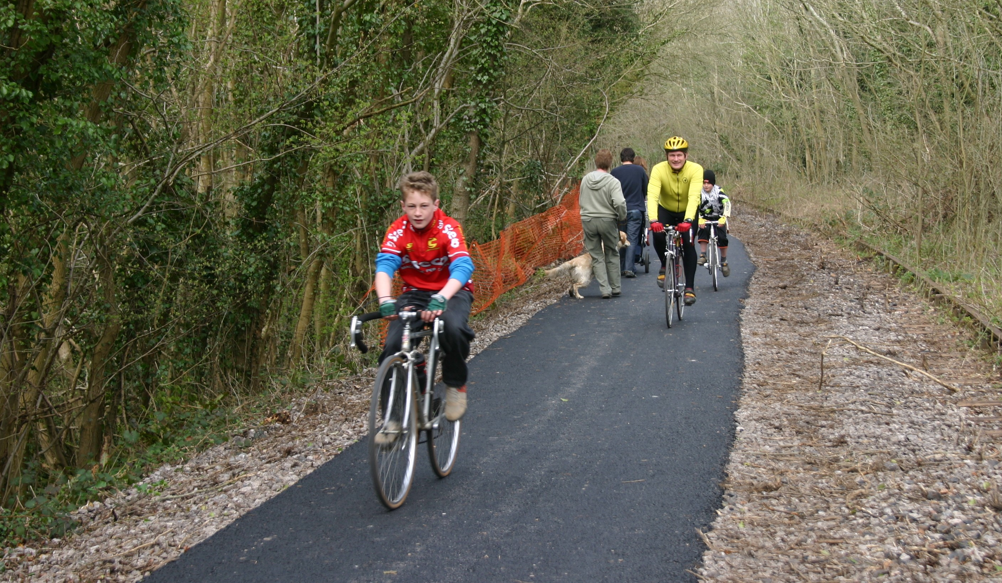

NCN Route 24, Colliers Way, Kilmersdon

- 7 The Next Steps

7.1. How will we organise ourselves to manage the implementation of the Plan?

7.1.1. As the Community Plan moves into its implementation phase we need to consider the most appropriate way to organise ourselves in order to do this job successfully.

7.1.2. Any arrangement should continue to be representative, and allow the whole community, including the young people, to understand and become involved in implementing the plan yet be sufficiently focused to act in a way that gets things done!

7.1.3. Although the support and encouragement from the various agencies will continue, it will be the community that will be responsible for implementing the plan.

7.1.4 The current Steering Group will continue to oversee the Plan while we explore options for developing arrangements for long term partnership working. In developing these arrangements, while recognising the need for clarity over structures and operation, we will seek to minimise bureacracy and to take advantage of the effeciencies of information and communications technologies

7.2. How are we going to keep the community involved?
    - This chapter identifies the next steps in the MCTI process; outlines plans for ongoing consultation and organisational development, monitoring progress and dissemination of the Community Plan; and marketing and publicity.
    - The Plan and its projects exist for this moment in time. As time moves on, other issues and opportunities will arise that will need to be taken into account. The Plan is a framework for development and decision-making. It should not be so rigid that it denies us the ability to seize an opportunity or to tackle a new issue.
    - Crucial in this will be ongoing work in the area which ensures that any changes and amendments to the Plan are in line with the needs and wishes of local residents.
    - It will also be important for us to engage with those who traditionally would not become involved in this type of activity. Young people, for example, have been involved to a certain extent in the consultation stages of making the Plan but, as our priority group, they should be involved also in the research and development of services for the future and the decisions about our future.
    - The Plan will evolve as projects are developed and implemented and new areas for attention come forward. It will be a continuous process of planning, implementation and review.

7.3. How will the community know what’s happening?

7.3.1. We want to market and publicise our activities. Audiences will be those as outlined in the table above. We will pursue a number of routes in marketing and promotion:
- Producing and distributing a summary of the Community Plan
- Posting the Community Plan on the South West MCTi site and our own local websites
- Newsletters for the community detailing progress in achieving the Plan
- An annual progress report
- An annual community event
- The use of local media including press, television and radio
    - There are key times when focused marketing and promotion will be important:
- The launch of the Community Plan
- When funding is secured for the Steering Group’s operations and for specific projects
- The launch of new projects
- The annual community event
    - We will seek funding for marketing and publicity within the annual budget needed to operate the MCTi Steering Group.

7.4. How will we measure the success of the Plan?
    - Quarterly reviews of the overall progress of the Plan and the projects and the programmes and service improvements within it will take place through the Steering Group with a view to identifying:
- Planned activity for the past quarter;
- Actual activity for the past quarter;
- Positive and negative issues for the past quarter;
- Planned activity for the next quarter, including changes as a result of analysis of past quarter activity;
- Any issues that need to be highlighted for discussion on planned activity in the short, medium or longer term.

    - In the Steering Group meetings we will review this information and, in the light of any discrepancies, will take action to ensure that the programme remains on track. In addition an annual review will take place with the production of an annual report highlighting the achievements of the Plan. All of this information will be available to the public in line with our Communications Strategy.
    - Much of our work will be innovative, and the lessons learned during implementation of the Plan would be of value to our local partners as well as other organisations elsewhere engaged in this type of work. For this reason, we will seek to share our findings with key audiences. We will highlight lessons learned and suggest models of good practice as a continuous process. Different audiences will require different types of communication. The table below provides examples of audiences we will try to engage and methods of communication.
Audience | Method of communication
The local community | Newsletter, local media, community event
Staff and Partnership members | As above and workshops/discussions
Partner agencies | As above and/or workshop/meeting, annual report
Funders and decision makers | As above and annual report
Specialist professionals and other MCTi towns in South West and nationally | Professional paper/academic journal, article in the professional press. Attendance and sharing at conferences

    - We are keen to engage with the local community and will have an annual community event for residents to highlight achievements and identify new and emerging issues.

7.5. Funding Sources
    - We have endeavoured to ‘phase’ projects where we know that there is a real need and an issue, to enable us to identify and support project champions and help them develop their project ideas to application stage for funding schemes.
    - Funding sources will need to be chosen according to their match with our project aims.
    - The well-developed projects endorsed in the Plan have identified their sources of finance, while the less developed projects have not got to that stage.
    - Examples of likely sources of funding and other forms of support include:
- Countryside Agency: social economic and environmental projects, public transport and community capacity building;
- Regional Development Agency: mainstream economic and social economy projects;
- Small Business Service – small and micro enterprise development, social economy measures;
- Business Link – business advice and signposting of sources of help;
- Learning and Skills Council;
- Heritage, Arts, Sports, Community Funds such as the Lottery – capital and revenue programmes and New Opportunities Fund;
- Culture South West – cultural projects with regional significance e.g. arts and tourism;
- ‘FutureBuilders’ and other community and voluntary sector development funds;
- Trusts e.g. BT for environmental improvements; Tudor Trust for Youth and Community;
- Local Authorities – Parish, Town, and Unitary Councils;
- Government and European initiatives.
    - We intend to build close relationships with all of these agencies and others we identify, and invite them to join us in ‘Round Table’ meetings, where we will present our Plan and outline our proposals for projects in the Plan to all likely funders.
    - “Round Table” meetings mean that we can simultaneously meet all those agencies which might have an interest in funding and supporting or otherwise making an investment in the future of our area.

Appendix 1
- Social and Economic Snapshot of the Area
  - This brief ‘snapshot’ sets out some of the key socio-economic conditions. Further details are contained in the ‘Healthcheck’ which consists of ‘Community Profiles’ and ‘Topic Papers’, which was undertaken at the early stages of the planning process and which are separate documents available along with the Community Plan.

Population
  - In 2001 the area had a total population of 46,291. The main settlements in the Plan area with populations above 1,000 are:
Settlement | Population
Midsomer Norton North | 5,367
Midsomer Norton Redfield | 5,091
Radstock | 5,276
Westfield | 5,591
Peasedown St John | 6,530
Paulton | 4,885
Timsbury | 2,500
Coleford | 2,250
High Littleton | 1,985
Chiltcompton | 1,873
Stratton-on-the-Fosse | 1,260
  - Since 1991 the population of Midsomer Norton has grown by almost 1,000 (6%), while the population of Radstock has grown by about 450 (9%). The two communities now constitute one continuous built up area.
  - By 2006, the population of Midsomer Norton is projected to rise by 5% to more than 17,000, and the population of Radstock by 12% to over 6,000.
  - Just under half (46%) of the population in the Plan area lives in Midsomer Norton & Radstock and just over half (54%) in the surrounding parishes.
  - In terms of the National Index of Multiple Deprivation (IMD) which looks at Income, Employment, Health Deprivation and Disability, Education, Skills and Training, Housing and Geographical Access to Services only one ward, Radstock (33%), is below the national ‘average’ (where 1% is the most deprived and 100% is the least deprived).

3 The Economy
  - Since the last collieries closed in 1973, the area has attracted a number of printing and packaging manufacturers, traditional engineering companies and in recent years, a number of new engineering, high-tech manufacturing, clothing and retail / distribution businesses have become established on industrial estates around Midsomer Norton, Radstock, and Paulton. Some employment sectors have potential to expand but are facing skills shortages.
  - The percentages of the workforce in different employment sectors is:
- Manufacturing – 19%
- Retail – 17%
- Real Estate – 11.5%
- Health and Social Work – 10.8%
- Education – 8.4%
- Construction – 8%
- Public Admin. & defence – 5.3%
- Transport, storage and communications – 5.2%
- Hotel and Catering – 4.5%
- Financial Intermediation – 3.3%
- Agriculture – 2.1%
- Public Utilities – 0.6%
- Other – 3.7%
  - About three quarters of employees work in the private sector and one quarter in the public sector. The service sector accounts for some 70% of jobs compared with Bath and B&NES as a whole, where services account for around 80% of jobs.
  - Around 5% (750) of the workforce is employed in tourism.
  - Almost 60% of employees travel more than five kilometres to work and 43% travel more than ten kilometres.
  - The area had a total of 1,200 VAT-registered businesses in March 2000, of which 98% are small or medium sized (1- 49 employees). Almost half of these firms are located in Midsomer Norton & Radstock.
  - Business West reports that enquiries and new ventures feature a wide variety of "lifestyle" and niche leisure companies, arts and craft-orientated activities as well as engineering, high tech internet, consultancy etc.
  - The total workforce in the area is around 15,000 and the unemployment rate is 1.96% (c300 people). Because of this employers are finding it difficult to source labour. However, unemployment in Radstock is 2.96% and 2.3% in Bathavon West, which includes Camerton. Unemployment in all other wards is below 2%.

  - In 2003 the average gross weekly earnings of full-time employees for the B&NES and Mendip areas were:
Category | B&NES | Mendip | UK
Male | £527 | £482 | £522
Female | £363 | £355 | £364

  - There are about a dozen established industrial estates which cater for small and medium enterprises .
  - In the Mendip area, there have been no major new developments of employment land in recent years, nor is there new site provision under the current Somerset Structure Plan and Mendip Local Plan.
  - In the Bath & North East Somerset area major sites are being developed or are allocated for development at Westfield, Peasedown, Welton Hollow, and Old Mills and in Radstock and Midsomer Norton Town Centres.
  - Over 8000 students of all ages followed courses at Norton Radstock College in 2002/03. The college is an active partner in providing IT training with Business West.
  - 31% of B&NES employers see IT skills as important, and expect an increase in the demand for IT literate admin. workers.
  - The main facility for supporting new small businesses in the area is Business West with a local outlet at the Wansdyke Business Centre
  - The social enterprise sector is not yet much developed in the MCTI area although there are a number of on-going or new initiatives including:

Norton Radstock Regeneration Company

Radstock Museum

Somerset and Dorset Railway Track Bed Trust

The North Somerset Railway Company

Somerset Food Links

The community transport schemes operating in both B&NES and Mendip sectors.
  - Agricultural land use and production has been in a steady decline for some time following the trend in many other rural areas which are relatively accessible to larger urban centres, however, farming forestry and woodlands exploitation are still important.

- Midsomer Norton and Radstock Town Centres
  - Our Plan focusses on the Town centres at Midsomer Norton and Radstock which are the focal points and main service providers for the Plan area.
  - Broadly speaking the B&NES Town Centres study concludes that Midsomer Norton & Radstock is well provided with food and grocery stores, but comparison and convenience shopping, and the environment of local centres should be enhanced to safeguard their viability.
  - There are 135 retail and service units in Midsomer Norton including Tesco, Focus DIY, Morrisons (Safeway), Lidl, traditional independent shops, banks and other services.
  - The B&NES study found that over 40% of shoppers visited Midsomer Norton town centre two to three times per week and of these, 63% came by private car.
  - Rental levels in Midsomer Norton are higher than Radstock but lower than Keynsham, and there are very few units vacant in the prime shopping area.
  - Local people have expressed dissatisfaction with the existing infrastructure and facilities especially the condition of the public realm and the lack of comparison shopping.
  - Improvements to the environment of the town centres are being tackled by theTown Centres Link Group and improvements to highways, footways and cycling facilities will be the focus of investment for B&NES over the next five years under the Local Transport Plan.
  - Radstock shopping centre comprises fifty three commercial units dominated by the Radco superstore. While there are few shop vacancies in the core area of the centre, the number of vacant units on the periphery of the centre result in a vacancy rate above the national average.
  - There is also one bank, financial service units and some specialist independent shops such as cycling, pet supplies and DIY. The small size of existing units in Radstock limits the likelyhood of attracting comparison shops.
4.10. The Norton Radstock Regeneration Company (NRR) owns 18 acres (7.3ha) of derelict railway land in the centre of Radstock. NRR has developed a masterplan that seeks to ensure development acts as a cataylst for wider regeneration. The masterplan makes provision for; housing which has a mixture of tenure and size and is of high quality, new retail space in order to build and strengthen the existing, new opportunities for enterprise and workspace, improving movement and linkages around the site and between the towns for pedestrians and cyclists, workshops and gallery space for arts and craft industries, improving the delivery of community services and providing opportunities for cultural expressions within a new Community Resource building, making effective use of existing environmental assets and provision of new public spaces

5 Other Retail Provision

Settlement | Retail provision
Paulton | Around twenty shops including a supermarket, post office, newsagent, pubs, two general stores, a baker's, florist, estate agent/bank, two hairdressers, a clothes/haberdashery/carpet shop, bike shop, a jeweller, pine furniture shop, a chemist, turf accountant, two petrol stations with shops and a charity shop and three take-away food shops. The Old Mills area has a Tesco supermarket, Focus DIY, tool hire shop, carpet and fabric shop, printers, interior designer, a supplier of mobility aids, a printer, locksmith and car dealer. Professional services include a bank, solicitor and a chartered accountant.
Chilcompton | Shops include a Co-op store, a post office, a hairdresser's, two pubs, two garages and a new doctor's surgery with a range of community services.
Timsbury | Co-op supermarket on North Road, another grocery store / newsagent, a green grocer, a celebration cake maker and shop, two hairdressers and a chemist’s/ local Post Office.
Peasedown | Co-op supermarket, a butcher, four convenience grocery and/or fast food outlets, two garages, three pubs, a vets practice, Post Office and some other outlets.
Hign Littleton/ Hallatrow | Post office and sorting officeand a pub in Hallatrow and the book barn, a post office / newsagent in High Littleton, which also has a pub, antique shop, general store, Co-operative society store and a chip-shop .
Coleford | A post office and general store, another grocery / convenience store, a chip-shop, two pubs, and a doctors' surgery.
Farrington Gurney | A farm shop stocking a wider range of groceries, a garage with a shop and off-licence,two public houses, and a 'Little Chef' roadside restaurant
Holcombe | A combined general store and post office, and two inns the Ring O’Roses and the Duke of Cumberland
Camerton | There is no village shop or post office (lost in 1991). There are two pubs/ hotels
Stratton | The original village shop closed down several years ago
Kilmersdon | The village has a pub (The Joliffe Arms), but no shop or post-office.
Shoscombe | There is no village shop or post office There is one pub

6 Tourism

6.1. The area is within 15 -25 kilometers of Bath which is a premier UK tourism destination, the regional capital (Bristol). The catchment area is 1.4 million people.
  - The main attraction in the area is Radstock Museum which was opened in 1999 and attracted 10,000 visitors in its first year. English Heritage has described Radstock as ‘one of the best preserved mining towns in Great Britain’.
  - There are local events such as the Norton Radstock Mardi Gras (July) and Midsomer Norton Carnival (Nov) and throughout the area there are the old coal canals, miners tracks, railway corridors, stone circles and barrows, Downside Abbey and other fine churches, folklore traditions at Holcombe and Kilmersdon, and wildlife sites.
  - There are eight graded establishments providing tourist accommodation in the Plan area - six hotels / inns / farmhouses and two self-catering. There are high quality facilities with a national reputation at Ston Easton Park and Babington House and around twenty five establishments of various types.
  - There is a Tourism Action Group for the area and a Tourism Development Plan.

7 Housing

7.1. The B&NES Housing Survey 2000 concluded that the vast majority of the population is satisfactorily housed in good quality accommodation with access to all basic amenities, though around 4,000 dwellings were in need for improvement or repair.
7.2. Current Housing Stock by Number of Bedrooms (2000)
Area | Percentage of 1, 2, 3 or 4+ bedroom accommodation
Area | 1 bed | 2 bed | 3 bed | 4 bed
Norton-Radstock | 5 | 26 | 50 | 19

7.3. A survey of the housing needs of young people showed that young people seemed to be well established in the areas where they lived. Nevertheless the Housing Strategy recognises that there is little provision for young people in Midsomer Norton and Radstock.
  - In 2004 the average house price in the B&NES area is £248,000 compared with £201,000 in the south west. This is ten times the average annual gross wage for the area.
  - In both parts of the MCTi area, the local authority housing stock has been transferred - in B&NES to Somer Community Housing Trust, and in Mendip to Mendip Housing Association. Somer CHT is the largest Registered Social Landlord in B&NES, with around 9,500 of the 11,500 properties. Other registered social landlords are Knightstone Housing Association, Orbit HA, Western Challenge HA, the Guinness Trust.
  - The area is strategically located just to the south of the Bristol-Bath Green Belt and is thus required to contribute to the housing supply target which is anticipated to be at least 6,100 for B&NES up to 2011.
  - With considerable existing housing commitments the priority in Midsomer Norton & Radstock is to promote additional economic development. And only two greenfield housing sites are identified, at Folly Hill, Chilcompton Road and Kilmersdon Road, Haydon.
  - The regeneration of the Radstock railway land site will contribute upwards of 100 dwellings, although the capacity could be greater provided a robust mixed-use scheme is achieved and ecological interests are taken into account.
  - In Mendip, housing schemes have recently been carried out in several of the villages - Chilcompton, Kilmersdon, Stratton (where 25 precast reinforced concrete properties were refurbished with the Guinness Trust) and Holcombe (9 units built to new energy efficiency standards).

8 Health and Community Care

8.1. Since April 2001, all parts of the area have been served by new Primary Care Trusts: the Mendip PCT and the B&NES PCT.
  - The only hospital, at Paulton, has been refurbished and has 28 beds, improved outpatient facilities and a new physiotherapy department. Public transport access to Paulton hospital, and to hospitals in Bath, is a continuing concern, particularly for older people.
  - There are GP practices at Chilcompton, Coleford, Peasedown St John, Paulton, Timsbury, Radstock (Hope House and Westfield) and Midsomer Norton (Somerton House and St Chad's). Health Visitors attached to the practices provide a range of community services to support parents and families with pre-school children.
  - Currently there are no NHS dentists in the area taking on new patients, but there is a new initiative to address this under the Health Improvement Plan.
  - The Adult Care Service for most of North East Somerset is based at the Hollies in Midsomer Norton, and provides home care, mobile meals, day care and residential care.
  - There is a residential home for older people in the area - Sunnyside Elderly Persons Home at Peasedown St John.
  - Community Work in Bath & North East Somerset is the responsibility of the B&NES Youth & Community Service.
  - The local authorities and the police are working together with local communities, as required by the 1998 Crime and Disorder Act to promote Community Safety. The Midsomer Norton & Radstock Area Community Safety Action Group works with some of the rural parishes, and there is a separate group in Peasedown. A Mendip group also meets regularly to discuss issues and plan actions.

9 Education and Child Care

9.1. Facilities in the area include pre-school provision, out of school clubs, holiday play schemes, activities at leisure centres, toy libraries, soft play centres, mobile projects such as the community bus, parks and children's play areas, and open spaces.
  - Radstock and Midsomer Norton together have 110 preschool or nursery places and 75 after school and breakfast club places, Peasedown has 74 and 24 and High Littleton has 54 and 0.
  - There are private day nurseries in Midsomer Norton, Welton, Farrington Gurney and Norton Radstock College, plus mother and toddler groups and around twenty playgroups in the B&NES part of the area and most of the primary schools in the area make some kind of after-school provision.
  - The Family Centre at Midsomer Norton, funded by B&NES and Barnardo's, provides play and parenting sessions for parents and young children.
  - In the Mendip villages, there is limited early years provision. Bishop Henderson school in Coleford has a nursery unit and is considering how to develop after-school and breakfast clubs, while Chilcompton has a playgroup, a parent-and-toddler group and a private nursery school. Stratton-on-the-Fosse has a private nursery school, but neither Kilmersdon nor Holcombe has any pre-school groups at present.
  - There are youth centres at Radstock and at Peasedown St John. The Girls and Young Women's Development Team is based in Midsomer Norton. The Youth Action Project, based in Midsomer Norton, helps young people address concerns on crime and community safety and works to tackle under achievement.
  - North East Somerset Arts (NESA) works in partnership with B&NES Youth Service to provide a broad programme of youth and visual arts services from Radstock Youth Centre'. A Youth Mobile Project uses its own bus to take provision to rural and socially disadvantaged areas.
  - There are no Youth Councils in the area, but a Youth Democracy Project has led to a B&NES-wide Forum. There is a wide range of guidance and support services for young people in B&NES and Mendip.

10 The Arts and Leisure and Recreation

10.1. There are a good number of Arts opportunities available in the area provided by voluntary groups. North East Somerset Arts (NESA) is a well established and substantial local community organisation providing a wide range of services as well as playing a key strategic role in the development of the Arts in the area. A recent development is the establishment of SomerScene – an Arts Umbrella Group for the area, facilitated by NESA and supported by B&NES Council.
  - Leisure and Recreation facilities in Midsomer Norton & Radstock include South Wansdyke Sports Centre, which has a swimming pool, squash courts, outdoor tennis courts and 5-a-side area. It offers aerobics classes and children's activities, an Adventure Play area and a public Health and Fitness suite. There are also good sports facilities at Writhlington and Norton Hill Secondary Schools. A local Active Leisure Task Group is working with B&NES on plans to develop better and more integrated facilities and opportunities in the area.
  - B&NES Council officers state that the village hall stock in the B&NES area is generally good, though one or two will need further development work in order to be sustainable.
  - In the Mendip village areas, activities centre round the village halls and recreation fields, and the Council's Leisure Link programme, which offers a range of arts and leisure activities through ten Key Organisation partners.

11 The Environment

11.1. The whole of the project area falls within the south-east corner of the “Natural Area” of Bristol, Avon Valley and Ridges with the Mendip Hills Natural Area lying immediately to its south and west.
  - At least fifteen sites in the area are designated as of Regionally Important Geological Sites. There are also three geological Sites of Special Scientific Interest south of Radstock at Kilmersdon Road quarry, north of Huish colliery and at Writhlington.
  - Both B&NES and MDC are undertaking, or have completed Local Landscape Character Assessments. It is understood that at least five distinct character areas are emerging for the Midsomer Norton & Radstock north hinterland based on the plateaux and valleys.

11.4. In Mendip seven areas have been identified Northern and Eastern Farmlands, Emborough Picot Ridge, Holcombe-Highbury-Coleford, Holcombe-Charlton Valley, Kilmersdon Valley, Nettlebridge Valley, Lower Mells River Valley. Overall the MCTI area has very high quality natural and historic landscape.
  - Around one hundred sites in the Plan area have been classified as either sites of Special Nature Conservation Interest or County Wildlife Sites, Sites of Special Scientific Interest (SSSI) or Special Area of Conservation (SAC). The Radstock Railway sidings is an important site and parts are designated as SNCI status. There are SSSIs in the Nettlebridge and Lower Mells Valley woodlands at Edford, Leigh and Ham, as well as the SACs at Fairy Cave Quarry and Becton Wood. Lower Mells Valley has been declared a Prime Biodiversity Area by Mendip DC. Camerton Batch has been recently designated a Local Nature Reserve by B&NES. Other areas rich in biodiversity are the Cam and Wellow Brook Valleys.
  - A large proportion of Radstock was designated a Conservation Area in 1999 to protect and enhance the value of its industrial and historic buildings and townscape.
  - New initiatives approved by B&NES Council (March 2001) will embrace the town centre of Midsomer Norton and village centre of Paulton. As in the case of Radstock, the Midsomer Norton designation is intended to complement environmental and retail improvement schemes for the town centre.
  - In the Mendip sector only Kilmersdon is presently designated as a Conservation Area.
  - There are three historic parks and gardens and twelve ancient monuments listed by English Heritage.
  - There are many fine churches especially at Stratton-on–the-Fosse (notably Downside Abbey), Kilmersdon, Midsomer Norton, and Timsbury. In Mendip there are also fine parks and gardens at Babington House and Ammerdown.
  - The area has a wealth of ancient sites. Some are classified as Scheduled Ancient Monuments including iron age hill forts at Blackers Hill (Chilcompton) and Tunley Farm, anglo-saxon burial sites near Camerton Farm and neolithic barrows at Stony Littleton.
  - Features of historical interest range from Roman burial sites, pottery, coins and mining sites around Stratton, Holcombe and Kilmersdon; medieval era mine shafts; deserted medieval villages near Coleford, Kilmersdon and Stratton; the old Dorset and Somerset Coal Canal and the North Somerset railway network.

12 Transport

12.1. In general, the infrastructure of the towns and its surrounding area is still being modernised in the aftermath of the coal mining and railway era but some major deficiencies remain - especially in the quality of transport links to Bristol, Bath and other Somerset towns.
  - Two principal road corridors, the A367 from Somerset through Radstock to Bath and the A362-A37 from Radstock and Midsomer Norton to Bristol via Farrington Gurney, supplemented by another primary route, the A39 from Bath to Wells via High Littleton and Hallatrow, and the distributor B-road network taking susbtantial traffic through Paulton, Timsbury, Peasedown St John, Chilcompton and Kilmersdon.
  - The extent and quality of public transport provision is variable across the area. Most services are operated by First Badgerline and some attract local authority subsidies. Some rural services have benefited from some new investment from national or regional sources in recent years, e.g. East Mendip Connector bus service linking Mendip villages to the main inter-urban bus routes linking Bristol, Bath and Somerset.
  - The Midsomer Norton & Radstock to Bath route is the best served with daytime buses every 20 minutes, bus lanes entering Bath and new low floor vehicles, but evening services are infrequent. Only Farrington Gurney has a direct service to Bristol via the A37. Several villages are poorly served in the daytime and some have no evening or weekend services.
  - In Mendip, the Frome-Midsomer Norton and Radstock-Bath bus serves Coleford, Holcombe, Stratton-on–the-Fosse and Chilcompton six times per week day - but not evenings - plus Sunday service. All of these villages, except Coleford, are also on the Shepton Mallet-Bath bus route with a similar frequency of service. Kilmersdon is linked to Radstock and Writhlington but services are less frequent.
  - Several community transport schemes operate in both B&NES and Mendip sectors of the area on a small-scale and voluntary basis and mostly catering for specific social needs. A dial a ride service has recently been launched.
  - B&NES Council recognises that in many localities - especially Midsomer Norton & Radstock – provision for pedestrians and cyclists is inadequate. Expenditure on new and improved footways, traffic calming, Safer Routes to School and other road safety initiatives has been increasing since 1996 and will continue to.
  - The Norton Radstock Greenway has been built along the old railway line to Bristol as far as Thicket Mead. There are plans to extend this to the Tesco Supermarket and then on to Farrington Gurney. National Cycle Network Route 24 (The Colliers Way) has recently been constructed from Radstock (Waterloo Road) to Shoscombe and from Radstock (Meadow View) to Mells. When finished this will provide a continuous link from Dundas Aqueduct (Limpley Stoke) to Frome via a combination of railway paths and quiet country lanes.

Appendix 2

The key issues facing our community

1 Employment

1.1. Although there has been a gradual decline in industrial employment since 1993, when just over 7,000 people were employed in manufacturing, the area still has around one third of its workforce (approximately 5,600 people) employed in manufacturing, mainly in printing, packaging, engineering and electronics.

1.2. Employment opportunities have not kept pace with residential development and almost 60% of the town's workforce now commutes to work.
  - Over the next ten years it is predicted that industrial employment in B&NES will fall by about 1,200 jobs (10%). Office based employment is expected to grow providing 100 extra jobs (6%). Non-business space activities will grow by 4,600 jobs (11%). The effect that these changes will have on Midsomer Norton & Radstock up to 2011 in terms of employment and the impact on the amount of floorspace required are shown in the table below:
Forecast employment change to 2011
Employee Jobs | Norton-Radstock
Industrial sectors | - 400 jobs
All Office Sectors | + 100 jobs
Net Floor space change sq. ms.
Industrial | -14,000m²
Offices | + 2,000m²

1.4. Our consultations clearly indicated a desire on behalf of the community to ensure the future of the areas employment base by the promotion of economic activity tailored to local strengths combined with diversification of the local economy and the local skills base.

1.5. It was felt that the area should be promoted as a location for businesses stressing the advantages of its proximity to Bath, a pleasant residential environment and low costs.

1.6. Despite success in attracting new companies, there is concern that a large part of the workforce is dependent on employment in printing, packaging, and engineering sectors.
  - Even if the area continues to attract new companies and new employment, it is unlikely that this will keep pace with the recent population growth due to the numbers of new houses built in the area. If this happens it will mean that an even greater proportion of the workforce will have to commute to employment outside the area.
  - Although the area has Broadband we want its commercial possibilities to be adopted by as many local companies as possible.

2 Business Sites and Premises

2.0. If the Plan area is to continue to attract new businesses and so create new employment within our community, these businesses must have available to them a proper ‘ladder’ of sites and premises on which to set up, develop and grow.
  - We are, however, aware of Midsomer Norton & Radstock’s location outside the green belt which makes it attractive to housebuilders who can afford to pay much more for sites than manufacturing and service companies.
  - A survey undertaken for B&NES of the demand for business sites and premises states that likely future demand for employment land is relatively weak and that allocations and existing commitments indicate an oversupply of land. It has been suggested therefore that, if a site is no longer to be retained for business use, then residential development, forming part of a mixed-use scheme may be acceptable outside the Housing Development Boundary.
  - We believe that, in these circumstances, it is particularly important that policies in the Structure and Local Plans continue to safeguard the future of employment sites and to ensure that a variety of type and size of development sites are available to companies. This would also help reduce the need for employees to travel outside the area to find work.
  - There is also a need to improve the availability of business advice and support across the area and our consultations have identified the need for support to encourage the formation and development of social enterprises.

3 Skills

3.1. Literacy skills in Radstock ward are 10% below the national average. High Littleton, Paulton, Peasedown St John, Radstock and Midsomer Norton Redfield are among the B&NES Wards where around one quarter of the population aged sixteen to sixty has low numeracy skills.
  - We also understand that there are skills shortages in relation to local manufacturing sector needs.
  - If the local economy is to prosper it will be necessary that the workforce has the skills necessary to take up any new jobs being created. This should include the tailoring of skills trainig programmes to local needs, improving access to local information centres such as libraries and the creation of outreach points for learning programmes in the rural areas.

4 The Town Centres

4.1. The weakness of Midsomer Norton as a retail centre is the lack of national multiples and quality comparison shopping which means that shoppers don’t stay for long in the centre and don’t spend very much. This is compounded by the poor quality of much of the public realm and the dilapidated condition of many buildings.

4.2. Similarly there is a need to regenerate Radstock town centre through improving the mix of uses and facilities – but without discarding the village-based culture, community spirit and continuity with the industrial past. Radstock town centre suffers from congestion and poor traffic management systems, limited pedestrian and cycling facilities, a lack of civic open space, larger retail and market facilities and leisure amenities, and poor disabled access.

5 Tourism

5.1. We believe that the area could benefit much more than it does from tourism. We understand that there is a tourism development plan and we are keen to see this implemented as soon as possible. However, there is limited awareness of the tourism strategy outside the sector itself and there is a need to link the actions proposed with other actions proposed.
  - There is also concern over the capacity of local tourism organisations to take ownership of the strategy and work with businesses and community groups across the wider rural area to develop quality tourism products.
  - The area has a poor visitor infrastructure and image, particularly the low level of tourist accommodation available, but there are good opportunities to improve and develop quality tourism products such as increasing visitor spend in the area through arts and cultural events.
  - However, there is no advisory or booking centre in the local area and many of the general facilities such as toilets, car parks, restaurants, shops, pedestrian and open space, signage and gateways in or to the towns are deficient or unattractive.
  - There are limited resources and support mechanisms for the villages to develop projects at present and there is a need to involve farmers and land-owners in developing accommodation and new projects.

6 Farming

6.1. Local farming is characterised by reduced economic viability and the capacity to support only part-time activity, often helped out by activities such as small-scale higher value food production, provision of leisure and tourism facilities, farm shops, environmental and forestry services contracting, and leasing of land and buildings for miscellaneous uses.
  - The profile of local farmers is an ageing one- due to recent crises and industry and market trends which deter young people from entering the industry.
  - We also understand that the base of food producers in the immediate local area may be small and may make the new Farmers Market initiative for Midsomer Norton difficult to sustain.
  - It is also the case that Intensive methods of farming may be in conflict with other local environmental objectives, clean water supply, conservation, biodiversity action plan, green tourism etc.

7 The Environment

7.1. Our consultations have shown that there is almost universal concern about the future of our natural and built environment.
  - A number of issues have to be resolved, including the need:

To have an integrated approach across B&NES and Mendip areas.

To Safeguard local nature conservation and historic sites (SSSIs, SNCIs, CWSs, RIGS, SAMs) from adverse impacts of development, pollution etc.

To encourage the use of local heritage assets and harness local knowledge and enthusiasm for interpretation and tourism / recreational projects.

To take forward quickly environmental and conservation policies and projects contained in B&NES and Mendip Biodiversity Action Plans, Village Design Statements and Conservation Area status.

To develop or extend incentive schemes and encourage good practice by property and site owners in the conservation of the built / historic heritage.

To improve access to information and expertise – networking, training and support for villages and local groups involved in biodiversity and heritage conservation issues.

To secure extra resources to implement schemes proposed under the Midsomer Norton and Radstock Streetscape Strategy and other physical regeneration plans for the town centres.

8 Families
  - We believe that families are the bedrock of our local community and that we must endeavour to provide support for them through our Plan. This includes the need:

To help families, local community and voluntary groups to fully engage in decisions being taken about their future and in the implementation of the Plan

To develop new neighbourhood based advice and support services in the fields of health and social care and child care, and/or town centre provision served by community transport

For better physical access for disabled people to local facilities, and for more arts and general activities for young disabled people.

9 Young People
  - Despite the good work done through the SRB programme we believe it is an important part of our Plan to ensure that young people are truly part of our community life.
  - We hope that the targets and plans of the Early Years Development and Childcare partnerships are achieved as soon as possible, so as to increase the level and quality of services for young children throughout the area.

9.3. There is a need to develop a comprehensive programme of activities across the area to engage young people and develop their capabilities and the first step in this may be to carry out a survey to establish just how well the existing and proposed facilities ‘fit’ the needs of young people.
  - Of particular importance is the need to see through the upgrading of the Somer Centre and to complete the Midsomer Norton Skateboard project.
  - We also feel that there is a need to improve village information services for children and young people; networking of service providers, and links with the Children's Information Service.

10 Health
  - At this stage we are not clear as to what a healthy and socially inclusive community in the area would be like, and what we need to do to help make it happen, however our consultations suggest that there is a need:

To secure equality of access to services, particularly in relation to public transport, and choice;

To achieve the objectives in the two Health Improvement Programmes that affect the area

To ensure access to basic health services such as dentistry is available to all

To develop more community-based ‘out of hours’ services for vulnerable people - local day care, befriending, community transport

To address the loneliness and isolation of older people, and the future provision of residential and supported accommodation for them.

To expand the services available to reduce drug and alcohol abuse, especially among young people

11 Housing
  - Of major concern in our consultations was the need for affordable housing for local people – given the relationship between the cost of housing and wages. We believe that Housing Plans may have to be reviewed to reconsider this issue and to secure an adequate provision of social and/or affordable private housing for young people and families.
  - Government advises that Local Authorities may require contributions towards affordable homes in developments of fifteen dwellings or more. Given the level of need for affordable homes in the area B&NES should ensure that this is enforced.
  - B&NES Housing Survey noted the need for more accommodation for elderly people particularly residential care, nursing care and sheltered housing with support units and the provision of flats and bungalows to enable old people to move out of their family homes into more suitable accommodation within the same neighbourhood.
  - The survey also recommended that a full range of properties should be available to meet the needs of black and ethnic minority residents.
  - In the first seven years of the Council’s Plan period about 400 were completed in Midsomer Norton & Radstock. We understand there is a need to identify further sites in the B&NES area for about 3,360 new homes to 2011. We want to be included in discussions about where these sites are to be in the Plan area since, in our consultations with the villages, most residents said they did not want more houses built in their villages.
  - Given the possible conflict between housing development and protecting the environment while at the same time ensuring that housing provision keeps in step with local employment we would hope to enter into detailed discussions with B&NES to find out how this can be achieved.

12 Sport, Leisure and Open Space
  - Our consultations indicated that there was a feeling in the community that the range and quality of community faciities should be improved including leisure, sports and arts facilities, green ways for cycling / walking, development of the town park, and perhaps the development of a major new leisure facility. This should be investigated by way of a survey to research local needs and to compare these with local provision.
  - Access to leisure facilities for people living in the villages is poor especially in Mendip and better use could be made of schools sports facilities.
  - There was particular interest in the refurbishment and extension of the Somer Centre and the Midsomer Norton Skatepark

13 The Arts
  - Generally speaking the feeling is that there is a need to involve more local people in arts and cultural activities and events and to develop more activities for young people including the provision of transport to and from activities and events and the better use of schools facilities for community arts activities.
  - It was also felt that there was a need for the co-ordination and joint marketing of the arts programme in Midsomer Norton and Radstock with other sports and recreational activities and that the information or publicity about what is happening in arts in the area is inadequate.

14 Community safety
  - Despite a general fall in crime figures in the area, increases have been recorded in Midsomer Norton, Radstock, and Peasedown St John.
  - Perceptions of community safety affect the quality of life of residents and although the area does not suffer from major criminal activity, there are activities which cause alarm and annoyance to residents. These include:

Youth nuisance and disorder/vandalism - from youths with skateboards, BMX cycles etc., in and around the Hollies Garden area in Midsomer Norton; round Fortescue Road in Radstock and the area from Church Lane to Northmead Road, Midsomer Norton via Redfield Rd/ Withies Park area as well as in the surrounding villages

Alcohol related disorder late at night when pubs and clubs are emptying

Retail and business crime

Vehicle related nuisance - centred on the area behind the Victoria Hall, Radstock where groups of young motorists gather in their vehicles to listen to music and generally ‘hang out’, but also across the area.

Minor criminal damage in residential areas which makes up more than one third of all crime recorded

Schools are often subject to attacks by vandals often over weekends and school holiday periods

Activities of off road motorcyclists

Evidence of drug dealing in some areas, particularly the larger population centres.
  - These activities can not only affect the community at the time they take place, they can also instill a ‘fear of crime’ which persists long after the incident is past, especially with the more elderly and vulnerable members of the community and can sour relations amongst the different ages groups.
  - We are concerned that community safety should be considered a fundamental part of our Plan and taken into consideration when any community project is under consideration.

15 Equalities
  - Like community safety, it was felt that, although ethnic minorities have a low representation in the area, every effort should be made to ensure that the views of the local ethnic minority community is taken into account when projects and other actions are being planned.

16 Transport

Strategic Infrastructure
  - There is feeling within the community that present transport proposals are not strategic enough and that a complete review of transport in the area is required. The suggestion is that a twenty year transport plan is needed.
  - Concerns expressed include the lack of provision, or integration, in some areas, of local employment locations, community facilities and public transport to service new housing developments, poor access to employment locations and a lack of sustainable transport alternatives.

Roads
  - Traffic congestion especially from HGVs and the impact on local environmental quality, safety, severance of communities and efficiency of public transport have become a widespread concern across the area particularly in the villages. There is also widespread concern about the conditions and cleanliness of roads and footpaths.
  - One specific issue is the safety, environmental impact and functioning of the A 362/ A367 juncion in the centre of Radstock.
  - It was felt that more ‘safe routes’ to schools are required and that these should be integrated with traffic calming measures, cycle routes, pedestrian safety measures and traffic management

Public transport
  - The need for better transport links to and from the rural areas and villages and Midsomer Norton & Radstock is a big issue in the community. The main deficiency is the services to Bristol from Midsomer Norton & Radstock, which run every 20-60 minutes during the day, via Keynsham, and are frequently delayed by congestion thus taking up to 90 minutes or more. There is a general feeling that public transport provision throughout the area needs to be reviewed.
  - Other issues raised were:

Consideration needs to be given to people with impaired mobility

Public transport for young people needs to be reviewed

Better information on services is required

The need to link existing provision with new community transport schemes under development in the area

The limited area coverage and capacity of existing community transport schemes

The need to integrate or link up B&NES and Mendip community transport schemes

Cycling
  - There is general support for cycling initiatives including the Radstock–Frome railway corridor.
  - Other issues raised were:
The need to encourage cycle routes
The need to improve cycle routes to make them less ‘remote’
The need to extend existing recreational routes and cycle network to link with
National Cycle Network Route 24.

Letter from Colin Molton Director of Operations and Development SWRDA
MCTi Sourcebook
Community Profiles – Robin McDowell Consultancy Services
Office for National Statistics
Topic Papers
City and Town centres Study – Nathanield Lichfield July 2000
City and Town centres Study – Nathanield Lichfield July 2000
Land Registry
Topic Paper
Topic paper
Topic Paper
Local Plan and Joint Structure plan,
2001 Census
Local Plan
Topic papers
National Farmers’ Union
South Wansdyke Social Support Services
Community Profiles

