In Bath & North East Somerset Council, the definition of Serious youth Violence is:
There is no agreed definition of serious youth violence. The Protocol applies whenever young people are believed to be at risk of involvement in one or more of the following, particularly where there is reason to believe they have been exploited:
- Possession of a knife or other weapon regardless of any intention to use it
- Threat of violence with a weapon
- Violence where weapons are used
- Any violence where young people may have been groomed, adversely influenced or coerced by other;
- Violence committed by groups of young people or young people and adults
- Violence perpetrated against repeat and/or vulnerable victims
- Possession of drugs with intent to supply
- Robbery
- Homicide

Key Principles include:
- Young people’s safety is paramount
- Young people involved in serious violence are to be treated as children first and offenders second
- Many young people who behave violently have themselves been victims and some continue to be victims. Some are traumatised as a result of their experience and work with them needs to take full account of this
- All screening and assessment of children in relation to their risk of committing serious violence will take full account of evidence-based risk and protective factors and what is effective in helping them to keep themselves safe and make changes
- All children are affected by this issue to some extent and we will continue to hear what they have to say, including those who believe this sort of crime is under-reported. Some are frightened and want more information about how to report knife crime and how to keep themselves safe
- Agencies addressing this issue need to focus on disrupting the adults behind it
- Staff who work to address this issue may be profoundly affected themselves and need relevant training and regular, reflective Supervision

If there is an immediate risk of significant harm to the young person or to someone else, call 999.
If the risk is not immediate but still significant, contact Children and Families Services on 01225 39631. If you have concern about a risk of harm outside usual office hours, call the Emergency Duty Team on 01454 615165
Otherwise, if a number of known risk factors are in evidence, speak to your safeguarding lead and initiate an Early Help Assessment to provide a full picture of the risk and any protective factors. Then make a multi-agency plan with the young person and their parents/carers wherever possible to address the concerns identified.
What should practitioners do?

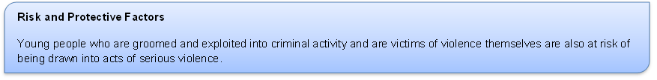

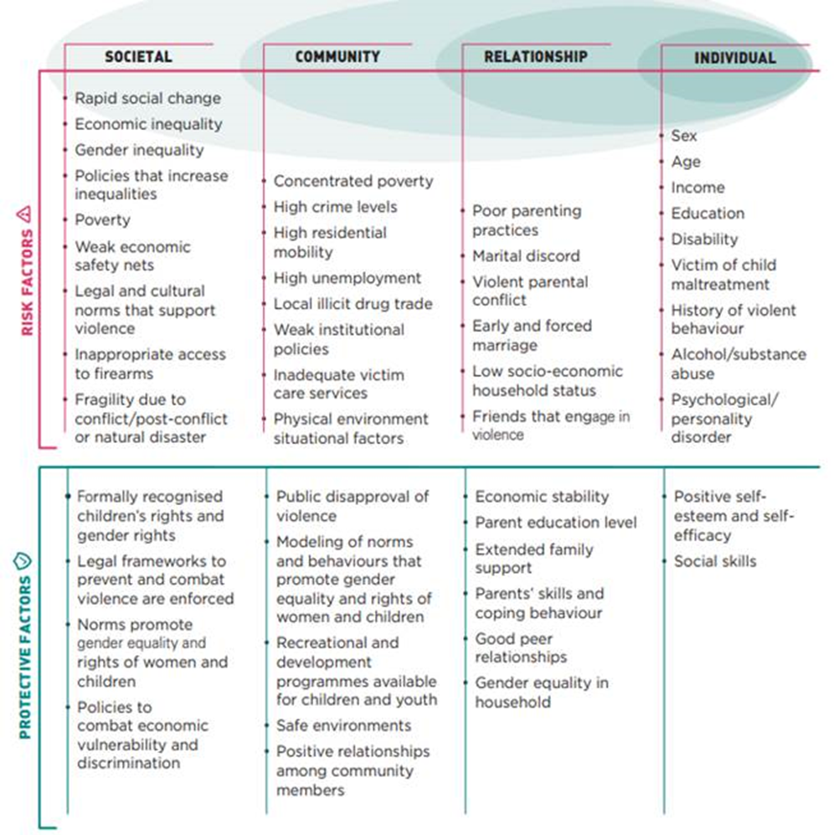

Services that may be able to help
The Early Help app (link to follow) provides information about a range of preventative services who have experience of working with young people who have been harmed or exploited and are at risk of offending, and with victims of violence, including Connecting Families, Project 28 substance misuse project, Mentoring Plus, Youth Connect, Compass and the Young Victims’ Service.
Future4Me works with Care and Custody Leavers, the Youth Offending Service works with young people who have committed an offence and the Adolescent Risk Team work with young people who have been exploited and are at risk of significant harm.
For further information about the Protocol, contact
Sally Churchyard, Head of Young People’s Prevention Service
Link to the Serious Youth Violence Protocol (to follow)
Link to the criminal Exploitation Protocol (to follow)
Local Strategy
B&NES is an area of relatively low crime and although we know some young people who have been involved in serious violence, numbers are currently low. We are taking a Public Health approach to ensuring the problem does not increase, focusing on the well-being of the whole community by:
- Defining the problem – sharing information between agencies to gain a better understanding of what is happening
- Applying wider knowledge and experience to identify local risk and protective factors
- Working on solutions, including for disrupting those who groom young people, and testing them out
- Promoting universal harm prevention initiatives, particularly in schools, to provide young people with the information they want, give them skills to develop positive relationships and increase aspiration and self esteem

