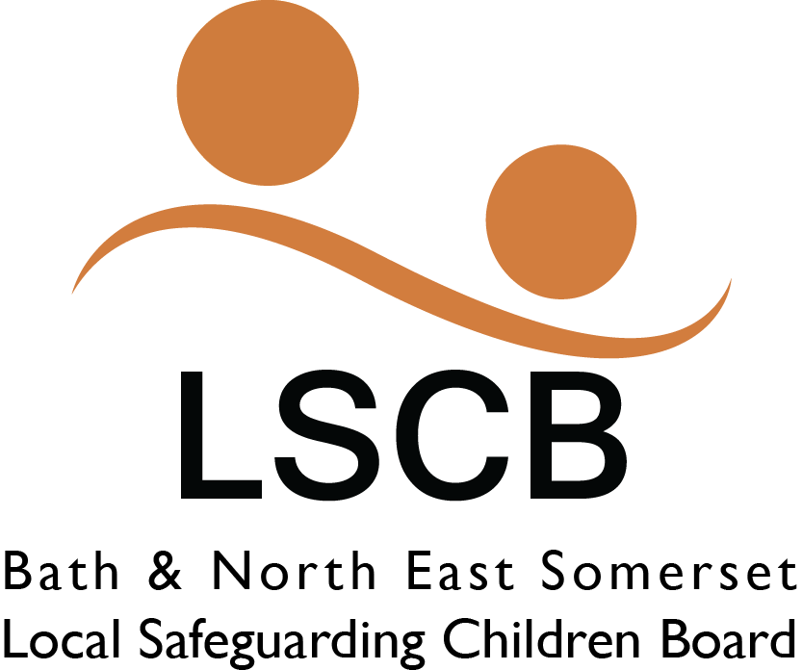

Multi-Agency Pre-birth Protocol to Safeguard Unborn Babies

This updated Protocol is specific to Bath and North East Somerset, please read this in conjunction with the South West Child Protection Procedures Procedure that can be found at www.swcpp.org.uk

Date approved by LSCB | June 2019
Author | Leigh Zywek
Date for review | June 2022
Detail of review amendments | June 2019 with changes to WT2018 and Threshold Document as well as the addition of a One Minute Guide.

Introduction
Young babies are particularly vulnerable to abuse, and work carried out in the antenatal period can help minimise any potential harm if there is early assessment, intervention and support. This multi-agency protocol sets out how to respond to concerns for unborn babies, with an emphasis on clear and regular communication between professionals working with the mother and family members involved.
Risk to children is the greatest in the first 3 months of life and parents are the usual perpetrators. Abuse and neglect during the first years of life have a disproportionate effect on later development, primarily due to rapid brain development and attachment. Physical and emotional neglect lead to poor developmental outcomes in all areas in early childhood. Frightened and frightening parenting can lead to a disorganised attachment which is linked to a range of problems throughout later life, particularly mental health problems.
Therefore, it is vital to get support to a family during the pregnancy and beginning of a child’s life.

The aim of this protocol is to enable practitioners to work together with families to safeguard unborn babies where vulnerability and risk indicators are identified. It provides an agreed process between Health agencies, Children’s Social Care and other agencies working with the mother and her family on the planning, assessment and actions required to safeguard the unborn baby.

This Protocol is specific to Bath and North East Somerset and how services are structured in our area, it is intended to be read alongside the South West Child Protection Procedures that can be found at: http://www.proceduresonline.com/swcpp/banes/p_prebirth_sg_unborn.html
and cover the whole of the South West.

2 Risk factors

Risk factors that should alert professionals to consider a co-ordinated response:

Where mothers, fathers or partners or any other significant member of the household

- Are involved in risk activities such as substance misuse, including drugs and alcohol
- Have perinatal/mental illness or support needs that may present a risk to the unborn baby or indicate their needs may not be met
- Are victims or perpetrators of domestic abuse
- Have been identified as presenting a risk, or potential risk, to children, such as having committed a crime against children
- Have a history of violent behaviours
- Are not able to meet the unborn babies needs e.g. significant learning difficulties and in some circumstances severe physical or mental disability
- Are known because of historical concerns such as previous neglect, other children subject to a child protection plan, subject to legal proceedings or have been removed from parental care
- Are known because of parental involvement as a child or adult with Social Care.
- Are currently ‘Looked After’ themselves or were looked after as a child or young person
- Are teenage/young parents
- Are living in poor home conditions, homelessness or temporary housing
- Any other circumstances or issues that give rise to concern

Where there is a late booking or a concealed or denied pregnancy any health or other practitioner should complete an immediate assessment in order to identify which agencies need to be involved and make appropriate referrals. In the case of a concealed or denied pregnancy a referral must be made to Social Care.

For Noting : A concealed pregnancy is described as one in which a woman knows that she is pregnant but does not tell anyone, or those who are told collude and conceal the fact from health professionals.

A denied pregnancy is when a woman is unaware of, or unable to accept the fact that she is pregnant. Although the woman may be intellectually aware that she is pregnant, she may continue to think, feel and behave as though she is not. Some women will deny they are pregnant until they actually deliver the baby, whereas others acknowledge the pregnancy before the birth.

Working with fathers or new partners

It is important that all agencies involved in pre and post birth assessment and support, fully consider the important role of fathers for their baby. The South West Child Protection procedures provide useful information and advice for professionals about working and involving fathers:

http://www.online-procedures.co.uk/swcpp/parenting-capacity-families/working-with men/

In addition any new partner or person within the household should trigger the professionals involved to re-assess the risk to the unborn child.

wheN concerns are identified about an unborn child
When any professional becomes aware of pregnancy or impending parenthood and is of the view that there will be a need for additional support or that the unborn child will be vulnerable due to the circumstances of their service user they must inform maternity services of their involvement and highlight any vulnerabilities identified. The mother should have the contact details for their midwifery support. If she is not willing or unable to share the contact details, then the midwifery team will depending upon their location. If the mother lives in Keynsham, their midwifery team can be contacted on 0117 9461000. If anywhere else in B&NES, please contact the Named Midwife for Safeguarding on 01225 825 323. Safeguarding team email
ruh-tr.RUHSafeguardingChildren@nhs.net

The professionals involved should then refer to Bath and North East Somerset’s Local Safeguarding Children’s Board Threshold Document to determine at which Level they believe support should be provided. This document in full can be found at:
Threshold for Assessment (June 2019)

3a Concerns which require an early Elp assessment
Providing early help is more effective in promoting the welfare of children than reacting later. Early help means providing support as soon as a problem emerges especially if the needs are unclear, multiple or complex. The professional that knows the family best should complete an Early Help Assessment (previously known as CAF).

Consider referring the family for a Family Group Conference https://www.bathnes.gov.uk/services/children-young-people-and-families/safeguarding-and-child-protection/family-group

In Bath and North East Somerset the most up to date information about the Early Help Assessment process can be found at:
https://www.bathnes.gov.uk/services/children-young-people-and-families/early-help-support-families

Following the completion of an Early Help Assessment, a Team around the Child/Family (TAC/F) meeting should be arranged. This will bring all the professionals who are working with the family, plus the parents, together to confirm a plan and set a date for the next meeting. Also, a Lead Professional will be negotiated at this meeting. The plan then gets reviewed at the next meeting and a further meeting set. This pattern continues until the concerns reduce where the process ends or if they increase and it is felt a step-up to Children’s Social Care is required.

There are a range of universal, targeted and specialist services available to support expectant parents from conception, all of which are detailed in the Integrated Early Childhood Service Pathway (0-5 years).

If the parent is under 18 consideration needs to be given as to whether they require their own support as a young person and appropriate signposting or referrals made.

It is important for practitioners to remember that an Early Help Assessment is not required where it has been identified that an unborn baby has already met threshold of being at risk of significant harm.

Early Help Assessment Pre-Birth Triangle- Unborn Bay’s needs, Parenting Capacity and Environment:
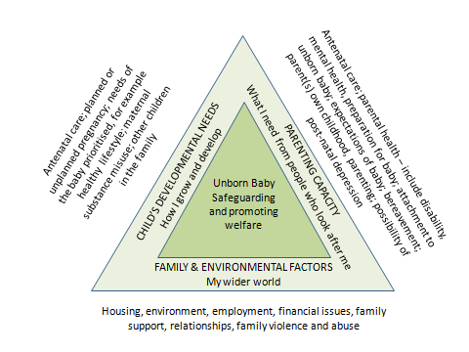Factors when considering the risks to an unborn baby:
These are examples and not an exhaustive list

Unborn baby
Unwanted pregnancy | Inability to prioritise baby’s needs
Emotional detachment from pregnancy/maternal ambivalence | Poor antenatal care/attendance
Concealed/Denied pregnancy/late booking | No preparation for baby’s needs
Lack of awareness of the baby’s needs | Premature birth
Inappropriate parenting plans | Foetal abnormality

Parenting Capacity
Adverse childhood experiences | Age - very young/teenager/immaturity
Experience of being in care | Communication difficulties
Abuse in childhood, denial of abuse | Mental health/personality health issues
Drug/alcohol misuse | Learning difficulties
Violence/abuse of others | Lack of engagement with practitioners
Abuse/neglect of previous children | History of Postnatal depression
Previous care proceedings | Asylum seekers/USAC/No recourse to public funds
Learning disability | Exploitation
Known offender against children | Previous Child Protection plans

Family and Environment
Domestic abuse | Relationship disharmony
Unsupportive relationship | Multiple relationships
Frequent moves of home | Lack of support networks
Inappropriate home environment | Financial difficulties
Unemployment | Inappropriate associates
Change of partner | Uncontrolled or potentially dangerous animals
History of violence | Mistreated animals
Homelessness/unsecure temporary housing

3b concerns which require a referral to children’s social care (CSC)
If there is identification of risks and vulnerabilities that would suggest upon their birth the Unborn may experience neglect, emotional, physical or sexual harm, then a Request for Service (known as a Referral in Working Together 2018 Guidance
https://www.gov.uk/government/publications/working-together-to-safeguard-children--2) This needs to be made to Social Care as early as possible and no later than 18 weeks. If the risks do not escalate to this level until later in the pregnancy, then a Request for Service should be made as soon as identification of the risks occur.

Ideally, consent from the parents should be sought before a request for service is made but this can be overridden if by gaining consent, the unborn baby is placed at further significant risk or where professionals have had difficulty making contact with the parents.
Information Sharing : Advice for practitioners providing safeguarding services to children, young people, parents and carers July 2018)

Requests for Service (referrals) to CSC should also be considered when there are complex needs or a significant level of support is required. In this situation, parents should be informed of the Request for Service and the content of it. If you would like advice on whether a Request for Service does reach SC thresholds, then please consult the Child Protection lead in your agency or if they are not available (or you are that person) Bath and North East Somerset Council’s Children and Families Duty and Assessment Team can be consulted on 01225 396312 or 01225 396313.

A Request for Service (referral) must always be made to Social Care if there are the following circumstances:
- There has been a previous unexpected or unexplained death of a child whilst in the care of either parent.
- A parent or other adult in the household is a person identified as presenting a risk, or potential risk, to children. This may be due to domestic abuse, violence, substance/alcohol abuse, mental health or learning difficulties. If it identified that parents have a learning need then consideration needs to be given to any additional support or intervention they may require.
- Children in the household / family currently subject to a child protection plan or previous child protection concerns.
- A sibling (or child in the household of either parent) has previously been removed from the household temporarily or by court order.
- Where there are serious concerns about parental ability to care for the unborn baby or other children.
- Where there are maternal risk factors e.g. denial of pregnancy, concealed pregnancy, avoidance of antenatal care (failed appointments), non-co-operation with necessary services, non-compliance with treatment with potentially detrimental effects for the unborn baby.
- Any other concern exists that the baby may be at risk of significant harm.
- There is a perinatal mental illness that presents a risk to the unborn baby

SC may not take further action (for example if a previous concern was unsubstantiated) but the decision whether to take action or not in the above instances needs to remain with SC. Professionals should always complete a Request for Service, in the above instances.

How to Request a Service (make a referral) to B&NES Children’s Social Care
The Request for Service form for Bath and North East Somerset’s CSC can be found on the B&NES website at: http://www.bathnes.gov.uk/services/children-young-people-and-families/child-protection

Details on how to complete and send the form once complete are on the form itself. It is recommended that you contact the Duty and Assessment Team on the telephone to confirm the form has been received. Within 24 hours/one working day CSC should contact the referrer to let them know the outcome of their Request for Service (Working Together Guidance 2018).

Practitioners must re-refer any case if they become aware that there has been significant change that increases the risk to the unborn baby, for example, a new partner.

Outcomes of the Referral to Children’s Social Care (CSC)

- If a Request for Service is not accepted by CSC, they may recommend an Early Help Assessment is completed or a referral to another service, e.g. Family Nurse Partnership. If you disagree with SC’s decision, Working Together guidance is clear that this should be followed up. Please refer to the B&NES LSCB Escalation Protocol:

LSAB & LSCB Escalation Protocol (March 2019)
Escalation Report Proforma (March 2019)

- If a Request for Service is accepted by SC then a social worker will be allocated and a pre-birth assessment will be completed within 45 working days (Working Together Guidance 2018). This will require input from all professionals working with the family.

- Where social care assess the baby to be at risk of significant harm , the baby’s needs and those of the family’s will be considered within the child protection process. All professionals involved with the family will contribute to the assessments and interventions.

Upon completion of the pre-birth assessment, SC may make the following decisions:

- No further action required by CSC however a step-down process will be followed and arrangements for ongoing support will be provided if identified. The ongoing support could be an Early Help Assessment, referral to Connecting Families or referral to the Family Nurse Partnership.
- Ongoing support to the family is required by SC through the Child in Need procedures (also known as Section 17 of the Children Act 1989). A social worker will remain involved, develop a plan with other agencies and hold regular review meetings entitled Child in Need Meetings.
- That the baby is at risk of significant harm

Notifying the Referrer of the outcome of a RFS
It is the responsibility of CSC to notify the referrer of the outcome of their referral which should normally be received in 72 hours. If this is not received within this time it is the responsibility of the referring practitioner to check the outcome with CSC.

Child Protection Concerns
If there is reasonable cause to suspect an unborn baby is likely to suffer significant harm, a strategy discussion will be convened. This will be co-ordinated and chaired by SC who will involve all other professionals involved with the family.
The strategy discussion will determine if there is evidence of risk or actual risk of significant harm. If this is the case a S47 enquiry will be initiated either jointly with SC and Avon and Somerset constabulary or SC only to ascertain the level of and source of risk to the unborn baby.

Outcome of S47 Enquiry

Child in Need
One of the outcomes of the S47 enquiry is that the unborn baby may not be at risk of significant harm but may require ongoing social care support in these circumstances a social worker will remain involved, develop a plan with other agencies and hold regular review meetings entitled Child in Need Meetings.

Child in Need of Protection
Another possible outcome of the s47 enquiry may be that there is evidence that the
unborn baby is suffering or at risk of suffering significant harm once born. In these circumstances Children’s Social Care will convene an Initial Child Protection Conference and will need to consider the most appropriate timing for this to be held. It may be that, where the pregnancy is in the early stages there is sufficient time for assessment and interventions to be provided to address the identified risks prior to birth. In such cases Children’s Social Care may decide, in consultation with other agencies undertake this work and hold a further strategy discussion at a later point in the pregnancy if necessary to consider whether the risk of significant harm is still evident. In such cases the unborn child will be subject to a child in need plan.

Whether the decision following the S47 enquiry is to proceed to an Initial Child protection Conference or hold a strategy discussion later in the pregnancy the Initial Child Protection Conference must take place within 15 working days of the date of the LAST strategy discussion and no later than week 28 of pregnancy. The Child Protection Conference should be informed by completed assessments to evidence the risk of significant harm.
The aim of the conference is to ensure all the information is brought together and analysed. If the child protection conference decides that the child is likely to suffer significant harm once born, a child protection plan will be drawn up that focusses on outcomes to be achieved, by whom and within what timescales.

Again, if at any point you disagree with any decisions then follow the B&NES LSCB Escalation Protocol:
LSAB & LSCB Escalation Protocol (March 2019)
Escalation Report Proforma (March 2019)

Following an initial child protection conference, where the unborn baby is subject to child protection planning, it is the responsibility of the Social Worker with core group members and involvement of the Named Midwife for Safeguarding, at the first core group meeting to develop a detailed safeguarding birth plan and ensure that it is disseminated to agreed partners and relevant birthing units. This will detail the planning for delivery and the immediate post-natal period, including who should be notified upon the birth of the baby.
The detailed safeguarding birth plan must be disseminated to relevant professionals including the Emergency Duty (out of hours social care) Service (EDS).The safeguarding birth plan should include contact numbers and names of professionals involved and the agreed arrangements for where the baby once born is to be discharged to.
It is the responsibility of the Named Midwife for Safeguarding Children to ensure that other health practitioners involved are informed, for example the obstetrician, neonatologist, GP, Health Visitors (HVs). The social worker is responsible for ensuring other relevant agencies such as EDS and the police are aware of the detail of the safeguarding birth plan. All professionals will need to be clear about their role and that of others, which should be set out in the safeguarding birth plan.
The Safeguarding Birth Plan should be shared with parents unless to do so is felt to put the mother or baby at increased risk of harm. Professionals will need to agree how the plan will be shared with parents.

It is also possible at any time during the above process that CSC will decide that the concerns are at such a high level that they will seek legal advice and possibly launch the pre-proceedings process, under the Public Law Outline. This will run alongside the Child Protection procedures above and will be undertaken by the allocated social worker although other agencies may be requested to submit evidence.

The new-born baby should not be discharged at weekends or on bank holidays unless there is a consensus of opinion that it is safe and reasonable to do so. This is documented in the child’s medical record and discharge plan.

Unique additional actions that only apply to unborn babies in the following circumstances:
  - Subject to a child protection plan
  - Subject to a pre-birth single assessment
  - Subject to pre-proceedings processes
If the above apply, then a Safeguarding Birth Plan and a Discharge Planning Meeting is required. For full details on both processes, please refer to the SWCPP at:
http://www.proceduresonline.com/swcpp/banes/p_prebirth_sg_unborn.html

If all above processes are followed, all professionals involved with the family should know the plans both during pregnancy and following the birth. It allows time for assessment and support to be provided before the child is born, positive relationships to develop and ultimately more babies to remain within their families.

Appendix 1- Bath and North East Somerset Integrated Early Childhood Services Pathway (details support available from conception to age 5 according to level of need/vulnerability)

Appendix 2 - Appendix Two BNES Safeguarding Birth Plan and Discharge Template

Appendix 3 – BNES Workflow for Birth Planning Meetings

Appendix 4 - Neglect Toolkit

