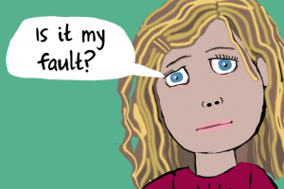

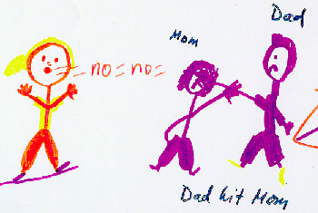

The New Way Service
117 Newbridge Hill
Bath BA1 3PT
01225 421686

www.bathnes.gov.uk

The NEW WAY Service

Children’s Social Care
Domestic Violence and
Abuse Service

Making Bath & North East Somerset a better place to live, work and visit

I feel scared when mummy
& daddy argue

How can I keep the
Children safe?

How can I make it
Stop?

What if someone gets
Really hurt?

New Way is a Service to help parents (and potential parents) understand that shouting, violence and other abusive behaviours, will have a negative impact on you and your children.

We will support you to;
• Understand the impact this has on your children
• Learn about why you feel angry or upset
• Reduce arguments
• Communicate in a positive way
• Learn about what is controlling behaviour
• Achieve a healthier happier relationship

We would be happy to talk with you if you require more information, please contact: Chris Martin, Project Worker or Shan Sinclair, Project Worker on Tel: 01225 421686 - Monday – Wednesday

Referrals to:
Maggie Ward (Senior Practitioner, Monday – Thursday)
01225 396324

WHAT DO YOU EXPERIENCE?

SHOUTING TALKING

ARGUING DISCUSSING

NAME CALLING COMPLIMENTS

SULKING SHARING FEELINGS

THREATS ENCOURAGEMENT

FRUSTRATION LISTENED TO

ISOLATION SUPPORTIVE

BLAMING SAYING SORRY

PUTTING
YOU DOWN APPRECIATED

MIND GAMES HONESTY

GUILT RESPONSIBILITY

CHECKING MY
PHONE TRUST

WHAT DO THE CHILDREN EXPERIENCE ??????

