Note: Base Map was taken from p134 of BANES Local Plans 2016-2036, Options Consultation, Oct 2018:-

<https://www.bathnes.gov.uk/services/planning-and-building-control/planning-policy/local-plan-2016-2036>

The red circles ( ) represent 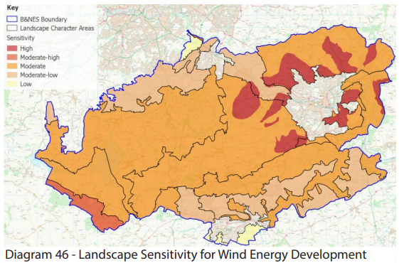wind turbines that have been Permitted by BANES Planning Dept and are actually installed. These have been added to the base map. The red crosses (**X**) represent wind turbine projects that were Refused by BANES Planning Dept. The BA Numbers refer to a specific BANES Planning Application number based upon the date of each Application. The lower numbers are more recent than the larger numbers. These numbers are referred to in the separate document titled “*Wind Turbine Planning Applications, BANES, Details, (2004 to 2019)”* – also attached.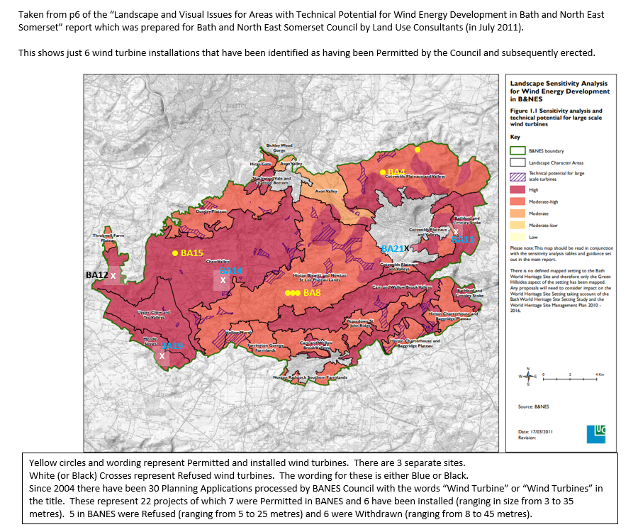

**BA21**

**X**

**BA11**

**X**

**BA19**

**BA12**

**BA14**

**X**

**X**

**X**

**BA15**

**BA8**

**BA4**