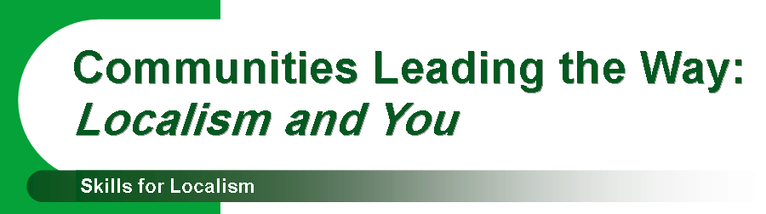
BOOKING FORM

Please complete one form per person attending

Name: | Tel:
Address:
Email:
Organisation Name:
Role:
Do you have any specific dietary requirements we should know about?
Are there any other needs to tell us about?
Please indicate your choice of workshops in the chart provided below:

Workshop Number
Workshop choice 1
Workshop choice 2
Workshop choice 3
Workshop reserve choice

We will do our best to ensure that you are able to attend the workshops you wish to participate in. However, in some cases we may only be able to offer the 2nd choice if participant numbers are too high.

If you do not complete a booking form we cannot guarantee you a place on any of the workshops of your choice.

Please return this booking form by Friday 19th October 2012:
Sharon Woolley, Community First, Wyndhams, St Josephs Place, Devizes, Wiltshire SN10 1DD
or email: swoolley@communityfirst.org.uk or fax it to: 01380 728476

