Keynsham Transport Strategy
Exhibition Comment Form
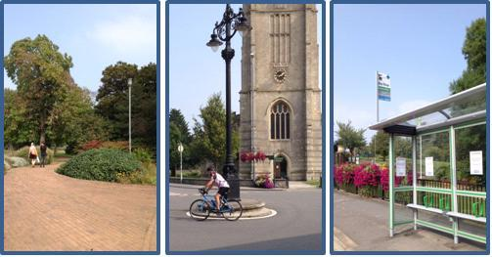

Please make any comments or changes you wish to see made to the Keynsham Transport Strategy below by 2nd October 2015 and return to transportation@bathnes.gov.uk, or
Transportation Planning, Bath & North East Somerset Council, Lewis House, Manvers Street, Bath, BA1 1JG.

