

**BATH AND NORTH EAST SOMERSET**

**SUSTAINABLE CONSTRUCTION CHECKLIST SUPPLEMENTARY PLANNING DOCUMENT**

**CONSULTATION DRAFT SPRING 2018**

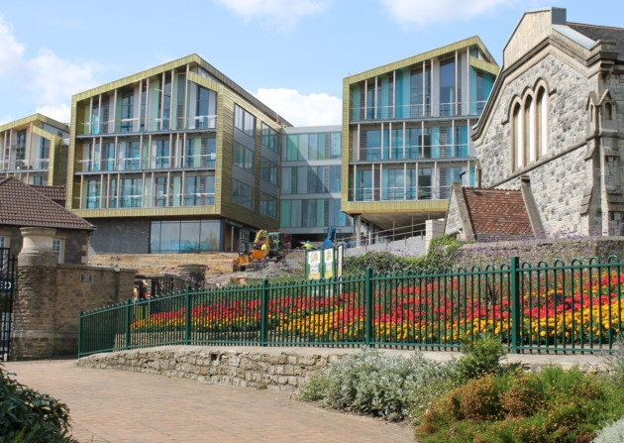

# **Contents**

Contents 2

PART 1: GUIDANCE 3

Background 3

Scope, Definitions and Approach 3

SECTION 1: THE PROPOSAL 4

SECTION 2: ENERGY EFFICIENCY & RENEWABLE ENERGY 5

1. Placemaking Plan Energy Policies 5

2. Completing the Summary Tables 2.1 and 2.2 5

3. Completing Tables 2.3, 2.4 and 2.5: General Points 6

Track 1: Major new build developments - Tables 2.3 and 2.4 7

Track 2: Minor new build development - Table 2.5 9

Track 3: Major and medium development on existing buildings - Table 2.5 9

Track 4: Certified Passivhaus (Table 2.5) 11

Exemptions 12

SECTION 3: DISTRICT HEATING 12

SECTION 4: WATER 13

SECTION 5: OVERHEATING 13

All Proposals: Table 5.1 14

Large Scale Development: Tables 5.2 to 5.6 15

SECTION 6: SUSTAINABLE CONSTRUCTION 18

SECTION 7: NON COMPLIANCE 19

APPENDIX: DOCUMENTATION EXAMPLES 19

1. Part L output documents: 19

2. Microgeneration Certificate Scheme (MCS) Certificates 21

PART 2: THE CHECKLIST 23

SECTION 1: THE PROPOSAL 23

SECTION 2: ENERGY 24

SECTION 3: DISTRICT HEATING 28

SECTION 4: WATER 30

SECTION 5: OVERHEATING 31

SECTION 6: SUSTAINABLE CONSTRUCTION 36

SECTION 7: NON-COMPLIANCE 37

# **PART 1: GUIDANCE**

The Guidance below sets out the rationale for the Sustainable Construction Checklist Supplementary Planning Document (SCC SPD) and how the Checklist in Part 2 should be completed.

# Background

Environmental sustainability and climate change is a key priority for Bath & North East Somerset Council. Our Environmental Sustainability and Climate Change Strategy[1] sets a CO2 reduction target for the area of 45% by 2029, in line with the government’s legally-binding target to cut national emissions 80% by 2050.

Development can play an important role in meeting this target, by minimising the emissions that cause climate change and future-proofing to cope with the climatic changes that will take place within the buildings’ lifetime. To facilitate this, tackling climate change is a cross-cutting objective within the Placemaking Plan.

**Case Study:** The Council aims to exemplify sustainable construction in our own development projects, for example Keynsham Civic Centre, pictured below. Our experience has been that energy efficiency does not have to cost more; by using a fabric-first approach, renewable energy and good design, the Civic Centre was built to achieve a Display Energy Certificate rating of “A” at no capital cost uplift. Annual energy bills have fallen from c.£180,000 in our old office to c.£7,000 at the Civic Centre. The focus on sustainability has also resulted in a healthy and comfortable environment for our staff and the receipt of many awards.

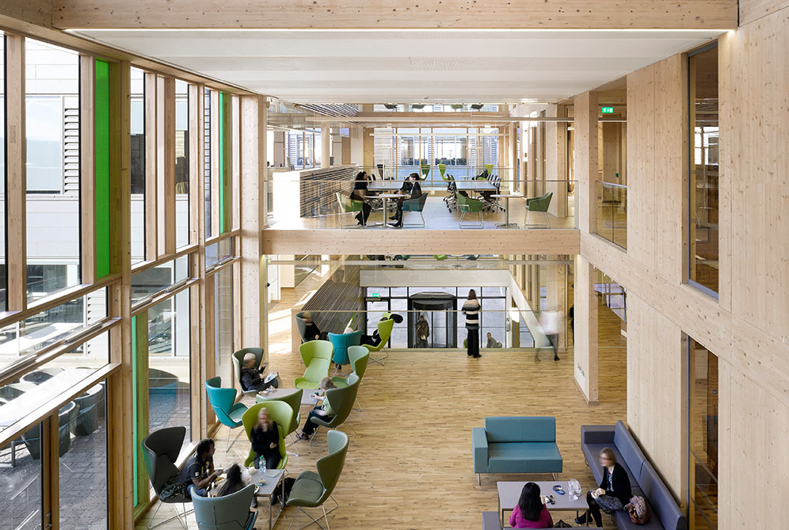

# Scope, Definitions and Approach

**Climate Change Policies:** The SPD address the key policies in the “Responding to Climate Change” section of the Placemaking Plan[2]. Please review this section in full for complete policy wording and further policies that are not covered by the SPD. Please also refer to our existing Sustainable Construction and Retrofitting SPD[3] which contains detailed guidance for the building types in our district, including historic buildings. Other aspects of sustainability such as transport, drainage and ecology are handled separately and are outside the scope of this SPD.

**Which proposals need to complete the checklist?**

* All new build proposals
* All proposals for works on existing buildings that have 5 or more dwellings or 500m2 or more of floor space to be created.

**Definitions of development size:**

* Large Scale development: 50 dwellings + or 5000m2 + of floor space to be created.
* Major development: 10 + dwellings or 1000m2 + of floor space.
* Medium development: 5-9 dwellings or 500m2 to 999m2 of floor space.
* Minor development: 1-4 dwellings or up to 499m2 floor space.

**Two stage compliance process:** The Checklist and accompanying documentation is to be submitted where required (1) at the application stage in order to register an application and (2) in order to discharge planning conditions.

**Application Stages:** The checklist is required in order to register all outline, full or reserved matters planning applications, except reserved matters applications for Access. Please see guidance below for which sections to submit by when. We also advise that the checklist is submitted with pre-application proposals.

**Change of Use:** For change of use proposals, policies will be applied to the proposed use. For example, if a non-residential building is being changed into dwellings, the proposal is to comply with the requirements for dwellings.

**Further documentation:** The checklist should accompany documents that provide further detail, such as Sustainability Statements or Energy Strategies. Please reference where further information and drawings can be found.

**Checklist Review:** The checklist may be periodically updated to reflect changes in legislation, policy and practice.

**Queries:** Please call Planning Services on 01225 394041 or email [development_management@bathnes.gov.uk](mailto:development_management@bathnes.gov.uk).

# SECTION 1: THE PROPOSAL

**Table 1.1: THE PROPOSAL:** Please input details of the proposal, stating the type and size of development and whether it is Large Scale, Major, Medium or Minor. Also note the type of application – if it is an Outline application please state which Matters have been reserved, or if it is a Reserved Matters application, please state which Matter/s the application covers.

# SECTION 2: ENERGY EFFICIENCY & RENEWABLE ENERGY

## Placemaking Plan Energy Policies

The SPD sets out the compliance requirements for the two key energy policies:

1. **Core Policy 2 (CP2): Sustainable Construction**: *“All planning applications should include evidence that the standards below will be addressed... Maximising energy efficiency and integrating the use of renewable and low-carbon energy”*

The SPD sets new benchmarks for demonstrating that energy efficiency has been “maximised” as required by CP2.

1. **Sustainable Construction Policy 1 (SCR1):** **On Site Renewable Energy:** *“Developers of Major proposals above a threshold of 1,000 square metres or 10 dwellings, excluding Industrial B2 and B8 uses, will be required to provide sufficient renewable energy generation to reduce carbon emissions from anticipated (regulated) energy use in the building by at least 10%”.*

All proposals need to respond to CP2 and major proposals will also need to respond to SCR1, as set out below:

Track 4

Certified Passivhaus

Track 3

Medium or major: Existing buildings

Track 2

Minor new build

Track 1

Major new build

Energy Policy Requirements

CP2: **19%** CO2 emissions reduction from energy efficiency or renewables

CP2 and SCR1: **10%** CO2 emissions reduction from renewables, or energy efficiency if renewables are not suitable for the existing building

Evidence of Passivhaus design process and certification

CP2: **19%** CO2 overall emissions reduction

SCR1: **10%** emissions reduction from renewables

## Completing the Summary Tables 2.1 and 2.2

**Table 2.1: Summary of requirements for Energy Tracks:** This table is to be completed by all applicants, to clarify for applicants and officers what will be submitted and by when.

Please note the approach to compliance for two stage Outline/ Reserved Matters applications. Where Appearance is being applied for, we assume that sufficient detail is known for a meaningful assessment of energy performance. So, if Appearance is not a Reserved Matter, Outline applications will be expected to attach full compliance documentation. If Appearance is Reserved, the documentation should accompany the Reserved Matters application for Appearance.

**Table 2.2: Summary of energy strategy:** All Outline, Full or Reserved Matters applications are to complete this table. Even at Outline stage some factors e.g. form and orientation may be proposed and the choice of technology may be a consideration in determination. For Outline applications where little detail is known, please state which Reserved Matters applications will address the issues.

Each section is to contain 500 words or less, summarising the approach and not simply cross-referencing other documents. Citations of specific documents should be made to provide further detail, e.g. roof layouts for PV, Sustainability Statements etc. If the proposal is not taking one of the approaches listed, please state why.

## Completing Tables 2.3, 2.4 and 2.5: General Points

* 1. **Building Regulations Assessments:** Policies CP2 and SCR1 address “regulated” emissions – those covered by Part L of the Building Regulations 2013[4]. Applicants are to demonstrate policy compliance through the energy assessment methodology that is already required for Part L compliance. Energy Tables 2.3 and 2.5 require figures from these assessments.
  2. **Design stage and post-completion assessments documents needed:** In line with the two-stage compliance approach, energy tables are to be submitted at design stage and again post completion to discharge the condition. Energy tables are to be accompanied by the **summary page** from the design-stage Part L assessment/s and post-completion assessment to enable verification of the figures quoted in the Table.
  3. **A qualified, independent energy assessor** is to model building performance using a thermal modelling tool approved for Part L compliance assessments e.g. the Standard Assessment Procedure (SAP) for residential development or the Simplified Building Energy Model (SBEM) model for non-residential development.
  4. This approach means that applicants may need a Part L assessment earlier in the design process than previously. This is to ensure the design maximises energy efficiency gains from “passive design[5]” from elements such as form, glazing and orientation. If these elements are not optimised at the earliest design stage, it becomes a lot harder and more expensive to achieve the energy performance required by the policies.
  5. **Multi- building developments:** If the proposal contains a number of buildings types applicants are expected to:

1. Demonstrate that a **representative building** from each building type is policy compliant, since the approach may be different for each type. For example, if a proposal contains large dwellings and small dwellings, non-residential buildings and works to existing buildings, a separate energy assessment and Table is required for a representative of each.
2. Confirm in the Table that the **site as a whole** will be policy compliant, explaining if performance is to be balanced across the site, e.g. if some buildings exceed the policy in order to offset lower performance in other buildings.

During the pre-application process, planning officers can advise on the number of assessments required. Please copy and paste the required number of tables into the same Checklist document so they can be viewed together. Scheme drawings should note which buildings have been selected. If queries arise, the Council may require assessments for other buildings on the scheme.

* 1. **Multiple-unit and mixed use buildings:** If a building contains more than one unit e.g. subdivided offices, a terrace or a block of flats, Block Compliance with the policy is to be demonstrated, as would be required by the Building Regulations, e.g. one assessment is to be conducted for the whole building. The same applies to mixed use buildings.
  2. **Ventilation and Overheating:** High energy performance can, and should, result in more healthy and comfortable buildings. However, it must be considered in conjunction with other factors, in particular overheating (Section 5) and ventilation to avoid unintended consequences. For example, air tight buildings must be adequately ventilated to prevent occupants having to open the windows in winter and losing energy.

### Track 1: Major new build developments - Tables 2.3 and 2.4

* 1. For Track 1, policies CP2 and SCR1 apply. The interaction of these policies is described below and in the chart overleaf.
  2. **CP2: A 19% reduction in regulated CO2 emissions:** The benchmark for demonstrating that energy efficiency has been “maximised”, as required by CP2, is a 19% reduction in regulated emissions. This is the equivalent of the energy requirement in the Code for Sustainable Homes Level 4.
  3. **SCR1: 10% emissions reduction through renewables:** After energy efficiency measures have been accounted for, a further 10% emissions reduction is to be achieved through renewables. By using a baseline which takes energy efficiency measures into account, energy efficient schemes are rewarded with a reduced requirement for renewables to comply with SCR1.
  4. The remaining CO2 reduction required for the overall 19% reduction can be achieved through renewables or energy efficiency measures, including mechanical ventilation and heat recovery (MVHR) or low carbon energy such as gas-fired Combined Heat and Power (CHP).
  5. **Table 2.3:** Since compliance with two policies; CP2 and SCR1 is required, two rounds of energy assessment are needed for Table 2.3:

1. **First round**: Calculate CO2 reductions from energy efficiency measures, starting from a baseline[6] of the Target Emissions Rate (TER)[7] to produce a Dwelling Emissions Rate (DER) or Building Emissions Rate (BER)[8] figure to use as the baseline for the second round of calculation.
2. **Second round:** Calculate the contribution of renewables by adding the renewable energy measures to the model. This should be at least 10% and the overall emissions should be 19% or more less than the TER.

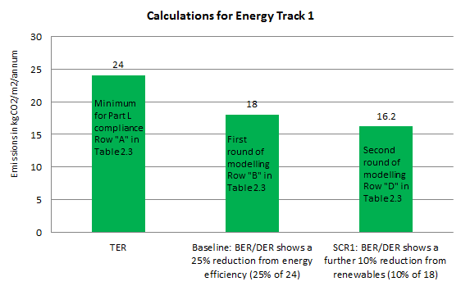

Example of Calculation for Energy Track 1

Overall emissions reduction of c. 33%, exceeding the 19% benchmark

* 1. **Table 2.4:** This is to be completed prior to occupation to discharge the planning condition, describing the renewables used and verifying that they will achieve the 10% emissions reduction. Please attach an MCS certificate for installations of up to 50kW (sample is included in the Appendix).

### Track 2: Minor new build development - Table 2.5

* 1. Minor development is covered by Policy CP2 but not SCR1 so applicants can choose whether to use energy efficiency, low carbon energy or renewable energy to meet the requirement.
  2. **CP2: A 19% reduction in regulated CO2 emissions:** The benchmark for demonstrating that energy efficiency has been “maximised” as required by CP2 is a 19% reduction in regulated emissions. This is the equivalent of the energy requirement in the Code for Sustainable Homes (CfSH) Level 4.
  3. **Table 2.5:** One energy assessment is required to demonstrate the 19% emissions reduction. A baseline of the Target Emissions Rate (TER) is to be used to produce a Dwelling Emissions Rate (DER) or Building Emissions Rate (BER) figure which is 19% lower than the TER.

### Track 3: Major and medium development on existing buildings - Table 2.5

* 1. Track 3 applies to proposals of a medium scale or above; 5 + dwellings or 500m2 + on existing buildings. Major developments also need to respond to SCR1, this is set out below.
  2. Existing buildings may have fewer options for improving energy performance and measures should be sensitive to the existing building. To reflect this, the requirements are lower:

1. **Lower benchmark for CP2:** The benchmark for CP2 compliance on medium scale development is lower than for new buildings; 10% compared to 19% for new buildings.
2. **Energy efficiency can be used on major proposals for SCR1 compliance:** Existing buildings may not be suitable for renewable energy. In this case, a 10% reduction in emissions can be achieved through energy efficiency.
   1. The reduction in emissions is to be achieved on the area within the planning application only, not the rest of the existing building that is outside the area of the planning application.
   2. **Table 2.5:** The table should demonstrate a 10% improvement in regulated CO2 emissions compared to a baseline building that meets the requirements of Part L1B for residential developments and Part L2B for non-domestic buildings. The baseline building/dwelling(s) should be modelled as follows:

* Geometry and space types as per the proposed building
* Building fabric and glazing U-values as per the requirements of Part L2B/Part L1B. Performance of thermal elements or controlled fittings that are not upgraded should be estimated as per the non-domestic EPC Conventions guidance/SAP guidance for existing dwellings
* Air tightness of the building envelope should be estimated as per the non-domestic EPC Conventions guidance/SAP guidance for existing dwellings
* New building services systems as per the minimum requirements of the Non-Domestic Building Services Compliance Guide/Domestic Building Services Compliance Guide
* Retained building services systems as per non-domestic EPC Conventions guidance/SAP guidance for existing dwellings

The proposed building/dwelling(s) should be modelled as the proposed design. Any retained systems or fabric that is not upgraded should have the same performance as the baseline building/dwellings(s).

* 1. **Historic Buildings:** Proposals for works to historic buildings will be judged on their own merits, taking into account the significance and character of the building and its setting. All Listed Building Consent application must provide full details of energy measures including their impact on fabric or building function. Further guidance is provided in the Council’s [Sustainable Construction and Retrofitting SPD](http://www.bathnes.gov.uk/services/planning-and-building-control/planning-policy/supplementary-planning-documents-spds/sustain), including advice on listed buildings and the particular building types in Bath and North East Somerset.

### Track 4: Certified Passivhaus (Table 2.5)

* 1. Proposals certified to the Passivhaus[9] standard for new build or Enerphit for existing buildings will be considered to have met the requirements for SCR1 and CP2, since the Passivhaus certification process itself has been demonstrated to reliably achieve reductions in energy use. Therefore Passivhaus projects do not need to incorporate renewables to demonstrate SCR1 compliance.

Passivhaus projects use rigorous design and construction to provide a high level of occupant comfort and use very little energy for heating and cooling. Passivhaus buildings have been shown to mitigate the “performance gap[10]” commonly found in new build projects, whereby energy use once occupied is significantly higher than predicted at the design stage.

* 1. **Compliance requirements**: In order to qualify for Track 4, applicants are to submit the following documents:

1. All applications are to include a written statement signed by the developer and the qualified Passivhaus professional working on the scheme confirming that Passivhaus professionals will be employed throughout the development process and that the scheme will be able to achieve full certification.
2. Full applications or Outline/ Reserved Matters applications for Appearance and Layout are to be accompanied by a summary output document from the Passivhaus Planning Platform (PHPP) software indicating that the design is Passivhaus compliant at this stage of development. These applications should also be accompanied by a completed Table 2.5 as per the methodology for Track 2 and supporting part L documents, which should show that emissions reductions are at least sufficient to achieve policy compliance.
3. There are a range of levels of Passivhaus certification and these may be subject to change. During the pre-application process, planning officers can advise on which of these will qualify for Track 4.
4. If a multiple-building proposal contains some units that are to be certified to Passivhaus and some that aren’t, those that are not to be certified will need to meet the usual requirements of the Energy Tracks above.
5. Achievement of Passivhaus certification will be a condition of consent, to be discharged by submission of a Passivhaus certification document prior to occupation.
6. If Passivhaus certification is not achieved, compliance with SCR1 and CP2 as set out in the other Tracks is to be demonstrated in order to discharge the condition.

### Exemptions

* 1. Our studies have shown that B2 and B8 industrial uses may find it more difficult to increase energy performance, so no requirements are set for these uses. This may be subject to change if studies are revised and applicants are still required to maximise energy performance, in line with CP2.

# SECTION 3: DISTRICT HEATING

1. **Background:** District heating can reduce CO2 emissions by using a renewable or low carbon heat source e.g. biomass, heat pumps or Combined Heat and Power.
2. **Placemaking Plan Policy CP4 - Table 3:** Below are excerpts from the Policy CP4:

*Development within Heat Network Priority Areas “will be* ***expected*** *to incorporate infrastructure for district heating, and will be expected to connect to existing systems where and when this is available, unless demonstrated that this would render development unviable”.*

For development in these Priority areas, full compliance with CP4 is required, as set out in Table 3.

*“Development within the Heat Network Opportunity Areas will be* ***encouraged*** *to incorporate infrastructure for district heating, and will be expected to connect to any existing suitable systems (including systems that will be in place at the time of construction), unless it is demonstrated that this would render development unviable”.*

For development in the Opportunity Areas, we expect to see consideration of heat networks as set out in Table 3.

1. **Maps:** To determine if a proposal is required to comply with CP4, please check the GIS layers on theCouncil’s My Maps application[11]; these maps may change as our evidence base is refined. These maps replace the “yellow circle” demarcations of Heat Network Priority Areas for the Enterprise Area, Central Bath and Keynsham on the maps contained within the Placemaking Plan.
2. **Table 3: See separate “Heat Networks Guidance Note” [forthcoming]:** CP4 only covers relatively limited areas, and requires detailed guidance which would not be relevant to most applications. In light of this, guidance for the completion of Table 3 is contained in a separate document which also contains all the technical considerations and requirements to demonstrate compliance with CP4.

# SECTION 4: WATER

Efficient use of water is important now and will become increasingly crucial as the climate changes.

1. **Policy SCR5: Water Efficiency** states that:

*a) All dwellings will be expected to meet the national optional Building Regulations requirement for water efficiency of 110 litres per person per day;*

*b) Rainwater harvesting or other methods of capturing rainwater for use by the residents (e.g. water butts)* ***will be required*** *for all residential development, where technically feasible.*

1. **Table 4: Water:** Full applications or Outline/ Reserved Matters applications applying for Appearance for residential proposals are to complete Table 4. Mixed use proposals should provide an assessment for the residential element of the scheme.
2. **Major residential applications** are to attach the outputs of a Part G Water Calculator (widely available online) to illustrate the water efficiency strategy and demonstrate compliance with the standard. Pre-applications can provide an outline of their approach to water efficiency in the narrative section of the table.

# 

# SECTION 5: OVERHEATING

Global temperatures have already [risen 1°](https://climate.nasa.gov/news/2391/analyses-reveal-record-shattering-global-warm-temperatures-in-2015/) from a pre-industrial baseline. A 2°C rise in temperature, predicted by the 2030s, would provide temperatures roughly equivalent to the South of France. Climate change is already causing overheating and this is likely to worsen over the lifetime of the buildings. The design of buildings should ensure comfortable conditions for future occupants without relying on carbon intensive active cooling. Policy CP2 states that all proposals should have *“consideration of climate change adaptation”* and overheating is a major element of this. All proposals are to respond to overheating, with specific requirements for Large Scale development.

## All Proposals: Table 5.1

1. **Table 5.1: Overheating mitigation strategy:** Full applications or Outline/ Reserved Matters applications for Appearance are to include Table 5.1 stating how the Cooling Hierarchy has been implemented:

1. **Minimising internal heat generation through energy efficient design:** For example, heat distribution infrastructure within buildings should be designed to minimise pipe lengths, particularly lateral pipework in corridors of apartment blocks, and adopting pipe configurations which minimise heat loss e.g. twin pipes.
2. **Reducing the amount of heat entering the building in summer:** For example, through use of carefully designed shading measures, including balconies, louvres, internal or external blinds, shutters, trees and vegetation.
3. **Use of thermal mass and high ceilings to manage the heat within the building:** Increasing the amount of exposed thermal mass (dense materials that can absorb and release heat slowly) can help to absorb excess heat within the building.
4. **Passive ventilation:** For example, through the use of openable windows, cross-ventilation, dual aspect units, designing in the ‘stack effect’.
5. **Mechanical ventilation:** Mechanical ventilation can be used to make use of ‘free cooling’ where the outside air temperature is below that in the building during summer months. This will require a by-pass on the heat recovery system for summer mode operation.
6. Overheating should be considered alongside other design criteria[12]. Proposals should respond to their context and the measures set out in Table 5.1 will not be suitable in all cases. We expect to see the optimisation of measures that do not increase CO2 emissions as opposed to active cooling e.g. air conditioning.

## Large Scale Development: Tables 5.2 to 5.6

1. **CIBSE Assessment:** Large Scale new-build development can demonstrate leadership in tackling overheating. The compliance tools for Building Regulations are not intended to accurately evaluate overheating, so Large Scale proposals are to use the more sophisticated CIBSE standards TM52 for non-residential development and TM59 for residential development[13].
2. The CIBSE methodologies assess “adaptive thermal comfort” which takes into account that building occupants already adapt to high temperatures, e.g. by wearing lighter clothing. This is captured in the criteria below:
3. TM59 & TM52: “Hours of Exceedance”, a measure of how often the temperature exceeds a threshold comfort temperature during a typical warm season, and sets a limit of 3% of occupied hours.
4. TM52: “Daily Weighted Exceedance”; the severity of overheating within any one day. The limit is no more than 6 hours a day above the thermal comfort threshold.
5. TM52: “Upper Limit Temperature” which sets an absolute maximum temperature for a room beyond which the level of overheating is unacceptable.
6. **Early-stage condition:** We appreciate that CIBSE assessments are a cost for applicants and also that they are not meaningful until the detailed design is complete. To reflect this, CIBSE assessments will be required at a later stage; in order to discharge an early-stage condition; instead of being required at the application stage. This means that the assessment is undertaken only once the design is finalised.
7. **Multiple Buildings:** Proposals with multiple buildings are to assess a representative sample of each building type. Please consult with an officer during the pre-application process about how many assessments are needed.
8. **Current and future climate scenarios:** Since the buildings constructed today will still be occupied in 2050, it is important to consider how buildings will perform under future conditions. The CIBSE assessment should be run twice with the following data files/ scenarios:
9. **Current Climate:** CIBSE Design Summer Year (DSY1) for the 2020s, high emissions, 50th probability scenario (Swindon data should be used for this and all other modelling using CIBSE files).
10. **Future Climate:** 2050 files, medium emissions, 50th probability scenario. Applicants can select whether to use the CIBSE 2050 data files or those available from the PROMETHEUS[14] project or its successor, Project COLBE[15] which are based on climate change models and will shortly be available at a 5km grid resolution, including for Bath.
11. **Compliance benchmark:** Large development will be expected to meet the TM59 or TM52 standard for the 2020s scenario (CIBSE DSY1), showing that it will not require active cooling to remain comfortable in the current climate.
12. We expect most residential development to achieve a “pass” for the current climate, and most non-residential development also, unless there are exceptional circumstances, e.g. a deep-plan office building. If the proposal cannot achieve a pass without active cooling, Table 5.5 “Active Cooling” is to be used. It is understood that achieving compliance when using future climate scenarios may be more difficult. If a pass is not possible, Table 5.6 is to be completed (see below).
13. **Table 5.2: Overheating in residential development:**  Large residential proposals of 50 units or more should conduct the assessment for CIBSE TM59 *“Design methodology for the assessment of overheating risk in homes”*[16]*.* Outputs are to be used to complete Table 5.2. The CIBSE assessment is to be undertaken on a baseline building with no active cooling, to demonstrate that passive measures have been maximised. As noted above, two assessments are to be undertaken, for the current and future climate respectively.
14. **Table 5.3: Overheating in non-residential development:** Large non-residential proposals of more than 5000m2 are to use the methodology in CIBSE TM52 *“The Limits of Thermal Comfort: Avoiding Overheating in European Buildings”.* Modelling should be conducted for the part of the building hat has the greatest risk of overheating as per the CIBSE methodology. The CIBSE assessment is to be undertaken on a baseline building with no active cooling, to demonstrate that passive measures have been maximised.
15. Compliance benchmark: Meet the CIBSE standard in the current climate:Proposals are to achieve a “pass” for the current climate, meeting criteria A and B (hours of exceedance in living rooms, kitchens and bathrooms and hours of exceedance in bedrooms).
16. We expect residential development to achieve a “pass” for the current climate unless there are exceptional circumstances. If the proposal cannot achieve a pass without active cooling, Table 5.5 “Active Cooling” is to be used to show that the performance of the active cooling system exceeds the requirements of Part L.

1. **Table 5.4 CIBSE Modelling Notes:** CIBSE Modelling Notes is to be completed for all large scale applications to state how modelling has been conducted.
2. **Table 5.5: Active Cooling:** For some large proposals (e.g. offices with deep floorplates) active cooling may be a lower-carbon way to comply with CIBSE TM52 (e.g. when compared to increasing non-cooled airflow). If this can be shown to be the case, active cooling systems that exceed the requirements of Part L are to be used.
3. To verify compliance, the Part L output report’s ‘HVAC Systems Performance’ table is to be used. This compares the cooling demand of the actual and notional buildings for different building elements. Applicants should reduce the actual cooling demand below that of the notional Part L compliant cooling demand for each of the non-domestic spaces in the development where an active cooling load exists. This may mean that more than one table is completed.
4. The results should be used to complete Table 5.4 and the output document from the Part L assessment containing the HVAC Systems Performance table is to be attached to the application.
5. **Table 5.6 Future Proofing:** Meeting the CIBSE standards using future data may not be achievable in all cases. In this case, Table 5.6: Future Proofing, should be completed, setting out how the existing design facilitates the implementation of further low or zero carbon measures to address overheating should they be needed in the future.
6. **Table 5.6: Future Proofing:** Meeting the CIBSE standards using future data may not be achievable in all cases. In this case, Table 5.6: Future Proofing, should be completed, setting out how the existing design facilitates the implementation of further low or zero carbon measures to address overheating should they be needed in the future.
7. **Exemptions:** Large proposals are expected to conduct an assessment as above unless the applicant can demonstrate exceptional circumstances where opportunities for reducing cooling demands via passive measures are constrained, for example industrial buildings including warehouses used for storage purposes; supermarkets; cinemas or theatres; laboratories or temporary structures.
8. **In the case of query** during the application process, a full written report using the CIBSE methodology including modelling outputs, or direct contact with the modelling personnel may be required for verification.

# 

# SECTION 6: SUSTAINABLE CONSTRUCTION

1. **Background**: CP2 sets out requirements for important aspects of sustainable construction that cannot be verified using a standard methodology e.g. a part L Assessment for energy or a CIBSE Overheating Assessment. Compliance with these requirements will be assessed on a case-by-case basis by planning officers and consultees.

1. **Table 6: Sustainable Construction:** Full applications or Outline/ Reserved Matters applications for Appearance are to complete this table to demonstrate how they have responded to the issues in Policy CP2 listed in bold below. Links o suggested compliance routes are provided:
   1. **Minimisation of waste and maximising of recycling of any waste generated during construction and in operation:** Production of a Site Waste Management Plan (SWMP) in line with WRAP guidance[17] can enable the best use to be made of waste materials produced during construction. The Home Quality Mark[18] provides useful criteria for designing waste and recycling facilities for domestic properties, the BREEAM criteria for waste can inform non-domestic projects.
   2. **Efficiency in materials use, including the type, life cycle and source of materials to be used:** A review of how the environmental impact of materials is assessed is provided by the UK Green Building Council. For the impact of particular materials, please see the Building Research Establishment’s (BRE) Green Guide to Specification[19]. For example, applicants could commit to using only materials rated “A” or “B” on the Green Guide.
   3. **Flexibility and adaptability, allowing future modification of use or layout, facilitating future refurbishment and retrofitting**: The principles of Lifetime Homes[20] can be followed, enabling buildings to adapt to be suitable for occupants at all life stages and be adaptable for future uses.
   4. **Consideration of climate change adaptation:** A review of measures to adapt to the changing climate is provided in the Technology Strategy Board’s document “Designing for Future Climate”[21].

# SECTION 7: NON COMPLIANCE

1. We expect development to be able to comply with the requirements above. The Council has undertaken extensive study which shows that the requirements are achievable within viability constraints in the district so it is unlikely that non-compliance on the grounds of viability or technical feasibility will be accepted.
2. If non-compliance with any of the Sustainability requirements above is proposed, a full open-book viability test or technical rationale will be required. The applicant will be expected to pay the cost for an independent review to determine the validity of the review. Please complete Table 7 in this case.
3. In the case of proposed non-compliance, the Checklist is to be completed in full clearly stating which sections are non-compliant.

# APPENDIX: DOCUMENTATION EXAMPLES

## Part L output documents:

Where Part L documents are required the TER and BER/DER should be clearly displayed on the output documents as illustrated below Below is an excerpt from a Part L documents with the TER and BER/DER circled, making it straightforward to calculate whether the DER has achieved the percentage reduction required

1. **SAP summary for dwellings**

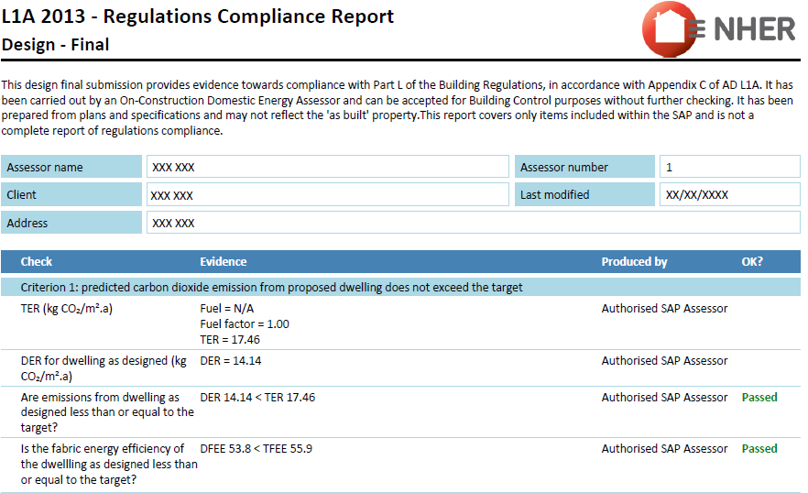

**Calculating Compliance**

To comply with CP2 for new build, the DER figure above (14.14) must be 19% lower than the TER figure (17.46) e.g.

17.46- 14.14 = 3.32

3.32 / 17.46 x 100 = 19.01

= 19.01 %

So this example demonstrates compliance with CP2.

1. **BRUKL summary for non-residential**

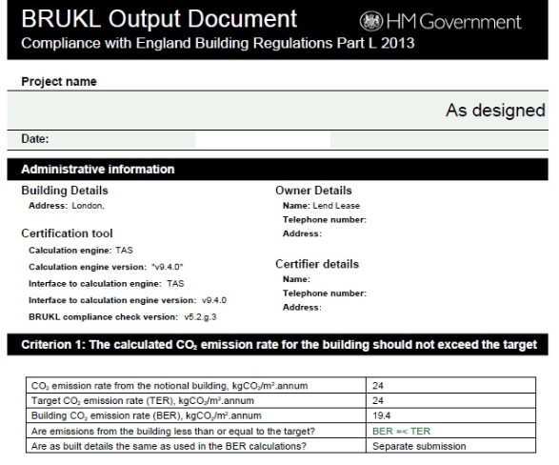

**Calculating Compliance**

To comply with CP2 for new build, the BER figure above (19.4) must be 19% lower than the TER figure (24) e.g.

24 - 19.4 = 4.6

4.6 / 24 x 100 = 19.16

= 19.16 %

So this example demonstrates compliance with CP2.

## Microgeneration Certificate Scheme (MCS) Certificates

An MCS Certificate is produced by the renewable energy installer stating that the equipment is live and connected (example below). It normally acts as the sign off from the installer, indicating they are happy their work is complete (other than snagging). It has the necessary detail to verify the information provided in Energy Table 2.

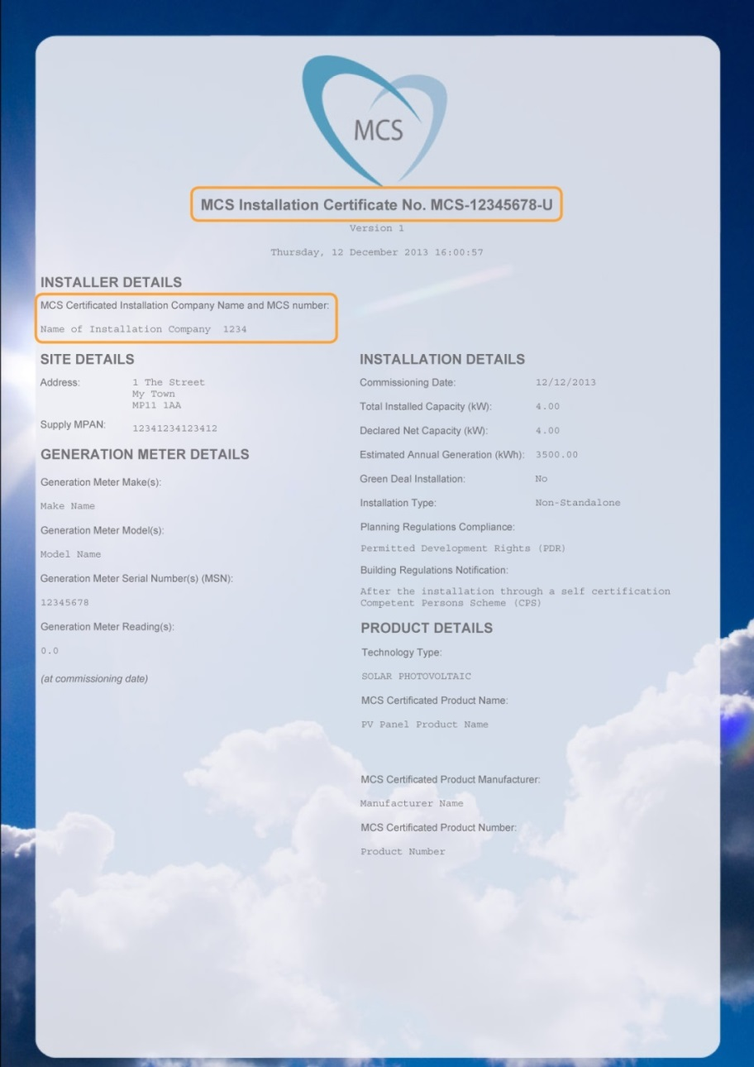

# **PART 2: THE CHECKLIST**

# SECTION 1: THE PROPOSAL

|  |  |
| --- | --- |
| **TABLE 1.1: THE PROPOSAL** | |
| **Required for:** All applications within the scope of the Checklist | |
| Name of Proposal |  |
| Brief description e.g. residential, commercial, and size | *[Insert text here]* |
| Type of application e.g. Pre-Application, Outline, Full, Reserved Matters (noting Matters Reserved) | *[Insert text here]* |
| Tick if the application is a Reserved Matters application for Access | ☐Tick here – no further information required |

# 

# SECTION 2: ENERGY

|  |  |  |  |  |
| --- | --- | --- | --- | --- |
| **TABLE 2.1 SUMMARY OF REQUIREMENTS FOR ENERGY TRACKS** | | | | |
| **Required for:**   1. Full applications or outline applications 2. To discharge the condition prior to occupation | | | | |
| **Track** | **Development Type:** Please tick to indicate which development type/s your proposal contains | **Please tick the boxes below to indicate that the required documentation has been attached** | | |
| Outline or reserved matters applications if not applying for Appearance | Full applications  Outline or reserved matters applications applying for Appearance | Prior to occupation in order to comply with conditions |
| **Track 1** | ☐ Major new build residential development  ☐ Major new build non-residential development | ☐Table 2.2: Summary of Energy Strategy | ☐Table 2.2: Summary of Energy Strategy  ☐ Table/s 2.3  ☐ Part L design stage document/s for energy efficiency measures  ☐ Part L design stage document/s for energy efficiency and renewable energy measures | ☐ Table/s 2.3  ☐ Table 2.4  ☐ Part L post-completion document/s for renewables  ☐ Part L post completion document/s for energy efficiency  ☐ MCS Certificate/s |
| **Track 2** | ☐ Minor new build residential development  ☐ Minor new build non -residential development | ☐Table 2.2: Summary of Energy Strategy | ☐Table 2.2: Summary of Energy Strategy  ☐ Table/s 2.5  ☐ Part L design stage document/s | ☐ Table/s 2.5  ☐ Part L post completion document/s |
| **Track 3** | ☐ Major or medium works to existing buildings | ☐Table 2.2: Summary of Energy Strategy | ☐Table 2.2: Summary of Energy Strategy  ☐ Table/s 2.5  ☐ Part L design stage document/s | ☐ Table/s 2.5  ☐ Part L post completion document/s |
| **Track 4** | ☐ Passivhaus | ☐Table 2.2: Summary of Energy Strategy | ☐Table 2.2: Summary of Energy Strategy  ☐ Statement from Passivhaus professional and Summary of outputs from design stage PHPP  ☐ Table/s 2.5  ☐ Part L design stage document/s | ☐ Table/s 2.5  ☐ Part L post completion document/s  ☐ Passivhaus certification |
| **Exempt** | ☐ Industrial B2 or B8 uses |  |  |  |

|  |  |  |  |
| --- | --- | --- | --- |
| **TABLE 2.2: SUMMARY OF ENERGY STRATEGY** | | | |
| All required sections are to be completed in 500 words or less per section. A summary is to be provided, stating the approach, not simply a reference to other documents, although additional detail should be signposted via references to specific, named documents. See Section 2 of the Guidance above for details. | | | |
| **1 & 2 below required for all applications, inc. outline applications where appearance is Reserved** | | | |
| 1. **Passive design** e.g. building form, orientation and shading, including orientation of roofs to maximise solar energy potential. Please note - this is an important consideration for Layout, so applications covering Layout should provide a full explanation of the approach. | | | |
| *[Insert text here]* | | | |
| 1. **Renewable and low carbon energy approach** e.g.solar energy, biomass, heat pumps, solar thermal, heat networks and Combined Heat & Power (CHP). Please cite where drawings of renewable/low carbon technology are included in the application. | | | |
| *[Insert text here]* | | | |
| **3- 7 below required for Full or Reserved Matters applications for Appearance** | | | |
| 1. **Energy efficiency measures** e.g. materials with high energy performance (lower U values than required by Part L), minimisation of thermal bridging, more insulation, low energy fixtures, heat recovery e.g. Mechanical Ventilation with Heat Recovery (MVHR) and appliances. | | | |
| *[Insert text here]* | | | |
| 1. **Heating and hot water strategy** e.g. air source heat pumps, responsive heating controls, underfloor heating. | | | |
| *[Insert text here]* | | | |
| 1. **Smart infrastructure** e.g. smart meters and appliances, energy storage, electric vehicle charging (please reference transport policies), building management systems. | | | |
| *[Insert text here]* | | | |
| 1. **Ventilation and Indoor Air Quality Strategy** e.g. airtightness, natural or mechanical ventilation, windows, use of natural or low Volatile Organic Compound (VOC) materials. Where wood burners are to be used, please comment on the mitigation of impacts on external air quality. Please note how the building will be ventilated in winter if a high airtightness is proposed. | | | |
| *[Insert text here]* | | | |
| 1. **Performance Gap during and after construction:** Note (1) construction management practices to ensure buildings are constructed to meet the target performance levels and (2) aftercare and post-occupation measures to ensure that systems are commissioned correctly and occupants know how to optimise energy performance, e.g. Soft Landings or seasonal commissioning of plant. | | | |
| *[Insert text here]* | | | |
| **TABLE 2.3: CALCULATIONS FOR TRACK 1** | | | |
| **Required for:**   1. Full applications or outline/ reserved matters applications for Appearance 2. To discharge the condition prior to occupation | | | |
| For multiple building proposals, please state which building this is an assessment for; the reason for selecting this building as an example of building type, and a reference to where the building can be found on the drawings. | | *[Insert text here]* | |
| For multiple building developments, please highlight Yes or No to indicate whether the proposal as a whole will comply with Energy Track 1 and note how; e.g. if some buildings will have lower energy performance and be offset by others with higher performance. | | **Yes/No**  *[Insert text here]* | |
| A | Baseline emissions | | kg CO2/m2 |
| B | Emissions after Energy Efficiency and Low Carbon measures (baseline for SCR1 compliance) | | kg CO2/m2 |
| C | % CO2 reduction from Energy Efficiency measures only (A-B)/A*100 | | % |
| D | Emissions after Renewables are added to the Energy Efficiency Measures | | kg CO2/m2 |
| E | Further % CO2 reduction from Renewables only.  **At least 10% to comply with SCR1**  (B-D)/B*100 | | % |
| F | CO2 savings from all measures- Renewable and Energy Efficiency | | kg CO2/m2 |
| G | % CO2 reduction from all measures.  **At least 19% to comply with CP2** (A -F)/A*100 | | % |
| ☐ Please tick to confirm that the two sets of design stage or post-completion SAP/SBEM summary documents are attached. This is required for registration of the application:   1. The reduction in CO2 from energy efficiency measures only (C) 2. The overall reduction once renewables are added (G) | | | |
| Company name of independent assessor conducting the assessment: *[Insert text here]* | | | |

|  |  |  |  |  |
| --- | --- | --- | --- | --- |
| **TABLE 2.4: RENEWABLE TECHNOLOGIES FOR TRACK 1** | | | | |
| **Required for:** Submission post-completion, to discharge the planning condition | | | | |
| Technology type (e.g. PV, solar thermal, biomass) | Description | Capacity from this technology (kW) | Estimated annual generation (kWh) | Total CO2 saving from this technology (kg CO2/m2) |
| ***Sample:*** *Solar PV* | *28m2 of 345W PV panels, 16% efficiency* | *3kWp* | *2550 kWh* | *1045* |
| *[add lines as needed]* |  |  |  |  |
|  |  |  |  |  |
| **TOTAL** |  |  |  |  |
| ☐ Please tick to confirm that the MCS Certificate is attached showing that the renewable technologies cited in this table have been installed and are operational (for installations of up to 50kW). This is required for discharge of the condition. | | | | |

|  |  |  |  |
| --- | --- | --- | --- |
| **TABLE 2.5: CALCULATIONS FOR TRACKS 2, 3 AND 4** | | | |
| **Required for:**   1. Full applications or outline/ reserved matters applications for Appearance 2. To discharge the condition prior to occupation | | | |
| For multiple building proposals, please state which building this is an assessment for; the reason for selecting this building as an example of building type, and a reference to where the building can be found on the drawings. | | *[Insert text here]* | |
| For multiple building developments, please highlight Yes or No to indicate whether the proposal as a whole will comply with Energy Track 1 and note how; e.g. if some buildings will have lower energy performance and be offset by others with higher performance. | | **Yes/No**  *[Insert text here]* | |
| A | Baseline emissions | | kg CO2/m2 |
| B | Emissions after All Measures (Renewables plus Energy Efficiency Measures) | | kg CO2/m2 |
| C | **Track 2 and 4:**  % CO2 reduction from all measures should be at least 19% (A-B)/A*100 | | % |
|  | **Track 3:**  % CO2 reduction from all measures, should be at least 10% (A-B)/A*100 | | % |
| ☐ Please tick to confirm that design stage or post-completion SAP/SBEM summary documents are attached. This is required for registration of the application | | | |
| Company name of independent assessor conducting the assessment: *[Insert text here]* | | | |

# SECTION 3: DISTRICT HEATING

|  |  |  |  |
| --- | --- | --- | --- |
| TABLE 3: DISTRICT HEATING | | | |
| **Required for:** Full applications or outline/ reserved matters applications for Appearance within a Heat Network Priority Area or Heat Network Opportunity Area. Pre-applications should respond to questions 1 - 5. See Section 3 of the Guidance for details and the **separate “Heat Networks Guidance Note”** | | | |
| **1** | Is the proposal in a Heat Network Priority Area? | Yes | No |
| **2** | Is the proposal in a Heat Network Opportunity Area? | Yes | No |
| **If “Yes” to Question 1 (Priority Area), at least one of Questions 3-5 must also be a “Yes”**  **If “Yes” to Question 2 (Opportunity Area), please complete the table. If Questions 3-5 are “No” please explain further in Question 13.** | | | |
| **3** | Does the proposal include a heat network? If “Yes” please complete question 8. | Yes | No |
| **4** | Does the proposal include connection to an existing heat network? If “Yes” please complete question 8. | Yes | No |
| **5** | Is the proposal future-proofed to connect to future heat networks? If so, the answer to Questions 9- 12 should be “Yes” | Yes | No |
| 6 | If the proposed development is in proximity to an existing district heating scheme (e.g. Bath Western Riverside), has the incumbent district heating operator been contacted to discuss the potential for connection to the existing network? Proof of contact with the operator may be required. | Yes | No |
| 7 | If the proposed development is a large scale multi-building development (e.g. over 500 residential units and/or over 10,000m2 of non-residential floor space – in particular with hotels, hospitals, leisure centres or student residences), has an open-book viability assessment for district heating been carried out and full report attached? This is required for policy compliance. | Yes | No |
| 8 | If a heat network or connection to a heat network is proposed, has a document providing further details been attached? Please reference below.  If a fossil-fuelled heat source is proposed please summarise below the strategy for switching to a renewable heat source in the future. Where a mix of energy sources is being proposed e.g. biomass with backup gas boilers, please explain the controls which will ensure the mix of energy sources used post occupation will be in compliance with policies CP2 and SCR1. | Yes | No |
| *[Insert text here]* | | |
| **Future Proofing** | | | |
| 9 | **Single heat source:** If the development includes residential apartment buildings, is heating provided to the apartments from a single central heat source as opposed to heating plant for individual units? Please explain in Question 13 if the answer is “no”. | Yes | No |
| 10 | **Protected Pipe Routes:** (a) Has a potential intake route for district heating pipe to the building(s) been identified and safeguarded? (b) Have the pipe routes been safeguarded to connect from the building plant room to the route of the district heating network. Enterprise Area applications please reference the “Potential District Heating Cluster” map in the Heat Networks Guidance Note.  Please note below the document and page number containing the drawing/s upon where these measures are identified. | Yes | No |
| *[Insert text here]* | | |
| 11 | **Plant room location**: Is the heating plant room(s) in a location that allows access for district heating pipe (e.g. located on ground floor, adjacent to public highway) Please note below the document and page number containing the drawing/s upon where these measures are identified. | Yes | No |
| *[Insert text here]* | | |
| 12 | **Plant room design:** Does the plant room design allow for future connection e.g. space allowed for installation of a plate heat exchanger and additional plant as required? Please note below, including the calculations for space allocated, and reference the document and page number showing where this is included in drawings. | Yes | No |
| *[Insert text here]* | | |
| 13 | Please add any further information | | |
| *[Insert text here]* | | |

# SECTION 4: WATER

|  |  |
| --- | --- |
| **TABLE 4: WATER** | |
| **Required for:** Full applications or outline/ reserved matters applications for Appearance for residential development, or the residential element of a mixed use scheme. Pre-applications within this scope should provide a summary of the approach in the box below. See Section 4 of the Guidance for details. | |
| Outline below the approach to water efficiency e.g. greywater or rainwater harvesting, low-flow rate sanitary ware and white goods | |
| *[Insert text here]* | |
| **Confirming compliance and documentation required** | |
| ☐ Major residential development: 10+ dwellings.  All three boxes opposite should be ticked. | ☐ The 110 litres per person per day standard will be met  ☐Rainwater harvesting or other methods of capturing rainwater for use by the residents (e.g. water butts) has been included  ☐The output from an accredited Part G water calculator has been attached, demonstrating the results and measures used. |
| ☐ Non- major residential development  Both boxes should be ticked. | ☐ The 110 litres per person per day standard will be met  ☐Rainwater harvesting or other methods of capturing rainwater for use by the residents (e.g. water butts) has been included as required by the policy |

# SECTION 5: OVERHEATING

|  |
| --- |
| **TABLE 5.1: OVERHEATING MITIGATION STRATEGY** |
| **Required for:** Full applications or outline/ reserved matters applications that address appearance, and suggested for pre-applications within this scope. See Section 5 of the Guidance for details. |
| Please describe how the Cooling Hierarchy has been followed. All sections are to be completed giving a summary of the response to the issue and cross-referencing where further detail can be found, in 500 words or less per section. |
| **Minimising internal heat generation through energy efficient design:** For example, passive design that minimises solar gain on south facing facades in buildings likely to overheat e.g. offices; heat distribution infrastructure within buildings should be designed to minimise pipe lengths, particularly lateral pipework in corridors of apartment blocks, and adopting pipe configurations which minimise heat loss e.g. twin pipes. |
| *[Insert text here]* |
| **Reducing the amount of heat entering the building in summer:** For example, through use of carefully designed shading measures, including balconies, louvres, internal or external blinds, shutters, trees and vegetation. |
| *[Insert text here]* |
| **Use of thermal mass and high ceilings to manage the heat within the building:** Increasing the amount of exposed thermal mass (dense materials that can absorb and release heat slowly) can help to absorb excess heat within the building. Please cite floor to ceiling heights. |
| *[Insert text here]* |
| **Passive ventilation:** For example, through the use of openable windows, cross-ventilation, dual aspect units, designing in the ‘stack effect’ |
| *[Insert text here]* |
| **Mechanical ventilation:** Mechanical ventilation can be used to make use of ‘free cooling’ where the outside air temperature is below that in the building during summer months. This will require a by-pass on the heat recovery system for summer mode operation. |
| *[Insert text here]* |

| **TABLE 5.2: OVERHEATING IN RESIDENTIAL DEVELOPMENT – CIBSE TM59** | | | | | | | |
| --- | --- | --- | --- | --- | --- | --- | --- |
| **Required For:** Full applications or outline/ reserved matters applications for Appearance for large scale residential proposals, in order to discharge the condition.The proposal should achieve a “pass” in the current climate scenario to comply with CP2 and set out an overheating future proofing scenario in Table 5.4 | | | | | | | |
| Zone Name and Room Use | **Criterion A:** Hours of exceedance for living rooms, kitchens and bedrooms | | | **Criterion B:** Hours of exceedance for bedrooms only | | | **Result**  To comply, Criteria A & B to be met for current climate |
| **A**. Occupied Hours | **B.**  Max. no. hours exceedance (3% occupied hours) | **C.** Calculated No. hours exceeding Comfort Range – **Not to exceed “B”** | **D.**  Annual Night time occupied hours | **E**.  Max. no. hours exceedance (1% occupied hours) | **F**.  Calculated no. hours exceeding Comfort Range – **Not to exceed “E”** |
| Example: Bedroom 1 | 3,672 | 110 | 90 | 3285 | 32 | 25 | Pass  X |
| Example: Living room | 1,989 | 59 | 40 | n/a | n/a | n/a | Pass  X |
| **CURRENT CLIMATE - CIBSE DSY1.** Results expressed in hours | | | | | | | |
|  |  |  |  |  |  |  | Pass ☐ |
| [Add rows as needed] |  |  |  |  |  |  | Pass ☐ |
| **FUTURE CLIMATE:** Results expressed in hours | | | | | | | |
|  |  |  |  |  |  |  | Pass ☐ |
| Add rows as needed] |  |  |  |  |  |  |  |
| **Please tick to confirm**  ☐ Two CIBSE TM59 assessments have been completed   1. Present climate 2. Future climate   ☐ Tick here to verify that the cover sheet for both assessments have been attached, summarising overheating performance | | | | | | | |

| **TABLE 5.3: OVERHEATING IN NON-RESIDENTIAL DEVELOPMENT – CIBSE TM52** | | | | | | | |
| --- | --- | --- | --- | --- | --- | --- | --- |
| **Required For:** Full applications or outline/ reserved matters applications for Appearance for large scale non-residential proposals, in order to discharge the condition. The proposal should achieve a “pass” in the current climate scenario to comply with CP2. | | | | | | | |
| **Building for which the assessment has been carried out (more than one table may be required):**  *[Insert text here]* | | | | | | | |
| Zone Name (E.g. stairwell) | Room use (e.g. circulation space) | **Criterion 1:** Hours of exceedance  Maximum number of hours internal temperature above outside temperature | | | **Criterion 2:** Daily weighted exceedance | **Criterion 3:** Upper limit temperature | **Results**  To comply, 2 out of 3 criteria to be met for the current climate |
| **A.**  Occupied Hours – will depend on use type | **B.**  Maximum number of hours of exceedance (3% occupied hours) | **C.**  Calculated no. hours exceeding comfort range - **Not to exceed “B”** | **D.**  Calculated peak daily weighted exceedance –**to be under 6 hours** | **E.**  Calculated no. hours exceeding absolute limit – **to be zero hours** |
| **CURRENT CLIMATE (CIBSE DSY1):** Results expressed in hours | | | | | | | |
|  |  |  |  |  |  |  | **Pass ☐** |
| [Add rows as needed] |  |  |  |  |  |  | **Pass ☐** |
| **FUTURE CLIMATE:** Results expressed in hours | | | | | | | |
| [Add rows as needed] |  |  |  |  |  |  | **Pass ☐** |
|  |  |  |  |  |  |  | **Pass ☐** |
| **Please tick to confirm**  ☐ 2 CIBSE TM52 assessments have been completed   1. Present climate 2. Future climate   ☐ Tick here to verify that the cover sheet for both assessments have been attached, summarising overheating performance | | | | | | | |

|  |  |  |
| --- | --- | --- |
| **TABLE 5.4: CIBSE MODELLING NOTES** | | |
| **Required For:** Full applications or outline/ reserved matters applications for Appearance for large scale residential or non-residential proposals, in order to discharge the condition | | |
| For accommodation with vulnerable occupants such as babies, elderly or disabled people have Type 1 occupancy parameters (as per CIBSE TM52) been used? | Yes | No |
| Has a full written report for TM52 or TM59 been produced in line with the CIBSE methodology? | Yes | No |
| Please note which buildings were selected to model compliance and why: | | |
| *[Insert text here]* | | |
| Please note which part/s of the building/s were selected to model compliance and why: | | |
| *[Insert text here]* | | |
| Please note modelling including the datasets, locations, software used and emissions scenario: | | |
| *[Insert text here]* | | |
| Company name of independent assessor conducting the assessment: | | |
| *[Insert text here]* | | |

|  |  |
| --- | --- |
| **TABLE 5.5: ACTIVE COOLING** | |
| **Required For:** Full applications or outline/ reserved matters applications for Appearance for large scale residential or non-residential proposals, in order to discharge the condition. | |
| Please describe below why active cooling would result in lower CO2 emissions whilst meeting the CIBSE TM52 requirement than passive cooling, and outline the active cooling strategy. Include the type of plant and efficiencies, and whether free or renewable cooling sources such as ground or river water cooling have been used. | |
| *[Insert text here]* | |
| Please insert below the figures from the BRUKL “HVAC Systems Performance” table | Area weighted average building cooling demand (MJ/m2) |
| Actual (must be lower than the notional value): | *[Insert text here]* |
| Notional: | *[Insert text here]* |
| **Please tick to confirm**  ☐ Part L output section containing the “HVAC Systems Performance*”*  table is attached | |

|  |
| --- |
| **TABLE 5.6: FUTURE PROOFING** |
| **Required For:** Full applications or outline/ reserved matters applications for Appearance for large scale residential or non-residential proposals for which the current design does not achieve compliance with the CIBSE standard in the 2050 climate, in order to discharge the condition. |
| Please describe the measures that could be applied in the future to enable the building to address overheating in the future climate and how the existing design has facilitated the implementation of these measures, with an emphasis on low or zero carbon measures. |
| *[Insert text here]* |

# SECTION 6: SUSTAINABLE CONSTRUCTION

|  |
| --- |
| **TABLE 6: SUSTAINABLE CONSTRUCTION** |
| **Required For**: Full applications or outline/ reserved matters applications within this scope. See Section 6 of the Guidance for resources. All sections are to be completed giving a summary of the response to the issue and cross-referencing where further detail can be found, in 500 words or less per section. |
| **Minimisation of waste** and maximising of recycling of any waste generated during construction and in operation: |
| *[Insert text here]* |
| **Efficiency in materials use**, including the type, life cycle and source of materials to be used: |
| *[Insert text here]* |
| **Flexibility and adaptability**, allowing future modification of use or layout, facilitating future refurbishment and retrofitting: |
| *[Insert text here]* |
| **Climate change adaptation** other than overheating e.g. heavy rain, flooding, landslide. Measures might include slope stabilisation, Sustainable Urban Drainage Systems (SUDS), oversized gutters: |
| *[Insert text here]* |
| **Please note any sustainability standards** to be sought e.g. BREEAM, Home Quality Mark, or other energy targets |
| *[Insert text here]* |

# SECTION 7: NON-COMPLIANCE

|  |
| --- |
| **TABLE 7: NON-COMPLIANCE** |
| We expect development to be able to comply with the requirements above. If non-compliance with any of the Sustainability requirements above is proposed on the grounds of viability or technical feasibility, a full open-book viability test or technical rationale is likely to be required and the applicant will be expected to pay the cost for an independent review to determine its validity.  **In the case of proposed non-compliance, the Checklist is still to be completed in full, making it clear which sections are non-complaint.** |
| **Please tick here if non-compliance with any of the policies above is proposed** ☐  Please summarise below the policies for which non-compliance is proposed and summarise the rationale for non-compliance, and reference the background reports. |
| *[Insert text here]* |
| ☐ Viability: An open-book viability test is attached  ☐ Technical feasibility: An open-book technical rationale is attached  ☐ I confirm my understanding that the Council is likely to require an independent assessment to be undertaken at the applicant’s cost |

1. Bath and North East Somerset Environmental Sustainability and Climate Change Strategy 2016-2020 <http://www.bathnes.gov.uk/sites/default/files/siteimages/Environment/Sustainability/new_structure_esp_strat_version_9_-_web.pdf>
2. http://www.bathnes.gov.uk/services/planning-and-building-control/planning-policy/placemaking-plan
3. http://www.bathnes.gov.uk/services/planning-and-building-control/planning-policy/supplementary-planning-documents-spds/sustain
4. If Part L, or the methodology used to calculate compliance, is updated, the compliance requirement for this policy may also be updated
5. [Passive design](https://www.designingbuildings.co.uk/wiki/Passive_building_design) maximises the use of 'natural' sources of heating, cooling and ventilation to create comfortable conditions inside buildings. This is as opposed to 'active' design; using active building services systems to create comfortable conditions, such as boilers and chillers, mechanical ventilation, electric lighting, renewable energy and so on.
6. When determining the baseline, it should be assumed that the heating would be provided by gas boilers and that any active cooling would be provided by electrically powered equipment.
7. The target CO2 emission rate (TER) sets a minimum allowable standard for the energy performance of a building to comply with Part L of the Building Regulations and is defined by the annual CO2 emissions of a notional building of same type, size and shape to the proposed building. TER is expressed in annual kg of CO2 per m2.
8. The DER and BER is a calculation of the CO2 emissions for the building as actually specified. For more information, see the [Designing Buildings Wiki](https://www.designingbuildings.co.uk/wiki/Target_emission_rate_TER).
9. http://www.passivhaustrust.org.uk/
10. http://www.zerocarbonhub.org/current-projects/performance-gap
11. https://isharemaps.bathnes.gov.uk/atmycouncil.aspx?MapSource=BathneS%2Fplanning&Sta
12. Approaches to overheating are summarised in the Zero Carbon Hub’s leaflet: http://www.zerocarbonhub.org/sites/default/files/resources/reports/ZCH-OverheatingLeaflet-5-TechnicalSolutions-S_0.pdf
13. Links to the CIBSE standards can be found here: https://www.cibse.org/news-and-policy/policy/overheating-position-statement
14. http://emps.exeter.ac.uk/engineering/research/cee/research/prometheus/downloads/
15. http://projectcolbe.org/
16. https://www.cibsejournal.com/technical/using-tm59-to-assess-overheating-risk-in-homes/
17. <http://www.wrap.org.uk/sites/files/wrap/WMM%20guide%20Mid%20level.pdf>
18. <https://www.homequalitymark.com/standard>
19. <https://www.bre.co.uk/greenguide/podpage.jsp?id=2126>
20. <http://www.lifetimehomes.org.uk/>
21. <http://www.arcc-network.org.uk/wp-content/D4FC/01_Design-for-Future-Climate-Bill-Gething-report.pdf>