OFFICER DECISION REPORT – TRAFFIC REGULATION ORDER (TRO)
1

INFORMAL CONSULTATION

PREPARED BY: Traffic Management Team, Highways and Transport Group

TITLE OF REPORT:  PROPOSAL:  SCHEME REF No:  REPORT AUTHOR: | York Street and Swallow Street, Bath  Prohibition of Motor Vehicles  21 – 002  Neil Terry / Georgi Tyler

1. DELEGATION

The delegation to be exercised in this report is contained within Part 3, Section 4 of the Constitution under the Delegation of Functions to Officers, as follows:

Section A | The Chief Executive, Strategic Directors, Divisional Directors and Heads of Service have delegated power to take any decision falling within their area of responsibility….”
Section B | Without prejudice to the generality of this, Officers are authorised to:  serve any notices and make, amend or revoke any orders falling within his/her area of responsibility.
Section D9 | An Officer to whom a power, duty or function is delegated may nominate or authorise another Officer to exercise that power, duty or function, provided that Officer reports to or is responsible to the delegator.

For the purpose of this report, in June 2020, the Divisional Director Environmental Services delegated the power to make, amend or revoke any Orders to the Assistant Director, Highways & Transport.

2. LEGAL AUTHORITY

This proposal is made in accordance with the Road Traffic Regulation Act 1984, which under Section 1 provides, generally, for Orders to be made for the following reasons, and in the case of this report specifically for the reason(s) shown below:

(a) | for avoiding danger to persons or other traffic using the road or any other road or for preventing the likelihood of any such danger arising, or
(b) | for preventing damage to the road or to any building on or near the road, or | X
(c) | for facilitating the passage on the road or any other road of any class of traffic (including pedestrians), or | X
(d) | for preventing the use of the road by vehicular traffic of a kind which, or its use by vehicular traffic in a manner which, is unsuitable having regard to the existing character of the road or adjoining property, | X
(e) | (without prejudice to the generality of paragraph (d) above) for preserving the character of the road in a case where it is especially suitable for use by persons on horseback or on foot, or | X
(f) | for preserving or improving the amenities of the area through which the road runs, or | X
(g) | for any of the purposes specified in paragraphs (a) to (c) of subsection (1) of section 87 of the Environment Act 1995 (air quality)

3. PROPOSAL

To introduce a permanent ‘Prohibition of Motor Vehicles’ restriction to remove traffic from York Street (between its existing closed end at Stall Street and its junction with Abbey Street) and Swallow Street (between York Street and a point approximately half-way along its length). The extent of the proposed restriction is shown in Appendix A.

4. BACKGROUND

In 2016 the Heritage Services were awarded £5million by National Heritage Lottery Fund to expand the Roman Baths and create an educational centre in the heart of Bath. The new state-of-the-art World Heritage Visitor Centre and Clore Learning Centre will bring back to life an important group of buildings in the city centre.

In the final stages of redevelopment, the buildings include the former Bath City Laundry, constructed by the City Architect Major C. E. Davis in the late 19th century and no. 10 York Street, as well as the vault below the highway excavated by Major Davis in the 1880s. The Visitor Centre will serve the city by expanding the knowledge and understanding of the World Heritage Site and the Learning Centre will provide the general public with the opportunity to explore parts of the Roman Baths that have never been opened to regular public access.

The Roman Baths is already one of the top tourist attractions in the UK, attracting over 1.3 million visitor every year (ALVA 2019). These new assets are expected to attract an additional 100,000 annual visitors to the area increasing footfall and creating new opportunities for trade in the Abbey Quarter.

The project is supported by a public realm scheme which will help to further enhance visitors’ experience to this special part of the city. The key aims of the public realm scheme are to enhance the sense of place and ease of movement for visitors to both the Visitor Centre and Learning Centre as well as, the Abbey, Kingston Parade and the businesses in the Abbey Quarter. The proposals will also facilitate the delivery of an accessible entrance to the Learning Centre (compliant with the Equality Act 2010 and Building Regulations), provide a solution to water ingress in the vaults below the highway and protect the vaults below the highway to further damage, whose structures are at risk if vehicular access is not removed. A temporary restriction has been in place here since 2017 due to the weakness of the structure.

The delivery of a new pedestrianised public realm in the heart of the city, will increase the amenity and accessibility of the area. In additional to this the quality of the built environment has been identified by many industries (RIBA, RICS, RTPI) as a driving factor in encouraging people back to cities and towns post Covid-19. The Visitor Centre and Learning Centre creates an opportunity to showcase Bath on the world stage and invite people back into the city. A safe and inviting public realm will be essential to achieving this.

5. SOURCE OF FINANCE

This proposal is being funded through the capital works budget for the Archway Project.

6. CONSULTATION REQUIREMENT

The proposal requires informal consultation with the Chief Constable, Ward Members and the Cabinet Members for Transport.

PROPOSAL APPROVED FOR INFORMAL CONSULTATION WITH THE CHIEF CONSTABLE AND WARD MEMBERS.

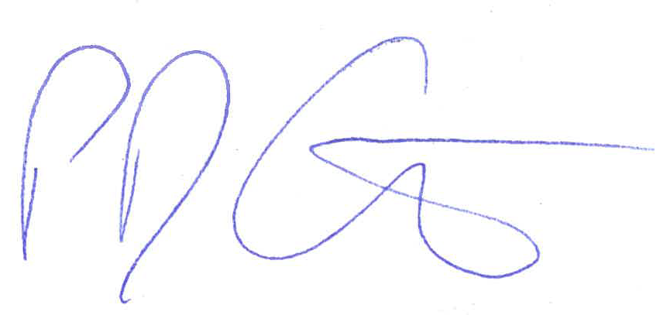 Date: 18th May 2021

Paul Garrod
Traffic Management and Network Manager

