Activities and Worksheets

**Knife Crime resources**

Developing Health and Independence

Project 28 – Serious Violence

Tel: 01225 463 344

www.dhi-online.org.uk

**Contents**

Risk scale – what are the risks?.............................................................................................2

Knife crime quiz – Agree or disagree?...................................................................................4

Knife crime quiz – True or false?.......................................................................................... 5

Gang profile……………………………………………………………………………………………………….…………….6

Kyle’s story……………………………………………………………………………………………………………….………8

‘What if’ flashcards…………………………………………………………………………………………………………11

Values…………………………………………………………………………………………………………………………….14

Violent language…………………………………………………………………………………………………………….15

No knives vs Knives………………………………………………………………………………………………………..16

Circle of peace……………………………………………………………………………………………………………….18

Resolving conflict…………………………………………………………………………………………………………..19

Conflict in the community…………………………………………………………………………………..…………20

Living peacefully…………………………………………………………………………………………………………….21

Behavioural risks……………………………………………………………………………………………………..…….22

Worry tree…………………………………………………………………………………………………………….……….25

True stories……………………………………………………………………………………………………………….…..27

Asking for help…………………………………………………………………………………………..………………….28

Help cards………………………………………………………………………………………………………………..……30

DHI - Project 28

15 – 16 Milsom Street, Bath BA1 1DE

Tel: 01225 463 344

www.dhi-online.org.uk





**What are the risks?**

Where would you put these statements on the ‘**Risk Scale**?’

“I’ve started hanging out with a new group of friends.”

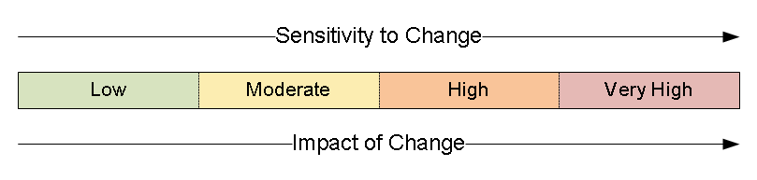

Not that risky

Very risky



Not that risky

Very risky

“I’m getting bullied and someone threatened to stab me.”

“My friend showed me a knife during break time.”



Not that risky

Very risky



Not that risky

Very risky

“My dad gave me a pen knife for my 15th birthday.”

“I’ve joined a group of older mates, I really want to fit in.”



Not that risky

Very risky

“I carry a knife to feel safe.”



Not that risky

Very risky

“My friend asked me to look after their knife.”



Not that risky

Very risky

“I carry a knife to protect myself. I don’t plan to use it.”



Not that risky

Very risky



Not that risky

Very risky

“I play GTA for about 4 hours every day.”

“I’ve been sending anonymous hate mail to this girl online.”



Not that risky

Very risky



Not that risky

Very risky

“My new boyfriend says he’s in a gang.”

“I want to look cool in front of my older friends so I stole my mum’s kitchen knife.”



Not that risky

Very risky

Most of these statements do not have a correct answer. Use these for interesting points of discussion.

*Knife Crime Quiz!*

*Agree or Disagree?*

1. An argument would get out of control quickly if someone had a knife
2. It will be harder for a person to achieve their goals and ambitions if they are involved in knife crime
3. Is there any valid reason to carry a knife
4. A person will carry around a lot of guilt if they have seen or been part of an attack
5. If someone’s friend carries a knife that person may stop hanging around with them
6. A person’s friends and family would be really disappointed and upset if they got arrested
7. People who carry a knife often have, an increased feeling of danger, fear and stress
8. People who have survived knife incidents are often left with permanent life-changing trauma

*Knife Crime Quiz!*

*True or False?*

1. A person can get up to one years in prison for carrying a knife
2. A person could end up in hospital if attacked by a knife
3. A person can get a criminal record for carrying a knife
4. A person can die from a knife attack
5. A person who uses a knife to attack someone can get a life sentence of 25 years in prison
6. It will be harder to get into college, university, a job or even travel to different countries with a criminal record
7. 87% of young people aged 10-29 don’t carry a knife. True or false?
8. People under the age of 18 are allowed to buy cutlery knives (knife and fork). True or false?
9. A person who carries a knife could have it used against them
10. If someone took a knife into school, it’s the teachers who will deal with it.
11. 10. If a group of friends were with someone who uses a knife to hurt somebody, they will get into trouble too.
12. Countries like America and Canada may not allow someone with a criminal record into their country, even just to go on holiday.

**Answers:**

1. **False, 4 years**
2. **True**
3. **True**
4. **True**
5. **True**
6. **True**
7. **False, 99% of young people do not carry knives**
8. **False, it’s illegal**
9. **True, you are more likely to be hurt by your own knife**
10. **False, the police would be called immediately**
11. **True, they could all face the same punishment. This is known as ‘‘joint enterprise’’**
12. **True**

**NAME:**

**AGE:**

**GENDER:**

**TASK:** Create a gang member. Think about what they physically look like, what clothes they wear, how they speak. Also consider emotional qualities, what they might be thinking, what their future looks like and what impression they give off.

**Gang Profile**

**Hints!**

* What are they wearing?
* How do they speak?
* Do they go to school or work?
* What might their future look like?
* What impression do they give off – Good? Bad?
* How might they feel?
* What are their relationships with others like?
* What do others think of them?

**Kyle's story:**

**Read, act or storyboard the text then answer questions below**

'It was my brother, Dante, who got me involved, really. I'm not blaming him though. It's not like I don't have my own mind or anything, but the way things were, it was sort of like, if you weren't part of a gang, you were nothing. You got no respect.

I didn't have to do much at first, maybe just drop some weed off to a house the other side of town. It was always the kids on bikes that did this. I guess we were less likely to be stopped. I didn't always get a cut of any of the money they made - it felt enough just to be seen to be around the older gang members - like no one could touch you. No one would even dare look at you the wrong way - they knew who you were with; who had your back - they protected their own.

Or at least I thought they did.

I didn't know what had happened the night before, but Dante had come into my bedroom really early before school. He was still wearing the same clothes from the night before and acting weird. He looked exhausted. 'Brov, I gotta ask you to do somet. I don't want to - but,' he started to whisper, 'Rage-Boi needs you to step up.' Rage-Boi was one of the older gang members. He was 17 at the time. My brother was 15 and I was just 12.

My brother handed me this object wrapped up in a newspaper. I could tell by the shape of it is was a shank.

'What you want me to do?' I was pretty concerned at this point and I could tell something bad had gone down.

'Just keep it on you for the day. We're gonna sort it all later - just go to school, be normal. We just need this out of the way for a while.'

Dante never told me anything about what had happened the night before and when I got into school and heard some boy in the year above had been shanked, I didn't really think nothing of it. That kind of thing happens round here a lot, so I just carried on to my French class.

Then I saw these girls crying their eyes out in the corridor. There were people hugging each other. One girl was hysterical. She was sort of screaming and crying at the same time and then she curled up on the floor.

When I got in the classroom I asked my mate, Chelsey, what had happened. She said Dijon McClaren had been stabbed last night and died. No one knew why or when exactly. Just that some random guys had jumped him and he was dead by the time he was found. Probably selling on rival turf, I thought to myself.

Although I did get that this was sad news, but I didn't really know who he was so just sort of carried on my day. Teachers made announcements about people being allowed to leave to see the school councillor if they needed to - and we had this special assembly too. None of it really touched me. I didn't know the guy, I just sort of daydreamed through the assembly.

Later on we had PE and were playing football. I saw these two coppers and the Headteacher coming our way up the field. I thought they probably wanted to ask someone some questions about that boy that got shanked. It dawned on me very slowly, that they were actually only coming for me. While we were out all our bags had been searched in the changing rooms.

Looking back now, I realise what an idiot I was. The very thing that gave me that buzz, that feeling of respect; being linked with people like Rage-Boi,was the same thing that ruined my life. My brother was arrested. He's doing eight years; concealing a murder weapon and accomplice to murder. Rage-Boi's doing twenty. I was taken into foster care. Social Services decided my mum wasn't capable of looking after me and my brother. She started to drink more and more after Dante's arrest. She just couldn't cope.

I found out later that Dijon McClaren wasn't some petty drug dealer or rival gang member. He was just a 14 year old on his way home from football training. He had his hood up, it was a cold night, and unfortunately he just happened to have the same new shoes and bag as a rival gang member Rage-Boi was after.

He was stabbed in the back. He was wearing the new shoes as a birthday present from his mother. The girl crying on the floor at school had been his sister. She lived at their Dad's and had the news broken to her by a teacher.

**Challenge:**

Why did Kyle's brother ask him to look after the knife?

How many lives have been ruined (that we know of) by Dijon's murder? How do you know?

How did Kyle feel when we was part of Rage-Boi's gang? Are there any other reasons he was in the gang?

What kind of jobs did the gang usually get Kyle to do? Why?

What does 'shanked' mean and what is a 'shank'?

What does 'selling on a rival's turf' mean?

**More challenging:**

Why wasn't Kyle affected by the murder when he first found out about it?

What does 'accomplice to murder' mean?

Why didn't Kyle ask any questions when his brother asked him to keep the knife with him at school?

Explain what Kyle should have done at this point.

**Mega challenge:**

What does Kyle's reaction to Dijon's murder tell us about the prevalence of knife crime? Explain your ideas in full.

Analyse what could be done to help prevent the rise of knife crime. Why do you think these measures haven't already been put in place?

Does it make any difference to how tragic this story is, whether Dijon was an innocent victim or a rival gang member selling drugs on a rival's turf?

**What if…**

**You found a knife in the street.**

**Ideas**

* **You would leave it there**
* **You would report it to the police**
* **You would take it**
* **You would hide it out of sight**
* **How would you feel? Scared/Worried/Angry/Funny**

**What if…**

**You took a knife from home to the park with you and a fight broke out.**

**Ideas**

* **You would flash it to scare the other person**
* **You would keep it hidden**
* **You would go home straight away**
* **How would you feel? Scared/Worried/Angry/Funny**

**‘WHAT IF’ flashcards…**

**What if…**

**Someone you respected asked you to use a knife to threaten someone.**

**Ideas**

* **You would say no**
* **You would stop being friends with them**
* **You would do it, it’s only to threaten someone**
* **How would you feel? Scared/Worried/Angry/Funny**

**What if…**

**Someone you respected asked you to look after a knife for them.**

**Ideas**

* **You would do it**
* **You would report it**
* **You would tell your friend they shouldn’t have it**
* **You would say no**
* **How would you feel? Scared/Worried/Angry/Funny**

**What if…**

**You were worried about who your brother/sister/cousin were hanging out with.**

**Ideas**

* **You would speak to them**
* **You would tell someone you trust**
* **You wouldn’t say anything**
* **You will let them make their own mistakes**
* **How would you feel? Scared/Worried/Angry/Funny**

**What if…**

**You knew someone who was a victim of knife crime.**

**Ideas**

* **You would ask for support**
* **You would be scared for your safety**
* **It wouldn’t bother you**
* **You would learn from it**
* **How would you feel? Scared/Worried/Angry/Funny**

**What if…**

**Your friend showed you they had a knife in their bag at school.**

**Ideas**

* **You wouldn’t say anything**
* **You would tell a teacher**
* **You would tell your friend they shouldn’t have it**
* **How would you feel? (Scared/Worried/Angry/Funny etc.)**

**What if…**

**You were scared of the people you were hanging out with.**

**Ideas**

* **You would stop being friends with them**
* **You wouldn’t do anything, it’s probably just a phase**
* **You would tell someone**
* **How would you feel? Scared/Worried/Angry/Funny**

**What if…**

**You heard that someone got stabbed and you saw the person with a knife a few hours before.**

**Ideas**

* **You would tell the police what you saw**
* **You would feel guilty for not stopping it**
* **How would you feel? Scared/Worried/Angry/Funny etc.)**

**What if…**

**You saw a stranger at the bus stop with a knife up their sleeve.**

**Ideas**

* **You wouldn’t do anything**
* **You would call the police**
* **You would get to a place of safety**
* **You would challenge them**
* **How would you feel? Scared/Worried/Angry/Funny etc.)**

**What if…**

**You were able to prevent a crime from happening but you didn’t do anything about it.**

**Ideas**

* **You would ask for support**
* **You will tell the police what you saw**
* **How would you feel? Scared/Worried/Angry/Funny**

***VALUES***

What is important to me?

**What violent language do they use?**

Write down some quotes/lyrics.

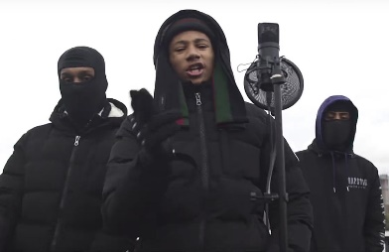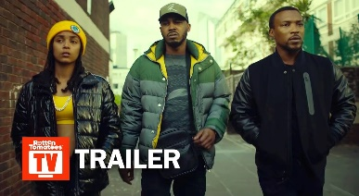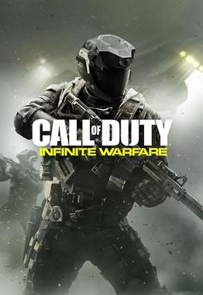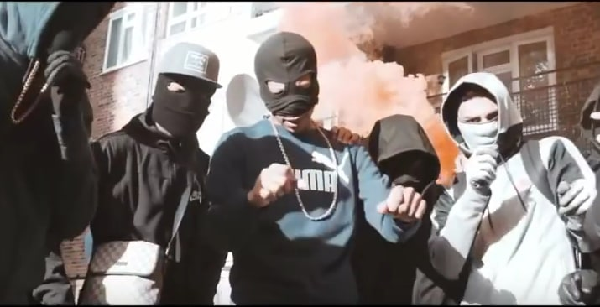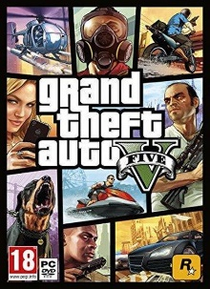

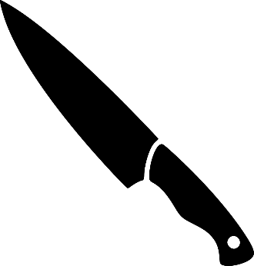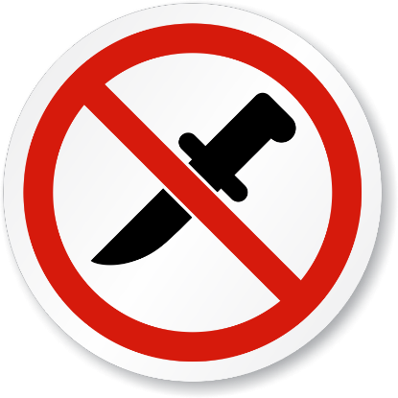

Choice

Choice

What would my life look like if I chose knives?

Think about your goals/aspirations/dreams.

Extension: How would feel in each scenario? Name some emotions.

How would my friends and family feel in each scenario?



**Circle of Peace**

**WHAT CAUSES CONFLICT?**

**Write down some appropriate solutions**

**Resolving conflict**

**What would the world look like if everyone chose this way?**

**How I would resolve conflict**

 **Would the world be a good place or a bad place?**

* Why there might sometimes be conflict in our communities?
* What might some of the problems be, that lead people to behave in this way?
* What emotions can drive conflict?

**What can I do to help promote peace in the community?**

**What does a peaceful community look like?**

**Write or draw**

**Behavioural risks**

**Use the flashcards to understand what might happen if you or someone else gets involved in knife crime.**

***Think about which ones might be the Immediate and Long-term consequences***

**Get seriously hurt/end up in hospital**

**…You can also use the cards to make a storyboard of events…**

**Get arrested/go to prison**

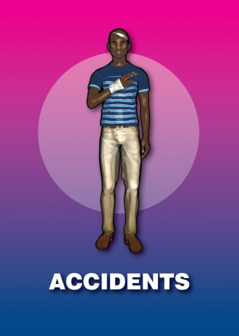

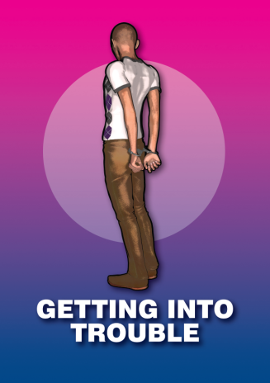

**Death**

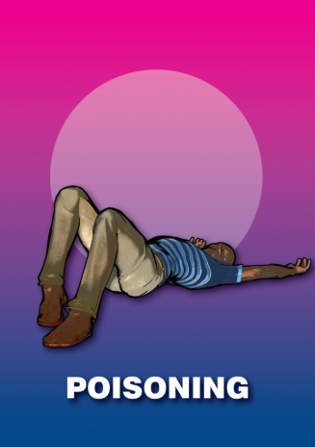

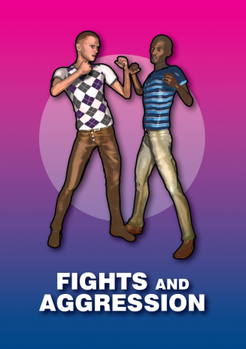

**Putting close friends and family at risk**

**Feelings of guilt, regret or fear**

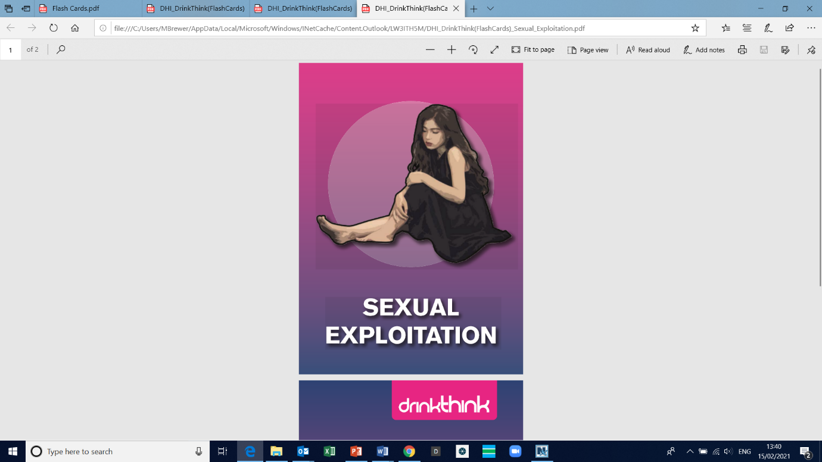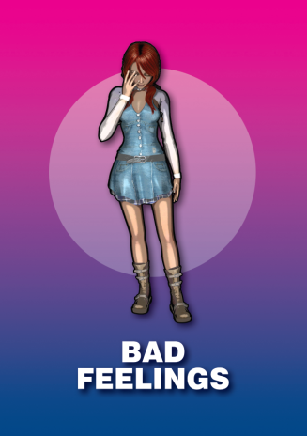

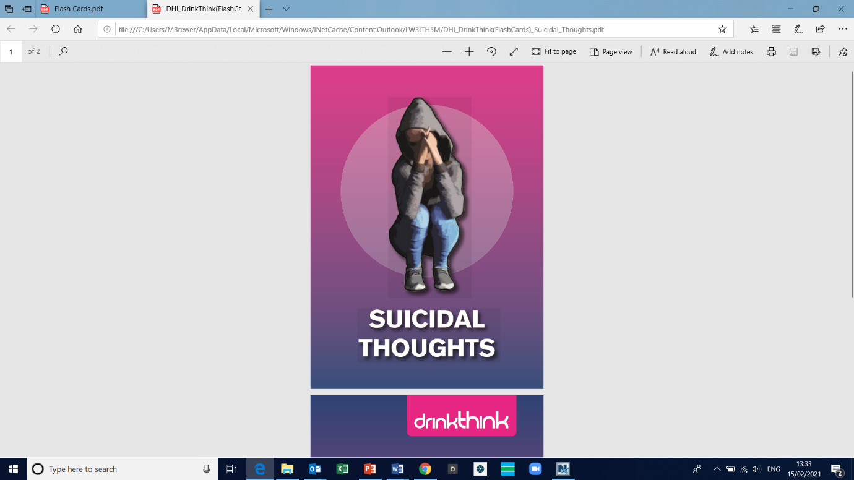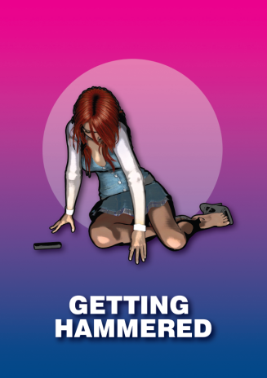

**Mental health issues such as suicidal thoughts or PTSD**

**Substance misuse or alcoholism**

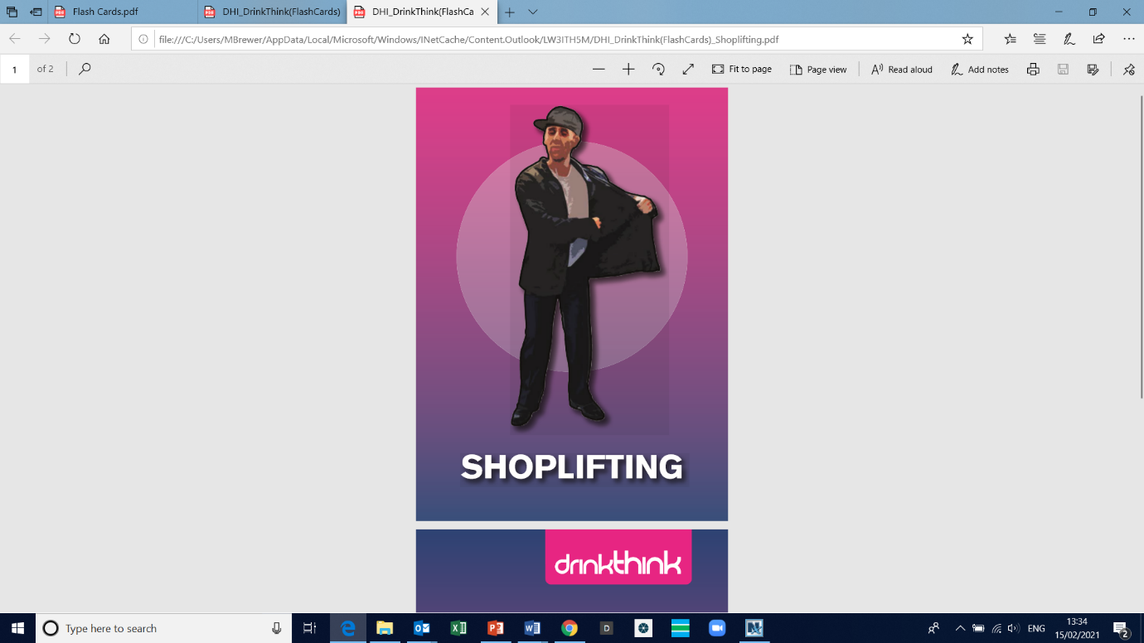

**Reoffending**

**Unsafe peer groups**

**Upset families**

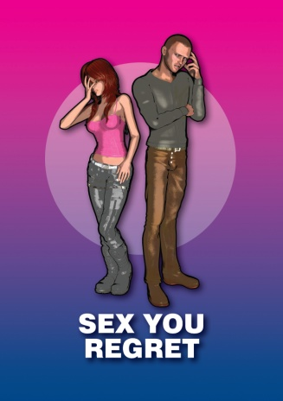

**Worry Tree**

**Notice the Worry**

“What am I worrying about?”

“Is this worry about a current problem or a hypothetical situation?”

Or

“Can I do something about this?”

(Hypothetical situation) (Current problem)

Let worry go

Action Plan

**What? When? How?**

Change focus of Attention

NOW?

LATER?

Do it!

Schedule it!

Let worry go

Let worry go

Change focus of Attention

Change focus of Attention

**TASK:**

**How would you deal with the following worries? Use the worry tree to find solutions.**

1. My friend showed me a knife at school
2. Someone told me to “go to the park afterschool or else.” I feel threatened
3. My mum told me off last week for playing too much GTA
4. What if someone stabs me on my way home from school
5. Will I be traumatised forever if I see someone get stabbed
6. My friend bought a knife to school and showed me at lunch time
7. I’ve joined a group of friends who carry knives
8. My brother who is in a gang asked me look after a knife for him
9. I’m scared I’ll get arrested

**Notes…**

**True Stories**

**Read these excerpts from various news articles and answer…**

1. What were the consequences
2. What could’ve been done to prevent the crime

Louis Holmes aka Bramble, 18, stabbed five young men in the early hours of August 21 (2016) leaving one Keynsham man with life-changing injuries.

Holmes, of no fixed address, was sentenced at Bristol Crown Court today.

Holmes stabbed the first victim, a 24-year-old man, three times while inside the nightclub on Bristol Harbourside. The other four victims were stabbed outside the Dojo Lounge nightclub in Park Row in an unconnected incident.

One of the victims, 23-year-old Dan Curtis from Keynsham, was stabbed in the neck leaving him paralysed from the neck down and confining him to a wheelchair.

[He says] “I needed specialist hospital treatment for the injuries I suffered and despite the expert medical attention I received, I’m still confined to a wheelchair and unable to walk….this incident has caused a tremendous amount of stress to my family and my mum now has to look after me 24/7 as I can’t do things for myself.”

Four people have been convicted of murdering two teenagers who were targeted in a “ferocious” ambush at a house party in Milton Keynes.

Dom Ansah and Ben Gillham-Rice, both 17, were fatally stabbed by masked attackers at the private party on the Emerson Valley estate in October 2019. Two others were stabbed and left with serious but non-life-threatening injuries.

One of the perpetrators was in an incident that was recorded and widely circulated on social media.

Jurors on Tuesday found Charlie Chandler, 22, Clayton Barker, 20, and a 17-year-old and 16-year-old guilty of the murders and two counts of wounding with intent.

The defendants were all linked to the B3 gang in west Bletchley, and had planned the attack.

A man in his 20’s was taken to hospital after being assaulted.

Witnesses described seeing a gang chase the man through Victoria Park before the knife attack.

Officers have spent hours searching through CCTV footage, and have now released a short video clip of three men they want to trace.

Investigating officer, PC Ed Moore said: “The victim was stabbed multiple times in the chest and back and was very fortunate not to have been more seriously injured.

A man who stabbed a woman three times with a kitchen knife in a random and unprovoked attack as she walked home from a night out in Yeovil has been jailed for nearly six years.

Eimantas Sakalauskis, 18, Yeovil, crept up on his 48-year-old victim in the early hours of August 24 last year and attacked her - before running off and disposing of his weapon in a nearby allotment.

The teenager, who had been drinking heavily before the attack and claimed to have no recollection of the events leading up to the stabbing, was initially charged with attempted murder.

His victim suffered wounds to her back and hand as she tried to ward off her attacker.

 The victim's life had been thrown "into turmoil" and she had been left afraid to go out after dark as a result of the attack. She has also suffered from increased anxiety and trouble sleeping as a consequence and her hand injuries left her unable to complete basic household tasks.

Yusuf's been in a gang since he was 15. He wears a stab vest when he leaves the flat he shares with his mum and carries a knife in his boxers because he fears he'll be killed if he can't defend himself.

Homelessness and domestic abuse feature heavily in Yusuf's past and he reckons there's an "80/20 chance" his future will involve prison.

Sitting on a white plastic chair beside his youth worker, Yusuf reels off some of the crimes he's been accused of - carrying acid, attempted murder, arming himself with a knife.

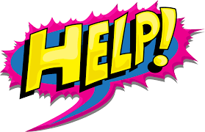

**Asking for help can be difficult!**

What might stop someone from asking for help if they, or someone they know, is involved in knife crime?

Some of the people you could tell if you are worried about something are…

* Teachers
* Police
* Trusted friend or family member
* Social worker
* Foster parent
* Mentor
* Healthcare worker

REMEMBER – If you are in immediate danger, call 999!

***“Something doesn’t feel quite right.”***

Here are some examples on how you can ask for help

**HELP cards!**

* I’m scared about knives
* I’m scared I’m going to get hurt
* I’m feeling unsafe
* I’m worried something bad might happen
* I’m getting pressured by someone
* I’m feeling under pressure
* Someone is forcing me to do something I don’t want to do
* I need to talk to you
* Can we have a chat in private
* I need some advice/help
* I don’t like what my friends are getting up to
* I’m worried about my mates
* I don’t want my friends to get into trouble
* I don’t want to get involved

***Can you think of any?***