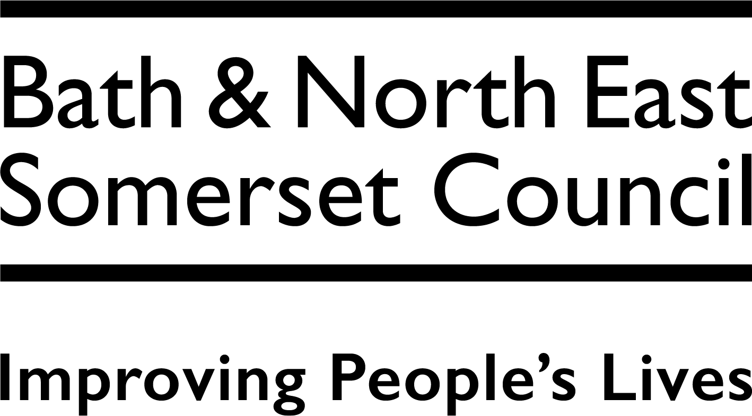 | Traffic Management Team  Bath & North East Somerset Council  Lewis House, Manvers Street, Bath. BA1 1JG  www.bathnes.gov.uk  Email: TROS_@bathnes.gov.uk
 | Telephone: 01225 394041

Traffic Regulation Order (TRO)
Statement of Reasons

Bath and North East Somerset Council
(WHITEWAY ZEBRA PEDESTRIAN CROSSING)

STATEMENT OF REASONS
Proposal
To introduce a new Zebra Crossing on Whiteway Road, Bath.
Reasons
Following requests from Local Residents and the Local Ward Members, funding has been secured to install a pedestrian crossing (Zebra) on Whiteway Road, Bath. Pedestrians are currently experiencing difficulties when crossing over Whiteway Road to reach sites such as Haycombe Cemetery, Haycombe Veterinary, Garden Centre and Roundhill park & play area. The proposed Zebra Crossing would also improve road safety for pedestrians.

The Council has considered article 8 within Schedule 1 to the Human Rights Act (Right to respect for private and family life, home and correspondence) and Protocol 1 Article 1 (Peaceful enjoyment of possessions). Both of these rights are qualified rights, and the Council does not consider that the measures proposed under the TRO amount to a deprivation of possessions as the right to access property has not been extinguished. The proposals are considered to have a minimal impact on human rights. However, the Council is entitled to affect these rights where it is in accordance with the law, necessary (such as in the interests of public safety or economic well-being, to prevent disorder and crime, to protect health, or to protect the rights and freedoms of others), in pursuit of a legitimate aim and proportionate to do so. The proposals within this report are considered to be in accordance with the law, necessary, in pursuit of a legitimate aim and proportionate.

The Council has had due regard to the needs set out in section 149(1) of the Equality Act 2010. It considers that the proposed Order is consistent with the section 149 public sector equality duty, which it has discharged.

Road Traffic Regulation Act 1984

This proposal is made in accordance with the Road Traffic Regulation Act 1984, which under Section 23 enables local highway authorities to establish crossings for pedestrians.

In making this proposal the Council has discharged its duty under section 122 of the Road Traffic Regulation Act 1984.

The Council is under a duty pursuant to section 122(1) of the Road Traffic Regulation Act 1984 (as amended) to exercise its duties under the Act (so far as practicable having regard to the subsection (2) matters), to secure the expeditious, convenient and safe movement of vehicular and other traffic (including pedestrians).

As for the subsection 122(2) matters:

- the desirability of securing and maintaining reasonable access to premises.

Comment: The proposal would not impact on access to premises within its vicinity. It is noted that the zig-zag markings would cross one property that does have a dropped kerb access for parking.

- the effect on the amenities of any locality affected and (without prejudice to the generality of this paragraph) the importance of regulating and restricting the use of roads by heavy commercial vehicles, so as to preserve or improve the amenities of the areas through which the roads run.

Comment: The proposal is considered to have a positive affect on local amenities, improving safety for pedestrians and a suitable place to cross the road in order to access facilities within the area.

bb) The strategy prepared under section 80 of the Environment Act 1995 (national air
quality strategy)

Comment: The proposal will encourage local residents to walk to the local amenities, therefore removing some vehicles from the road and reducing CO2 emissions.

- the importance of facilitating the passage of public service vehicles and of securing the safety and convenience of persons using or desiring to use such vehicles.

Comment: The proposal will have no impact on the passage of public service vehicles, however it will assist pedestrians to access the bus stop that is located within approximately 25 metres from the Zebra Crossing.

d) Any other matters appearing to the local authority to be relevant.

Comment: None.

Having balanced the various matters and considerations, the Council has concluded that it is appropriate to progress the proposed Order.

The Council has also discharged its duty under section 16 of the Traffic Management Act 2004. It has concluded that the proposed Order is consistent with that duty, given its other policies and objectives.

Neither section 16 nor section 122 of the 1984 Act precludes the making of the proposed Order.

Date: 20/11/2024

